Promoted for and behalf of Cycling Time Trials under their rules and regulations.

STOCKSBRIDGE CC
FULL GAS BIKES/IRWIN MITCHELL SOLICITORS

HILL CLIMB – OFFICIAL RESULTS

SUNDAY 24th SEPTEMBER 2017.

SPONSORED BY

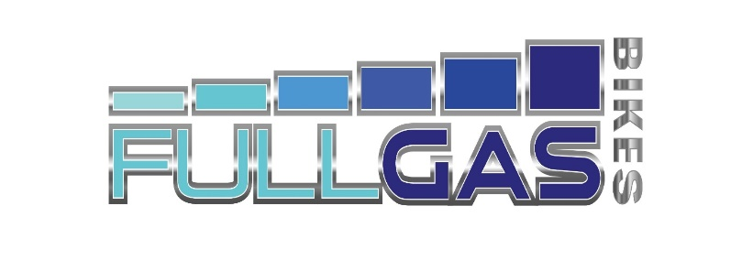

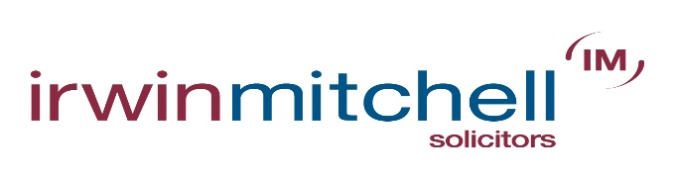

AWARDS
MILL BANK
MEN
1 | Leon Wright | Race Hub | 2.20.8
2 | Andy Nichols | Team B38/Underpin Racing | 2.22.4
3 | Joseph Clark | Cycling Sheffield Giant | 2.22.9
WOMEN
1 | Rebecca Goodson | Veloschils Interbike RT | 3.14.6
2 | Jo Holden | Macclesfield Wheelers | 3.54.3
VETERANS
1 | Jon Wild | Veloviewer | 2.59.7
2 | Trevor Mayne | Birdwell Wheelers | 3.22.6
3 | Conor Cairns | Bolsover & District CC | 3.26.3
JUNIOR
1 | Luke Hind | Team Jewson-MI Racing-Poly Pipe-McCann | 2.57.5
2 | Robert McAndrew | Team Jewson-MI Racing-Poly Pipe-McCann | 2.58.5
PEA ROYD
MEN
1 | James Hayward | Woolwich CC | 2.20.6
2 | Leon Wright | Race Hub | 2.21.8
3 | Calum Brown | Team B38/Underpin Racing | 2.25.8
WOMEN
1 | Rebecca Goodson | Veloschils Interbike RT | 3.20.3
2 | Emilie Verroken | Maxx RT | 3.23.0
3 | Jo Holden | Macclesfield Wheelers | 4.00.2
VETERANS
1 | Jon Wild | Veloviewer | 2.53.6
2 | Conor Cairns | Bolsover & District CC | 3.22.6
3 | Dominic Gregory | Common Lane Occasionals | 3.24.3
JUNIOR
1 | Luke Hind | Team Jewson-MI Racing-Poly Pipe-McCann | 2.53.8
2 | Robert McAndrew | Team Jewson-MI Racing-Poly Pipe-McCann | 2.59.6
COMBINED
MEN
1 | Leon Wright | Race Hub | 4.42.6
2 | Andy Nichols | Team B38/Underpin Racing | 4.50.9
2 | Joseph Clark | Cycling Sheffield Giant | 4.50.9
2 | Calum Brown | Team B38/Underpin Racing | 4.50.9
5 | Kieran Wynne-Cattanach | Maxxis 4 Racing Team | 5.02.4
6 | Hamish McDougall | Leicester Forest CC | 5.16.3
WOMEN
1 | Rebecca Goodson | Veloschils Interbike RT | 6.34.9
2 | Jo Holden | Macclesfield Wheelers | 7.54.5
VETERANS
1 | Jon Wild | Veloviewer | 5.53.3
2 | Conor Cairns | Bolsover & District CC | 6.48.9
3 | John Hind | Bolsover & District CC | 7.12.4
4 | Rapid Rich Stoodley | 3 RT | 7.33.9
JUNIOR
1 | Luke Hind | Team Jewson-MI Racing-Poly Pipe-McCann | 5.51.3
2 | Robert McAndrew | Team Jewson-MI Racing-Poly Pipe-McCann | 5.58.1
TEAM
1 | Team B38/Underpin Racing | Andy Nichols, Calum Brown, Rick Bailey | 15.17.1

