ANDCC Lighthouse Open 25TT Course Information

HQ- Barnstone Village Hall, Park Road/ Main Street NG13 9JG
Parking not available at the Village Hall however, can be found down the nearby Works Lane in Barnstone
Granby-Bingham-Harby-Bottesford
Start in Barnstone village opposite bench outside Church Farm (next to church)
Proceed north-east to the junction with Granby Lane: 0.934 miles.
Turn left (give way) into Granby Lane and proceed to the junction with the A52 east
of Bingham (give way): 3.264 miles.
Turn left WITH CAUTION onto the A52 and proceed westwards via Bingham by-pass
to the junction with Tithby Road: 4.814 miles.
Turn left and proceed via Langar to Harby village: 10.965 miles.
Turn left along Stathern Lane and continue to the junction with the A52 Bottesford by
pass (give way) : 17.614 miles.
Turn left WITH CAUTION onto A52 and proceed to the junction with Granby Lane:
22.729miles.
Turn left into Granby Lane to finish opposite Right Turn sign 50 yds before the lane to
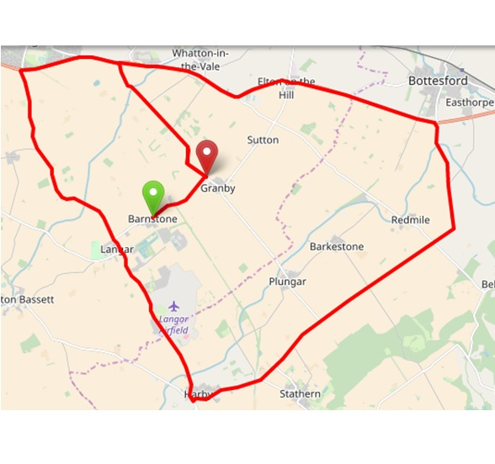
Barnstone, approx ¼ mile short of Granby Village: 25 mile

