NORWICH AMATEUR BICYCLE CLUB OPEN 10TT
Held on Saturday 9th September 2017 14.00
Results

Course: B10/43 HQ: Wortwell Community Centre

Event Sec: Graham Dilks
65 Cecil Rd
Norwich NR12QN
Tel: 01603 616236 Mobile: 07954164792

HQ Address: Tunbeck Close, Wortwell,Norfolk, IP20 0HS.

Timekeepers: Mr Mike Johnson, Mr Tony Howes, Richard Smith.
Start: James Lucas
Turn : Andy Blackwell, MartynTaylor
HQ Jenny and Oliver Cozens

Thank you to all riders and helper who helped make the event a success.
We had luck on our side with heavy rain before and after the event in surrounding areas but only a light shower on the course just before the 1st rider was off. A police incident near the start was just far enough away not to affect us either.
A westerly wind allowed for some fast times with three riders beating the previous course record and Harvey Matthews becoming the 1st rider to go under 20 minutes with a winning time of 19:56.
69 year old Chris Dyason time of 22:45 was the clear winner in the Vet on Std competition with +6:07.
At the other end of the age range it was good to see two schoolboys taking part. 15 year old Josh Sykes just taking the win from 13 year old Charlie Knowler. Well done to both and two to look out for in the future.

Scratch: 1st Harley Matthews. 19:56. 2nd Matthew Senter. 20:09. 3rd Daniel Bloy. 20:10

Women: 1st Kay Burgess. 25:22. 2nd Jan Smith 26:23 3rd. Catherine Pearce 27:08

Vets on Std: 1st Chris Dyason 6:07. 2nd Ed Dean 4:19. 3rd Martin Pyne. 4:18

Juvenile 1st Josh Sykes

Team: D A P CC. Harley Matthews, Mark Richards, Liam Gentry

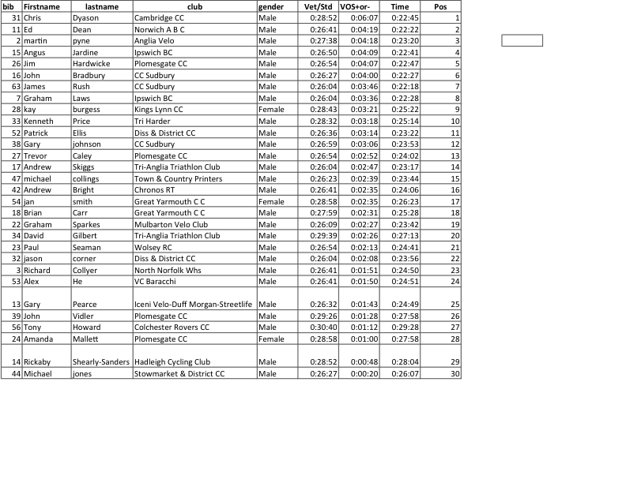
Vets on Std Results Norwich ABC 10TT 9th September 2017

