Promoted for and on behalf of Cycling Time Trials under their Rules and Regulations
2016 Welsh 10 Miles Time Trial Championship
promoted by
Pontypool Road Cycling Club
on behalf of
Welsh Cycling Association
Sunday 14th August 2016
Event Sponsors –

Event Secretary – Dax Jenkins, Tel: 07941487785
Timekeepers – Des Ward (start) & Robin Field (finish)
Event Headquarters: St. Michaels Centre, Pen-Y-Pound, Abergavenny, NP7 5UD

www.stmichaelscentre.org.uk

HQ opens at 7.06am

Awards (one rider/one prize)
Mens Championship
1st Championship Medal & Sunwise Eyewear
2nd Championship Medal & Sunwise Eyewear
3rd Championship Medal
Ladies Championship
1st Championship Medal & Sunwise Eyewear
2nd Championship Medal & Sunwise Eyewear
3rd Championship Medal
Junior Championship
1st Championship Medal & Sunwise Eyewear
2nd Championship Medal & Sunwise Eyewear
3rd Championship Medal
1st Girl Championship Medal & Sunwise Eyewear
1st Juvenile Championship Medal & Sunwise Eyewear
1st Juvenile Girl Championship Medal & Sunwise Eyewear
Also
1st Vet on Std Championship Medal
Awards will also be issued by the Welsh Cycling Association

Course Description for R10/17

O.S. References: Sheet 161 – Start and Finish 333100
Start at the first drain cover in 3rd lay-by east of Hardwick Roundabout, Abergavenny, on A40, 25 yards east of kilo post 97 and 400 yards east of bridge over road. Proceed on A40 to Raglan Roundabout (4.94 miles) and turn by circling roundabout and retrace on A40 to finish at road joint 136 at western end of lay-by opposite start (10 miles). District Regulations: No cars connected with riders are to travel on the A40 during the event. Competitors observed crossing the dual carriageway will be disqualified.

There should be enough parking at the HQ, as long as everyone parks considerately, but extra parking is available at the nearby Fairfields car park. The ride to the start involves navigating through Abergavenny town centre and a busy roundabout – please take care and allow at least 20 minutes.

Important Notice to all Riders
The WCA, CTT and South Wales Police all recommend the use of a good hard shell helmet manufactured to internationally recognised standards. For ALL Riders under the age of 18 these helmets are COMPULSORY.
Marshalls will be positioned around the course - they are there to show you the way but have no authority over the traffic. Please be familiar with the course, so there are no surprises. It is the Riders responsibility to ride within the laws of the road and with consideration to other road users.

There will be a short presentation immediately following confirmation of the results. All medals and Sunwise prizes need to be collected on the day of the event and will not be posted after the event. Please stay to applaud the Welsh 10 Miles T/T Champions for 2016!

Welsh Cycling Association awards will be issued by the WCA at a later date to be confirmed.

This event may be subject to a Doping Control - It is your responsibility to check!
As soon as you have finished you should return to the event HQ as it is your responsibility to check if you are required for Doping Control.
Race numbers required for Doping Control will be displayed at the HQ adjacent to the result board
If your number is displayed you should report immediately to Doping Control which will be nearby.
Remember, it is up to you to check and ensure that you comply.
If required you must report to Doping Control after finishing without delay.

Any complaints or protests must be made to the Event Secretary in writing, within 24 hours of the finish of the event.

Have a good, fast & safe ride!

This event is sponsored by:
Sunwise is a unique British brand of sunglasses offering high
performance sports and fashion eyewear at affordable prices.
Each pair of Sunwise sunglasses are precisely designed to be
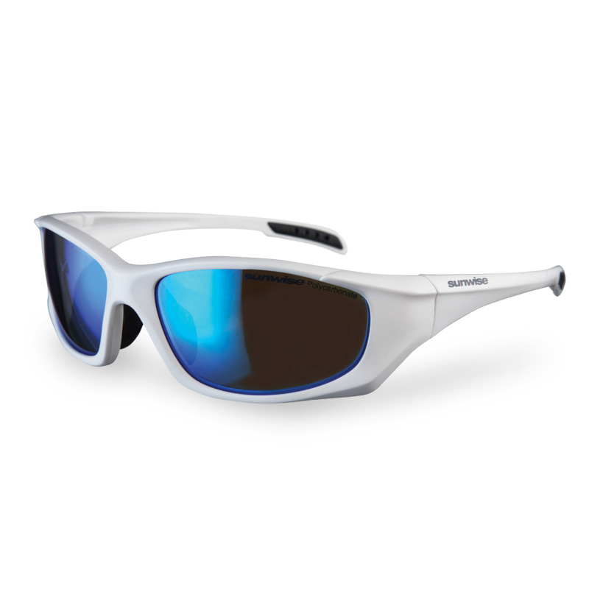lightweight, comfortable and fashionable, while featuring the
latest in optical technology. Multi-layered coatings, graduated
tints and glare-blocking polarised lenses reduce eyestrain and
provide 100% UV protection.
www.sunwise.co.uk Great British Eyewear!

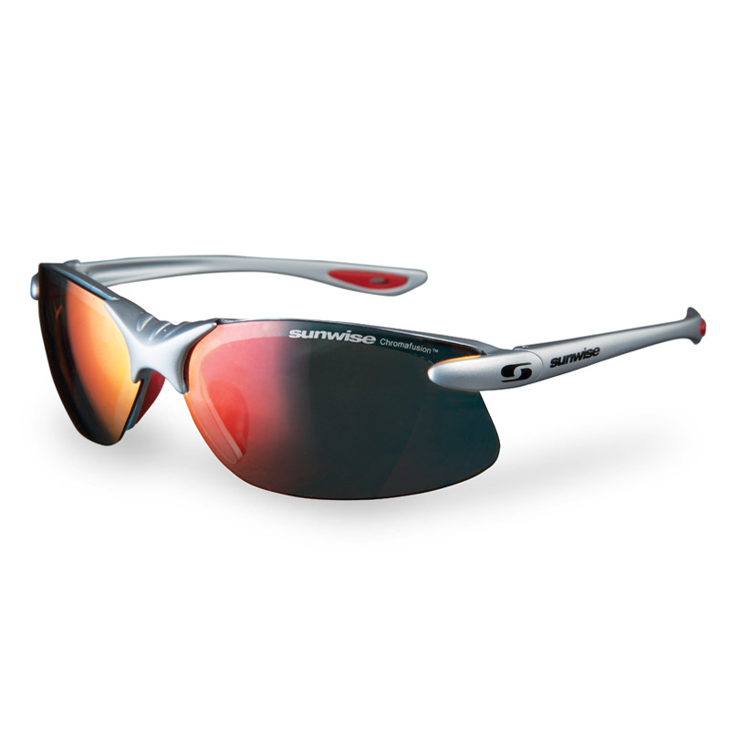
Dax Jenkins BSc(HONS) Optom. 13 New Street, Pontnewydd, Cwmbran.
Caroline Jenkins BSc(HONS) Optom. Tel: 01633 869777

For all your eyecare needs:
Eye Examinations
Contact Lenses
Glaucoma and Diabetic Screening with Digital Retinal Imaging
Sports Vision Correction (Official Sunwise Rx Partner)

Official Stockist of:
Calvin Klein, Ted Baker, Joules, Bench, Storm, Cubik, TitanFlex, Nike, Sunwise & more!
www.rjdjenkinsopticians.co.uk

2016 Welsh Championships 10 Miles TT
Juniors, Ladies & Mens Senior Overflow Event

No. | First Name | Last Name | Club | Age/Std | Start
6 | Joshua | Tarling | West Wales Cycle Racing Team | 12/M | 8.06
7 | Aimee | Lane | Wyre Forest CRC | 12/F | 8.07
8 | Twm | Bryn | Energy Cycles | 15/M | 8.08
9 | Oliver | Rowlands | Newport Phoenix CC | 14/M | 8.09
10 | Matthew | Hanford | Bynea Cycling Club | 15/M | 8.10
11 | Cadi | Jones | Energy Cycles | 16/F | 8.11
12 | James | Bell | Mid Shropshire Wheelers | 18/M | 8.12
13 | Awen | Lewis | Port Talbot Whs CC | 17/F | 8.13
14 | Sion-Kelly | Williams | Energy Cycles | 18/M | 8.14
15 | Huw | Owen | Energy Cycles | 16/M | 8.15
16 | Josh | Griffiths | Bristol South Cycling Club | 16/M | 8.16
21 | Kari | Jones | Ride Bike Wales | 37 | 8.21
22 | Jasmine | Bowyer | Cardiff Ajax CC | 22 | 8.22
23 | Gaynor | Hughes | Bynea Cycling Club | 51/28.58 | 8.23
24 | Jill | Colman | Pembrokeshire Velo | 52/29.03 | 8.24
25 | Katie | Price | Hereford & Dist Whs CC | 32 | 8.25
26 | Nadine | Cannon | Acme Whs (Rhondda) CC | 36 | 8.26
27 | Trish | Chalk | Velo Club St Raphael | 37 | 8.27
28 | Michelle | Robertson | Abercynon Road Club | 49/28.48 | 8.28
29 | Annamarie | Miles | Salt and Sham Cycle Club | 38 | 8.29
30 | Stephanie | Post | Onit Cycles | 30 | 8.30
31 | Andrea | Parish | Camel Valley C & TC | 48/28.43 | 8.31
32 | Kirsty | Murray | Pembrokeshire Velo | 43/28.19 | 8.32
33 | Jessica | Roberts | Team Elite/Paul Bethell Electrical | 37 | 8.33
34 | Carol | Bowen | Abercynon Road Club | 54/29.14 | 8.34
35 | Tina | Reid | In-Gear Quickvit Trainsharp RT | 51/28.58 | 8.35
36 | Joanna | Knight | Bristol South Cycling Club | 56/29.26 | 8.36
37 | Diane | Wilson-Evans | Bynea Cycling Club | 56/29.26 | 8.37
38 | Margaret | Coyle | Gloucester City Cycling Club | 40/28.02 | 8.38
39 | Julie | Stephens | Ross on Wye & Dist CC | 51/28.58 | 8.39
40 | Crystal | Spearman | NOPINZ | 28 | 8.40
46 | Gareth | Chislett | CC Blaenau Gwent | 40/25.59 | 8.46
47 | Ian | Liddiatt | Cardiff Triathletes | 47/26.32 | 8.47
48 | Tony | Emery | Dursley Road Club | 69/28.52 | 8.48
49 | Owen | Pocock | CC Blaenau Gwent | 81/32.00 | 8.49
50 | Jeffrey | Adams | Pontypool Road Cycling Club | 69/28.52 | 8.50
51 | John | Coles | West Suffolk Whs & Tri Club | 73/29.39 | 8.51
52 | Jame | Stevens | Bristol South Cycling Club | 41/26.04 | 8.52
53 | Kevin | Fiander | VTTA (South Wales) | 53/26.59 | 8.53
54 | Norman | James | Ogmore Valley Wheelers CC | 77/30.40 | 8.54
55 | Russell | Boon | Avonlea/Treasure RT | 51/26.50 | 8.55
56 | Ron | Boast | Ogmore Valley Wheelers CC | 65/28.14 | 8.56
57 | Richard | Bowmer | Ogmore Valley Wheelers CC | 51/26.50 | 8.57
58 | Gregory | Brett | Ogmore Valley Wheelers CC | 46/26.27 | 8.58
59 | Kevin | Grant | Frome and District Wheelers | 59/27.32 | 8.59
60 | Stephen | Landeg | Ogmore Valley Wheelers CC | 62/27.51 | 9.00
61 | Rick | Harris | Ross on Wye & Dist CC | 41/26.04 | 9.01
62 | Ed | Hadley | Hereford & Dist Whs CC | 60/27.38 | 9.02
63 | Brian | Parker | Abercynon Road Club | 41/26.04 | 9.03
64 | Michael | Williams | Hereford & Dist Whs CC | 59/27.32 | 9.04
65 | Michael | Tarling | West Wales Cycle Racing Team | 40/25.59 | 9.05
66 | Roger | Wood | Pontypool Road Cycling Club | 62/27.51 | 9.06
67 | Robert | Jones | Cardiff 100 Miles RCC | 64/28.06 | 9.07
68 | Jon | Airey | Ross on Wye & Dist CC | 63/27.59 | 9.08
69 | Matt | Grantham | Pontypool Road Cycling Club | 18 | 9.09
70 | Richard | Franklin | Salt and Sham Cycle Club | 47/26.32 | 9.10
71 | Les | Thomas | Port Talbot Whs CC | 54/27.04 | 9.11
72 | Brad | Davies | Bynea Cycling Club | 50/26.45 | 9.12
73 | Derek | Morgan | Gannet CC | 76/30.23 | 9.13
74 | Kevin | Bessant | Bynea Cycling Club | 53/26.59 | 9.14
75 | Nick | Hughes | Salt and Sham Cycle Club | 38 | 9.15
76 | Dean | Prosser | Hereford & Dist Whs CC | 47/26.32 | 9.16
77 | Paul | Rees | Bynea Cycling Club | 51/26.50 | 9.17
78 | Stuart | Jones | EC Cycles | 34 | 9.18
79 | Paul | Griffiths | Cardiff Ajax CC | 61/27.44 | 9.19
80 | Ron | Clews | Stourbridge Velo | 55/27.09 | 9.20
81 | Andrew | Harries | Ogmore Valley Wheelers CC | 56/27.14 | 9.21
82 | Robin | Fox | Dursley Road Club | 58/27.26 | 9.22
83 | Kerry | Trigg | Ross on Wye & Dist CC | 45/26.23 | 9.23
84 | David | Steel | Hereford & Dist Whs CC | 69/28.52 | 9.24
85 | Steffan | Jones | Energy Cycles | 49/26.41 | 9.25
86 | Gareth | Hill | Abercynon Road Club | 44/26.18 | 9.26

2016 Welsh Championships 10 Miles TT
Mens Senior Event

No. | First Name | Last Name | Club | Age/Std | Start
1 | Andrew | Legge | Bristol South Cycling Club | 40/25.59 | 9.31
2 | Gary | Flower | Acme Whs (Rhondda) CC | 47/26.32 | 9.32
3 | Paul | Stephens | Ross on Wye & Dist CC | 51/26.50 | 9.33
4 | Paul | Hudson | Severn Valley Cycles | 49/26.41 | 9.34
5 | Charles | Zanettacci | Cheltenham & County Cycling Club | 53/26.59 | 9.35
6 | David | Bucknall | Royal Dean Forest Cycle Club | 42/26.09 | 9.36
7 | Mark | Bradley | Bristol South Cycling Club | 51/26.50 | 9.37
8 | Gareth | Poulton | Abergavenny RC | 40/25.59 | 9.38
9 | Garry | Shuker | Walsall Roads Cycling Club | 61/27.44 | 9.39
10 | Carwyn | Davies | Cwmcarn Paragon Road Club | 38 | 9.40
11 | Emyr | Griffiths | Bynea Cycling Club | 49/26.41 | 9.41
12 | Iain | Cade | Bath Cycling Club | 36 | 9.42
13 | Jon | Wiggins | Frome and District Wheelers | 34 | 9.43
14 | Stephen | Taylor | Team NBCC | 51/26.50 | 9.44
15 | Steven | Cottington | Bath Cycling Club | 54/27.04 | 9.45
16 | Thomas | Shuker | Walsall Roads Cycling Club | 25 | 9.46
17 | Mike | Amery | VC Sevale (Malvern) | 58/27.26 | 9.47
18 | Glyndwr | Griffiths | 73 Degrees Bicycles | 38 | 9.48
19 | Karl | Davies | Stourbridge Velo | 54/27.04 | 9.49
20 | James | Lewis | NFTO Pro Cycling | 25 | 9.50
21 | Lloyd | Morgan | Cardiff Ajax CC | 42/26.09 | 9.51
22 | Vincent | Douglas | Gloucester City Cycling Club | 46/26.27 | 9.52
23 | David | Wood | Stourbridge Velo | 61/27.44 | 9.53
24 | Alan | Cooper | Avonlea/Treasure RT | 59/27.32 | 9.54
25 | Graeme | Boswell | Cardiff Ajax CC | 41/26.04 | 9.55
26 | Mike | Lindsay | Wills Wheels CC | 50/26.45 | 9.56
27 | Simon | Witts | Gloucester City Cycling Club | 45/26.23 | 9.57
28 | Simon | Geary | Hereford & Dist Whs CC | 44/26.18 | 9.58
29 | Paul | Jones | Cwmcarn Paragon Road Club | 39 | 9.59
30 | Christopher | Jones | Ride Bike Wales | 47/26.32 | 10.00
31 | Laurence | Douglas-Greene | Somerset Road Club | 23 | 10.01
32 | Jonathan | Wilkinson-Lockyer | Tor 2000 (Kalas, Whitelake, Scorpion) | 47/26.32 | 10.02
33 | John | Murphy | Gloucester City Cycling Club | 76/30.23 | 10.03
34 | Scott | Nash | Pembrokeshire Velo | 47/26.32 | 10.04
35 | Mark | Woolford | Chippenham & District Wheelers | 50/26.45 | 10.05
36 | Stuart | Evans | Port Talbot Whs CC | 70/29.02 | 10.06
37 | Paul | Cannon | Porth & District CC | 64/28.06 | 10.07
38 | Gary | Jones | Pontypool Road Cycling Club | 54/27.04 | 10.08
39 | Richard | Hier | EC Cycles | 36 | 10.09
40 | Danny Glyn | Roberts | Anglesey Cycling Group | 35 | 10.10
41 | John | Regan | Pembrokeshire Velo | 47/26.32 | 10.11
42 | Richard | Coomer | Pembrokeshire Velo | 38 | 10.12
43 | Gareth | Battle | Porth & District CC | 42/26.09 | 10.13
44 | Steven | Brown | Gloucester City Cycling Club | 43/26.13 | 10.14
45 | Anthony | Jones | Bynea Cycling Club | 44/26.18 | 10.15
46 | Paul | Lambert | Chippenham & District Wheelers | 50/26.45 | 10.16
47 | Andrew | Derrick | Severn RC | 37 | 10.17
48 | Ian | Lindsay | Royal Navy & Royal Marines CA | 43/26.13 | 10.18
49 | Andrew | Hayward | Cwmcarn Paragon Road Club | 44/26.18 | 10.19
50 | Graham | Collins | Tanks Direct Cycling | 35 | 10.20
51 | Julian | Harper | Revo Racing | 47/26.32 | 10.21
52 | David | Francis | Pembrokeshire Velo | 44/26.18 | 10.22
53 | Rob | Hall | Salt and Sham Cycle Club | 43/26.13 | 10.23
54 | Derek | Dowdeswell | Gloucester City Cycling Club | 62/27.51 | 10.24
55 | Aled | Roberts | Team Elite/Paul Bethell Electrical | 37 | 10.25
56 | Ed | Laverack | JLT Condor | 22 | 10.26
57 | Chris | Fishbourne | Abercynon Road Club | 42/26.09 | 10.27
58 | Christopher | Goodwin | Ogmore Valley Wheelers CC | 43/26.13 | 10.28
59 | Mike | Parry | Hereford Triathlon Club | 50/26.45 | 10.29
60 | Liam | Bard | Revo Racing | 27 | 10.30
61 | Rod | Hicks | Port Talbot Whs CC | 51/26.50 | 10.31
62 | Digby | Rusling | Royal Dean Forest Cycle Club | 47/26.32 | 10.32
63 | Rob | Hussey | Army Cycling Union | 37 | 10.33
64 | Andrew | Milner | Evesham & District Wheelers | 44/26.18 | 10.34
65 | Steve | Matthews | Team Elite/Paul Bethell Electrical | 33 | 10.35
66 | Justin | Ford | CC Blaenau Gwent | 43/26.13 | 10.36
67 | Rob | Jones | Cardiff Ajax CC | 39 | 10.37
68 | Mike | Broadbent | Swansea Wheelers/CS Abertawe | 55/27.09 | 10.38
69 | Howell | Mason | Ogmore Valley Wheelers CC | 61/27.44 | 10.39
70 | Paul | Jones | Severn Valley Cycles | 39 | 10.40
71 | Daniel | Colman | Pembrokeshire Velo | 21 | 10.41
72 | Daniel | Kempe | Bristol South Cycling Club | 50/26.45 | 10.42
73 | Peter | Ackroyd | Cheltenham & County Cycling Club | 58/27.26 | 10.43
74 | Dafydd | Hughes | Energy Cycles | 34 | 10.44
75 | Lee | Morgan | Team Bottrill | 43/26.13 | 10.45
76 | Michael | Portlock | EC Cycles | 46/26.27 | 10.46
77 | Paul | Milner | Worcester St. Johns CC | 46/26.27 | 10.47
78 | Matthew | Clarke | 73 Degrees Bicycles | 52/26.54 | 10.48
79 | John | Shehan | Bynea Cycling Club | 70/29.02 | 10.49
80 | Matt | Slater | Revo Racing | 41/26.04 | 10.50
81 | Earl | Smith | Severn Valley Cycles | 46/26.27 | 10.51
82 | Nathan | Leaves | NFTO Race Club | 18 | 10.52
83 | Mark | Rosser | Ogmore Valley Wheelers CC | 46/26.27 | 10.53
84 | Jon | Vickery | Cwmcarn Paragon Road Club | 52/26.54 | 10.54
85 | Ben | Anstie | 73 Degrees Bicycles | 39 | 10.55
86 | Christopher | Holman | Team Bottrill | 29 | 10.56
87 | Jonathan | Gould | Cheltenham & County Cycling Club | 39 | 10.57
88 | Neil | Poulton | Ogmore Valley Wheelers CC | 36 | 10.58
89 | Jeffrey | Rees | Acme Whs (Rhondda) CC | 53/26.59 | 10.59
90 | Luke | Cornish | Cwmcarn Paragon Road Club | 22 | 11.00
91 | Simon | Tarrant | Cheltenham & County Cycling Club | 42/26.09 | 11.01
92 | Daryl | Godden | Gloucester City Cycling Club | 57/27.20 | 11.02
93 | Matthew | Smith | Port Talbot Whs CC | 29 | 11.03
94 | Guy | Evans | Hereford & Dist Whs CC | 57/27.20 | 11.04
95 | George | Evans | Team Bottrill | 18 | 11.05
96 | Paul | Coles | 73 Degrees Bicycles | 43/26.13 | 11.06
97 | Gareth | Jones | Velo Club St Raphael | 46/26.27 | 11.07
98 | Paul | Colman | Pembrokeshire Velo | 55/27.09 | 11.08
99 | Chris | Ward | Team Echelon - Rotor | 61/27.44 | 11.09
100 | Matt | Burden | 73 Degrees Bicycles | 39 | 11.10
101 | David | Wilson-Evans | Bynea Cycling Club | 59/27.32 | 11.11
102 | Ross | Davies | NFTO Race Club | 36 | 11.12
103 | Richard | Long | Merthyr CC | 31 | 11.13
104 | Matthew | Phillips | Bynea Cycling Club | 29 | 11.14
105 | Tom | Ward | Team Echelon - Rotor | 22 | 11.15
106 | Chris | Massey | Team Bottrill | 44/26.18 | 11.16
107 | Robert | Hughes | Ride Bike Wales | 52/26.54 | 11.17
108 | Steven | Madeley | Ogmore Valley Wheelers CC | 55/27.09 | 11.18
109 | Luke | Bradford | Hereford Triathlon Club | 39 | 11.19
110 | Kieron | Davies | DRAG2ZERO | 29 | 11.20
111 | Mike | Appleyard | Lancashire RC | 50/26.45 | 11.21
112 | Ben | Skinner | Bath Cycling Club | 33 | 11.22
113 | Adam | Taylor | Royal Dean Forest Cycle Club | 38 | 11.23
114 | Marco | Marletta | Cardiff Jif | 50/26.45 | 11.24
115 | David | Woodhouse | G.S. Henley | 38 | 11.25
116 | Ben | Phillips | Bynea Cycling Club | 27 | 11.26
117 | Karl | Wills | Pontypool Road Cycling Club | 56/27.14 | 11.27
118 | Andrew | Spearman | Chippenham & District Wheelers | 56/27.14 | 11.28
119 | Vincent | Jenkins | LeisureLakesBikes.com | 76/30.23 | 11.29
120 | Dan | Evans | Team Elite/Paul Bethell Electrical | 35 | 11.30

