**Riders information Pack**

**Dooleys Classic 10 Mile TT**











**Promoted for and on behalf of Cycling Time Trials and under their regulations**

Sunday 27th August 2017, 1st Rider off at 09:01 hours



HQ: Bishopton Community Centre, Gledstane Road, PA7 5AU

Open at 08:00 am for Registration. Race numbers will be available for collection.

Figure

There are toilets facilities and tea, coffee and snacks will be available, there will be car parking spaces available.

**Organiser:** Alex Mcphee, 18 Holm Street, Stewarton, KA35HR

Mobile Tel: 07768064445. Email: [alexmcphee50@gmail.com](mailto:alexmcphee50@gmail.com)

Note: Mobile number above for use on the day, Reception will be patchy, so text messages are likely best on the day.

**Registration:**  Jim Cusick – Dooleys RT

**Pusher Off:** Hugh Jamieson

**Timekeepers:** Alex Hunter (Start), Linda and Geoff Smith

**Marshals:** Dooleys Cycles members and friends within the District

**Course:** West Ferry 10 Miles

**Course Description**

1. Start under railway bridge on Greenock Rd heading West approx. 2.5miles from RaceHQ

2. Immediate LEFT on slip-road to A8 at Westferry roundabout

3. Proceed westbound on A8

4. Straight through first roundabout at Langbank

5. Take 2nd exit at second roundabout at Woodhall

6. Continue on A8 to TURN at Newark Roundabout PLEASE OBSERVE EXTREME CAUTION.

7. Retrace to finish at slip-road to Westferry roundabout.

**Course Maps**

Thanks to Martin Knox

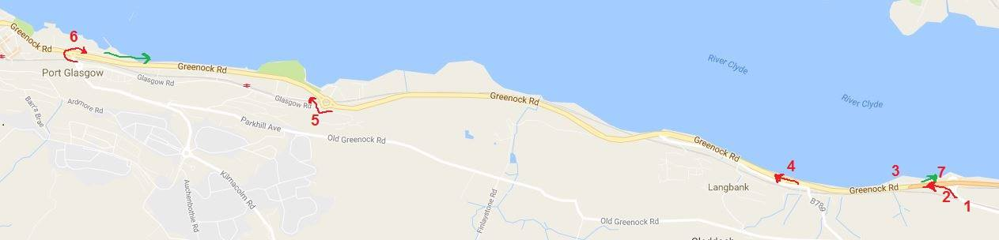

**Warnings/Caution**

Distance from HQ to Start line is approximately 2.5 Miles, please allow 15 minutes at least to make your Start time.

Start is in excellent condition to allow for ample riders queuing and Race Staff. Keep safe and maintain order not to get in way of on - coming cars from behind. Please do not cross the start line when warming up, this will result in disqualification.

Please do not Congregate at the Finish Line, Times will be available at the HQ.

Course Marshals have no legal authority to stop traffic on the course, and as such will only provide course directional information. It is a rider’s responsibility to abide by the rules of the Highway Code at all times. Police observers may be present on the course during the competition.

**Regulations**

Riders must exercise caution at all junctions. Any competitor who crosses the white line when approaching or leaving a junction will be liable to disqualification from the event and may be reported to the District Committee for further disciplinary action. No "U" turns in the vicinity of the start and finish. Observers will be watching. Head up and observe local regulations at all times. Pace must not be given or received and the onus is on the caught riders to adhere to this rule.

**Racing Bikes**

It is the Riders responsibility to ensure your bike is in working order, please ensure you double check all aspect of your bike and equipment and avoid potential hazards.

**Race Staff and Time Keepers**

Please ensure you Respect the Event organiser and Staff, we are all Volunteers and without us there would be no races. If you have an issue with anything related to the Event such as your finishing time please speak to the organiser in private, Respectfully.

**Prize Presentation**

If you can, please stay for the prize presentation, which takes place as soon possible after the finish at the HQ.

The Event Organiser has gone to extra ordinary lengths to ensure this Event is heavily supported with cash prizes and Vouchers of good Value.

If you do not stay for the Prize award presentation you will forfeit your prize to another competitor.

**Prize List**

Total amount of £650.00 is available in Dooleys cycles Vouchers

Fastest 3 in each Age category will be awarded Vouchers, Ian Dooley will ensure that you will GET MORE value for the amount given when you use the voucher at his Shop.

Fastest Male 1st 2nd 3rd £75.00 £50.00 £30.00

Fastest Female 1st 2nd 3rd £75.00 £50.00 £30.00

1st Espoir male & Female £20.00 £20.00

1st Junior £10.00

Vet 40 Male 1st 2nd 3rd £15.00 £10.00 £10.00

Vet 40 Female 1st 2nd 3rd £15.00 £10.00 £10.00

Vet 50 Male 1st 2nd 3rd £15.00 £10.00 £10.00

Vet 50 Female 1st 2nd 3rd £15.00 £10.00 £10.00

Vet 60 Male 1st 2nd 3rd £15.00 £10.00 £10.00

Vet 70 Male 1st 2nd 3rd £15.00 £10.00 £10.00

Laterne Rouge £10.00

£100.00 Cash Spot Prize

£50.00 Meal voucher at Glasgow Restaurant

2 x Massage vouchers

Various mixture of other additional prizes will be awarded on the day also

**Trophies**

Dooleys Cycles awarding 2 brand new trophies to Fastest Male and Female

**Other Prizes**

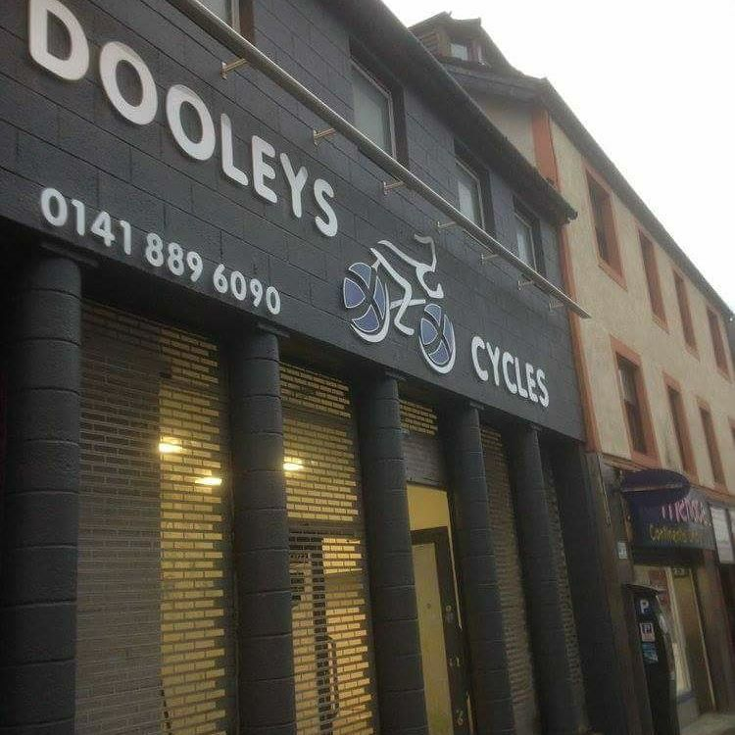Due to very generous Sponsors there will be spot prizes awarded on the day.