Law Wheelers Cycling Club

OPEN 25 MILE TIME TRIAL (INCORPORATING SVTTA Ben Smith Trophy) Sunday 2rd of July, 2017.

Event HQ:

HQ for the race is Cambusbarron Village Hall, St. Ninians Road. Cambusbarron. STIRLING. FK7 9NU.

Parking:

There is a small car park at the centre. Some limited on-street parking on St Ninians Road and some side streets available but please park considerately.

Please DO NOT park in the housing estate behind the hall.

Please DO NOT park in the lay-by at Touch Road junction (approximately 1.6 miles onto the course from the start)

Sign on: Hall should be open from 07:00 hours and sign on should start shortly after this once we are set up.

Start:

The start is on the A811 immediately to the west of the Kersebonny Road end, Cambusbarron. It is one mile from the event HQ.

The start is accessed from Cambusbarron village by turning right from the HQ entrance, proceeding into the village, turning right down Mill Brae after about a quarter of a mile and left onto Mill Road, which leads to Kersebonny Road. The route to the start is downhill.

Please wait at the foot of Kersebonny Road before being called to the start area.

DO NOT enter the course before your start time.

Start area at the junction with Kersebonny Road. The finish on the return is at the large Oak Tree seen in the distance. Giving a shout out of your number as you pass can be useful to spotter. (If you have the breath that is ;-) )

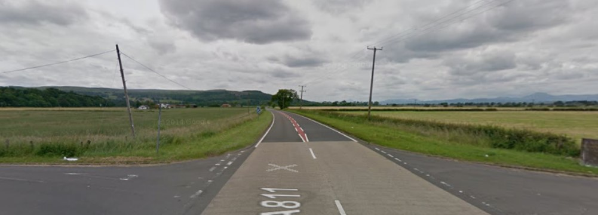

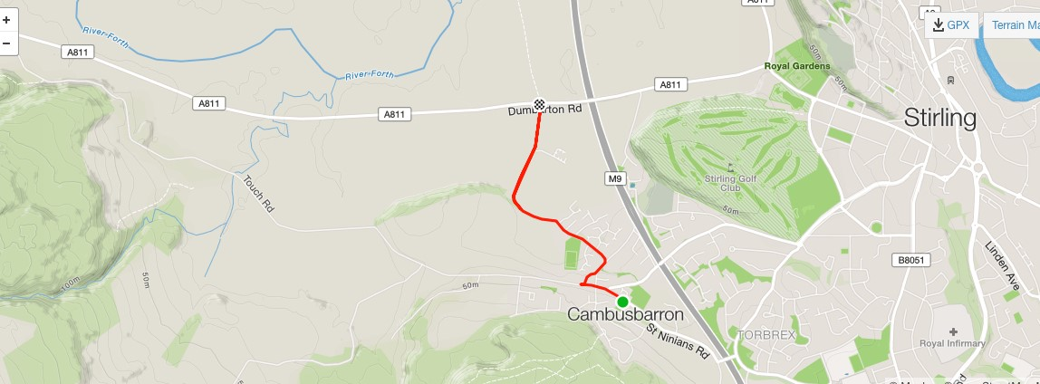

The course:

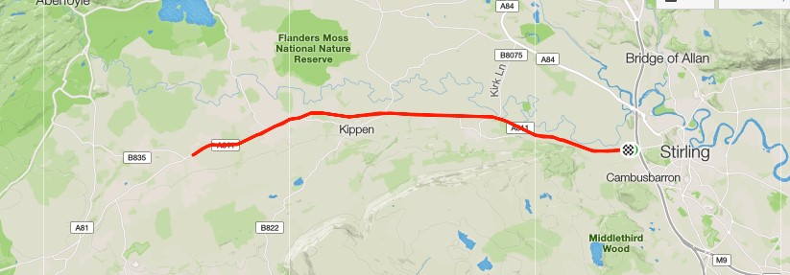

The course is an out and back along the A811. From the start it heads west through the Kippen roundabout. There will be Marshals at this point. They are not allowed to stop traffic so riders must adhere to highway code when negotiating the roundabout. You will traverse this roundabout on the way back also.

On the next stretch to the turn at the entrance to Buchlyvie riders will encounter some incline until they pass through Arnprior. Marshals will be present at the turn which is immediately before the island at the entrance to Buchlyvie. As this is a “dead turn” you will need to watch your speed and be aware of traffic both behind you and approaching from Buchlyvie itself. You must give way if necessary and, again, Marshals cannot stop traffic. Be careful of the road surface in this area.

The approach to the turn:

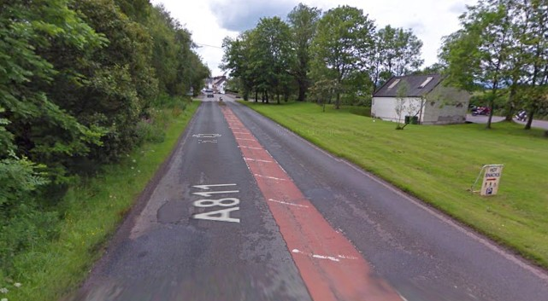

The Finish area.

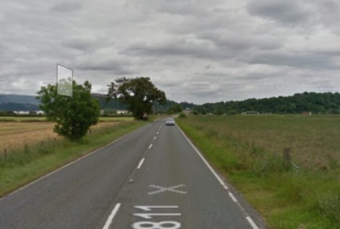

Once finished there will be catering available at the at the HQ. We hope you have an enjoyable and safe ride. If you have any feedback after the event that you feel would be useful for us in organising the event in future, please get in touch.

(robertclements55@gmail.com tel 07722013855)

The SVTTA are running 1 event in tandem with the Law Wheelers CC. For interest,here is some history on the Ben Smith Trophy.

Ben was initiated into cycling by his father prior to his serving in the Italian Campaign in world war two. Shortly after demob Ben took up cycling once more and during the year 1954, and on reaching the age of 42, rode his first SVTTA event. This was the start of an illustrious career in that, he held 11 British Records and during 1966 was second in the British VTTA B.A.R., and along with John Park won the Team Award. Unfortunately, this was Ben’s last year of quality cycling, as during the early part of 1967 he was struck from behind by a car and sustained severe head injuries as well as body. After a prolonged confinement he strived hard to get back to his love of cycling after which, and with the aid of several of his friends, he took part in his first event with one friend steadying him on the start line and other to assist him at the turn. Unfortunately, after several years the rigours of his injuries caught up with Ben.

Update Start Sheet.
Bib | Start Time | Firstname | Lastname | Club
1 | 08:01:00 | John | Russell | Law Wheelers
2 | 08:02:00 | George | Adam | SVTTA
3 | 08:03:00 | Elizabeth | Hunt | Coatbridge Clarion CC
4 | 08:04:00 | Michael | Devlin | SVTTA
5 | 08:05:00 | Martin | Gordon | Coatbridge Clarion CC
6 | 08:06:00 | John | Gormlie | Coatbridge Clarion CC
7 | 08:07:00 | Craig | Gilmour | Falkirk B C
8 | 08:08:00 | James | Brown | Carrick CC
9 | 08:09:00 | Stephen | Dickson | Falkirk B C
10 | 08:10:00 | sean | quinn | Law Wheelers
11 | 08:11:00 | Thomas | McNeish | Royal Albert CC
12 | 08:12:00 | Bill | Groves | EH Star Cycling
13 | 08:13:00 | Andrew | Stewart | Dunfermline CC
14 | 08:14:00 | George | Skinner | VTTA (North)
15 | 08:15:00 | Graham | Smith | Law Wheelers
16 | 08:16:00 | Neil | Mcleod | SVTTA
17 | 08:17:00 | James | Hall | Rock and Road
18 | 08:18:00 | Stuart | McGibbon | VC Glasgow South
19 | 08:19:00 | Iain | Binning | Stirling Bike Club
20 | 08:20:00 | Steve | Nutley | RT 23
21 | 08:21:00 | Gary | Longhurst | Stirling Bike Club
22 | 08:22:00 | Joe | McFadyen | Dundee Wheelers CC
23 | 08:23:00 | Katherine | Wren | Stirling Bike Club
24 | 08:24:00 | Miriam | Rennet | SVTTA
25 | 08:25:00 | Ian | Dobbie | West Lothian Clarion
26 | 08:26:00 | Robert | Shennan | Johnstone Wheelers
27 | 08:27:00 | Joseph | Thom | Glasgow Nightingale CC
28 | 08:28:00 | james | truswell | VC Glasgow South
29 | 08:29:00 | Scott | Cooper | Royal Albert CC
30 | 08:30:00 | Darren | Kean | Fullarton Wheelers
31 | 08:31:00 | Alan | Macintyre | Coatbridge Clarion CC
32 | 08:32:00 | John | McCrory | Glasgow United CC
33 | 08:33:00 | james | smith | Glasgow Nightingale CC
34 | 08:34:00 | Mike | Ferguson | Johnstone Wheelers
35 | 08:35:00 | John | Dunlop | Loudoun Road Club
36 | 08:36:00 | David | Pritchard | Kennoway Road Club
37 | 08:37:00 | Joe | Hands | Velo Club Vitesse
38 | 08:38:00 | Frazer | Bell | Walkers Cycling Club
39 | 08:39:00 | martin | kane | SVTTA
40 | 08:40:00 | David | Baird | Loudoun Road Club
41 | 08:41:00 | john | gallagher | Royal Albert CC
42 | 08:42:00 | Deidre | O'Reilly | Glasgow Wheelers
43 | 08:43:00 | Valerie | Martin | Dooleys RT
44 | 08:44:00 | JAMES | MUIR | SVTTA
45 | 08:45:00 | Rupert | Dickinson | Glasgow Nightingale CC
46 | 08:46:00 | Robert | Brown | EH Star Cycling
47 | 08:47:00 | Joe | Shaw | Falkirk B C
48 | 08:48:00 | Martin | Smith | Saint Christophers CC
49 | 08:49:00
50 | 08:50:00 | Mark | Skilling | Carrick CC
51 | 08:51:00 | John | Shelley | Perth United CC
52 | 08:52:00 | Colin | Knott | Pedal Power RT
53 | 08:53:00 | David | Fulton | Carrick CC
54 | 08:54:00 | Stephen | Makin | Falkirk BC
55 | 08:55:00
56 | 08:56:00 | Brian | Cameron | Lomond Roads CC
57 | 08:57:00 | Andrea | Pogson | Gala CC
58 | 08:58:00 | Alasdair | Macmillan | Musselburgh RCC
59 | 08:59:00 | Iain | Gordon | Musselburgh RCC
60 | 09:00:00 | Eddie | Addis | RT 23
61 | 09:01:00 | Paul | Robinson | Loudoun Road Club
62 | 09:02:00 | john | leonard | Velopreda CC
63 | 09:03:00 | stewart | mitchell | Deeside Thistle CC
64 | 09:04:00 | Alex | Munro | Lancashire RC
65 | 09:05:00 | derek | mcmillan | SVTTA
66 | 09:06:00 | Alan | Thomson | Johnstone Wheelers
67 | 09:07:00 | Frank | anderson | SVTTA
68 | 09:08:00 | Iain | Drummond | West Lothian Clarion
69 | 09:09:00 | Steven | Grier | Loudoun Road Club
70 | 09:10:00 | Kenneth | Armstrong | Carrick CC
71 | 09:11:00 | alex | mcphee | Dooleys RT
72 | 09:12:00 | DAVID | MILLAR | SVTTA
73 | 09:13:00 | Murray | Doyle | Bute Wheelers
74 | 09:14:00 | Sandy | Wallace | Fife Century Road Club
75 | 09:15:00 | Marc | Anderson | Loudoun Road Club
76 | 09:16:00 | neil | anderson | Deeside Thistle CC
77 | 09:17:00 | Alan | Davidson | Dundee Thistle
78 | 09:18:00 | Michael | Robb | Carrick CC
79 | 09:19:00 | Neil | Pendrich
80 | 09:20:00 | Douglas | Watson | Icarus Racing
81 | 09:21:00 | Karl | Farmer | VC Glasgow South

