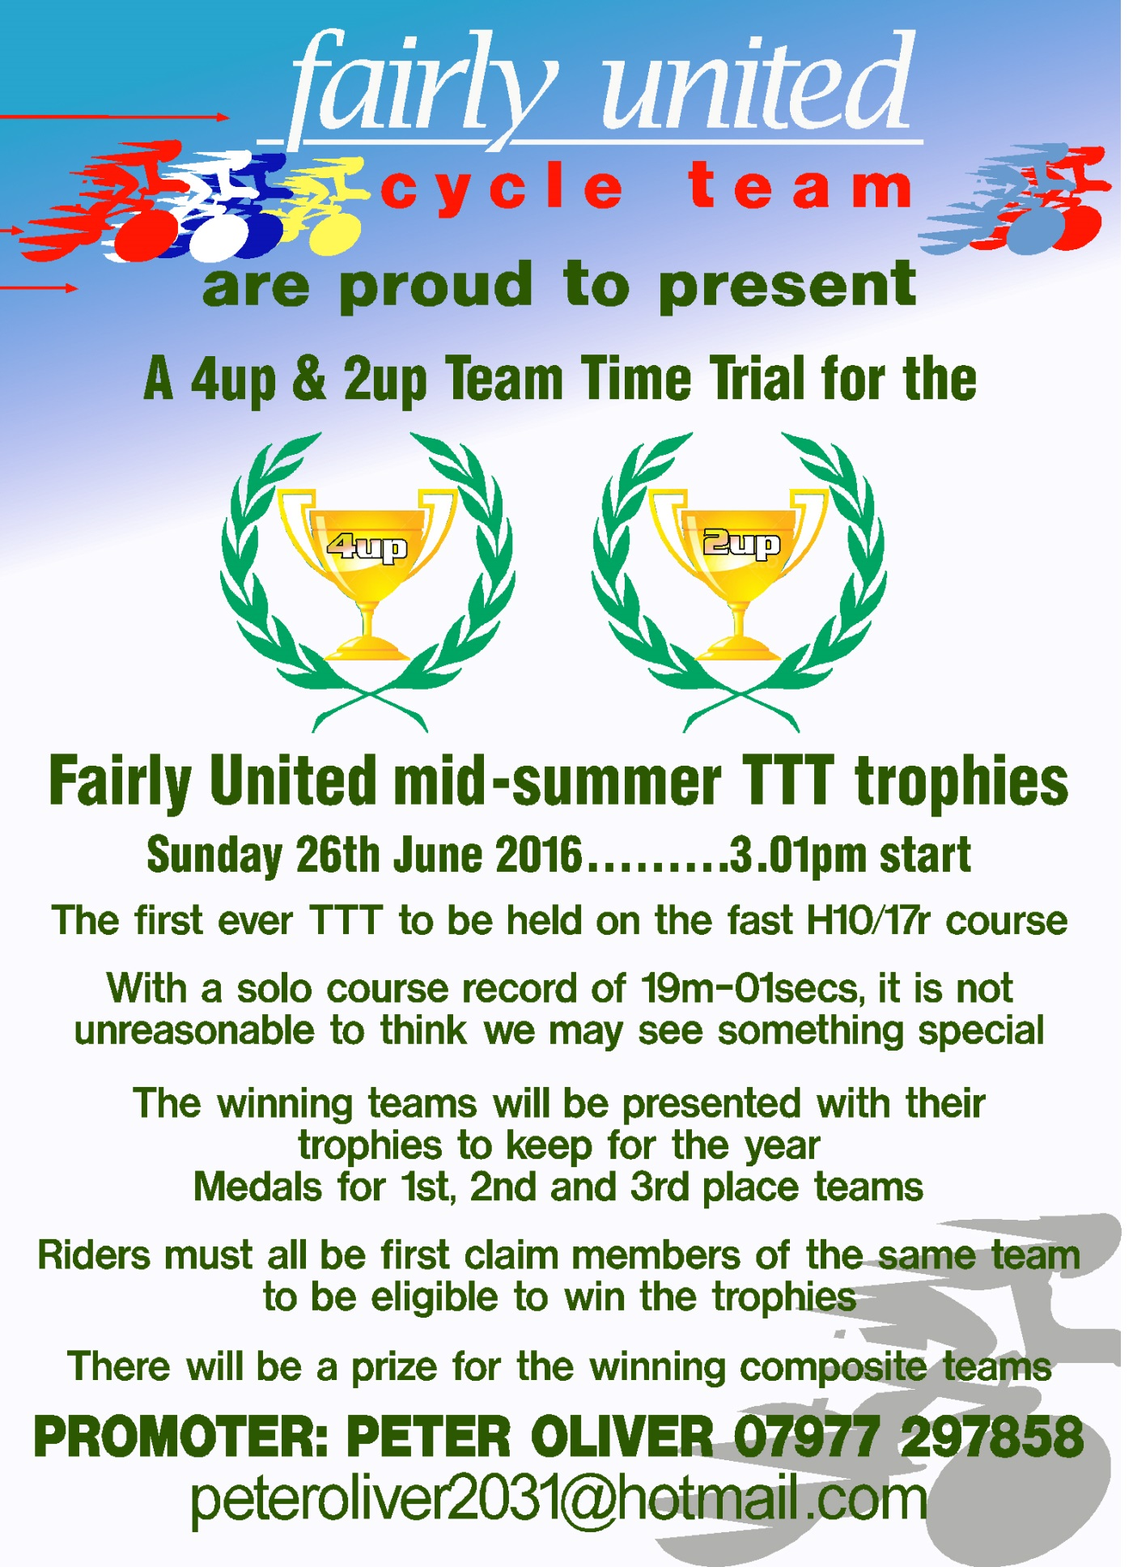
Results sheet
(Promoted for and on behalf of cycling time trials under their rules and regulations)
Course H10/17r
Sunday 25th June 2017 – 3:01pm start
HQ – Southmoor village hall - OX13 5BY
Event promoter: Peter Oliver
Time keepers: mick fountain & Mark Jones
results service: Marion Fountain

 |  | 2-UP TTT EVENT
Finish Place | Name | Club | Actual time
1st | Matt Alder | Fairly United CT | 19:59
 | Mark Cox | Fairly United CT
2nd | Eamonn Deeley | Fairly United CT | 21:17
 | Neil Johnson | Fairly United CT
3rd | Peter Oliver | Fairly United CT | 21:21
 | Paul Granger | Fairly United CT
4th | Anthony Turner | Mickey Cranks CC | 21:27
 | Matt Hermon | Mickey Cranks CC
5th | Mark Boyles | Banbury Star CC | 21:32
 | Lee Heron | Banbury Star CC
6th | Paul Renshaw | Mickey Cranks CC | 21:47
 | Mick Murphy | Mickey Cranks CC
7th | Michelle Lee (L) | Bicester Millenium CC | 22:08
 | Ian Marshall | Bicester Millenium CC
8th | Mick Carter | Mickey Cranks CC | 22:24
 | Andrew Pickett | Mickey Cranks CC
9th | Joe Graystone | Cowley Road Condors | 23:20
 | Mark Glendening | Cowley Road Condors
10th | Iain Cruden | Mickey Cranks CC | 23:38
 | Gary Salter | Mickey Cranks CC
11th | Andy Bennett | Fairly United CT | 23:50
 | Andy Grain | Fairly United CT
12th | Susan Crane (L) | Chippenham & District Wheelers | 24:27
 | Mark Wareham | Chippenham & District Wheelers
13th | Becky Puddle (L) | Outdoor Traders RT | 24:29
 | Sabrina Harris (L) | Outdoor Traders RT
14th | Richard Bellinger | Mickey Cranks CC | 24:30
 | Jason Holder | Mickey Cranks CC
15th | Wendy Gundry (L) | Oxonian CC | 25:57
 | Hannah Gundry (L) | Oxonian CC
16th | Jo Edwards (L) | Outdoor Traders RT | 26:49
 | Elinor Spencer (L) | Outdoor Traders RT

 |  | 4-UP TTT EVENT
1st | Johnathan Gates | Royal Air Force CA | 20:30
 | Dan Lewis | Royal Air Force CA
 | Rich Meadows | Royal Air Force CA
 | Robert Willcocks | Royal Air Force CA
2nd | Simon Drewett | Fairly United CT | 22:09
 | Mike Logue | Fairly United CT
 | Tom Yeatman | Fairly United CT
 | Paul Allday | Fairly United CT
3rd | Ines Rahez (L) | Cowley Road Condors | 27;14
 | Jessica Reynolds (L) | Cowley Road Condors
 | Mimi Harrison (L) | Cowley Road Condors
 | Harrie Drage (L) | Cowley Road Condors
DNF | Julia Adamson (L) | Bath Cycling Club | DNF
 | Kay Drury (L) | Bath Cycling Club
 | Claire Phillips (L) | Bath Cycling Club
 | Karina Stuart (L) | Bath Cycling Club
DNS | Angus Fisk | Oxford University CC | DNS
 | Oliver Bent | Oxford University CC
 | Bryn Davies | Oxford University CC
 | Charlie Cheeseman | Oxford University CC

Afternoon all, well after the weather looking as if it could have been a little wet it thankfully stayed dry although as I’m sure we all noticed rather windy!
I have to say having ridden the course for the past 17 years I don’t think I can ever remember getting to the turn any faster than myself and Paul did on the day and I’m sure many of felt the same. No need to mention the return leg to the finish!
First of all I feel as I must mention the unfortunate incident involving the Bath RC ladies 4-up team, I’m pleased to say I have an e-mail from Julia Adamson, who was the rider who went down, and she reports she is pretty much OK other than a few cuts and bruises and requires a bit of dental treatment but nothing too serious and no broken bones. I’m sure you’ll all join me in wishing Julia a speedy and full recovery.
We were hoping for a few more entries but that wasn’t to be and we are currently looking at moving the date and possibly the venue for the race but are determined to run it again next year and put the trophies up for grabs again.
An apology from myself now for omitting to mention the 2 mixed 2-up teams of Michelle Lee and Ian Marshall from the Bicester Millennium club and Susan Crane and Mark Wareham from the Chippenham and District Wheelers, both teams rode a very good race and it was the Bicester pair came out on top recording a very quick 22-08 and 7th quickest on the day and the Chippenham duo who managed 24-27, congratulations too you both.
Fairly United took the top 3 places in the 2-up event with the on form Mark Cox and Matt Alder clocking an impressive 19-59 for the win and a margin of 1-18 over second place.
The Royal Air Force CA bagged the silverware in the 4-up event with 20-30 although they did get delayed significantly passing the unfortunate Bath CC ladies incident. On checking with Jonathan gates and the information from his Strava it looked as if they would have done a short 19 had they not been delayed and been close to achieving the fastest time ever recorded on the course. The Fairly United 4-up finished second with 22-09 and an excellent ride from the Cowley Road Condors ladies on road bike saw them in third place with a very creditable 27-14. Well done CRC!
I hope you all enjoyed the event and I hope to see you at the next TTT where and whenever it takes place and in the nearer future the Fairly United “Late Summer 10” event on course H10/17r again on August 27th where once again there will be categories for Trikes, Tandems, fixed wheel any size gear, road bikes no aero kit and TT bikes. One difference this year is there will be 2 prize givings the first after the trikes, tandems, fixed bikes and road bikes to save these riders having to wait until the end of the whole event to see their presentation.
I wish you all well for the rest of the season and look forward to catching up with you on the circuit, best regards Pete.

