www.sussexca.org.uk
Sussex Cyclists’ Association
2017 PRESIDENT – MICK IRONS – Worthing Excelsior CC

Open 50 miles Time Trial Sunday 2nd July 2017
Course G50/10
Incorporating Sussex Individual, Veterans and Team Championships
Qualifying event for National B.A.R., SCA B.A.R. and SCA SPOCO
 | Event Secretary: Robin Johnson | 7 Gorselands, Billingshurst, West Sussex RH14 9TT  Email: mr_rjohnson@outlook.com  Tel: 01403 783368 (or 07733 132043 on day of event)

Promoted for and on behalf of Cycling Time Trials under their rules and regulations

HQ  Dial Post Village Hall  Worthing Road  Dial Post  West Sussex  Postcode RH13 8NS  Open from 05:30 | 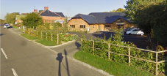
Limited parking in front of hall and in attached car park. Then use East side of road please.

Thank you in advance for not wearing cycling shoes or cleats in the hall.

Numbers at HQ only. After the event please return your race number to the event HQ in exchange for a cup of tea or coffee.

HQ to start: 3.37 miles (allow 20 minutes)
Route to start:
Right (North) outside village hall, and on to A24
North to traffic lights, where turn right onto A272

Finish to HQ: 0.58 miles

Course Records: | Overall: | 01:48:24 | Mark Smith | 2017
 | Ladies: | 02:07:44 | Laura Bartlett | 2017
 | Vets | 01:48:24 | Mark Smith | 2017

Event Records: | Scratch: | 01:48:56 | Steve Dennis | 2012
 | Ladies: | 02:12:11 | Tamar Vanderhaas | 2016
 | Vets | 01:48:56 | Steve Dennis | 2012
Juveniles 02:13:12 Jack Churchill 2016
Association Records: | Scratch: | 01:48:56 | Steve Dennis | 2012
(riders in Sussex C.A affiliated clubs) | Ladies: | 02:12:11 | Tamar Vanderhaas | 2016
Juveniles 02:13:12 Jack Churchill 2016

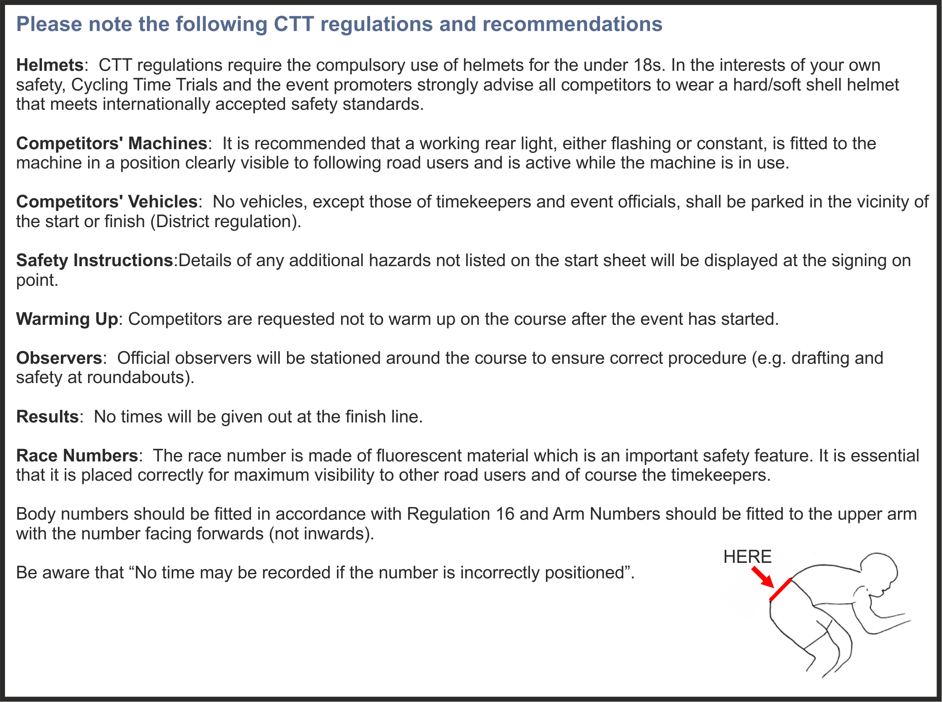

Open 50 miles Time Trial Sunday 2nd July 2017
Course G50/10
OFFICIAL TIME KEEPER
 | Start/Finish: | Richard Blackmore | East Grinstead CC

Prizes
1st | £30 + Champagne (value £25) | 1st on CTT Target | £8 + Wine (value £5)
2nd | £15 + Wine (value £5) | 2nd on CTT Target | Wine (value £5)
3rd | £10 + Wine (value £5)
4th | £8 + Wine (value £5)
5th | Wine (value £5) | 1st Veteran (40-44) | Wine (value £5)
1st Lady | £12 + Wine (value £5) | 1st Veteran (45-49) | Wine (value £5)
2nd Lady | £8 + Wine (value £5) | 1st Veteran (50-54) | Wine (value £5)
3rd Lady | £4 + Wine (value £5) | 1st Veteran (55-59) | Wine (value £5)
4th Lady | Wine (value £5) | 1st Veteran (60-64) | Wine (value £5)
 |  | 1st Veteran (65-69) | Wine (value £5)
1st Team | £10 + Wine (value £5) each | 1st Veteran (70-74) | Wine (value £5)
2nd Team | Wine (value £5) each

As Championship events, this race includes a selection of Trophies, Cups and Medals to be awarded to Sussex CA Riders in various categories:
First |  | Southern Radio Cup for a year, plus Sussex C.A. medal
2nd |  | Sussex C.A. medal
3rd |  | Sussex C.A. medal
1st Lady |  | Sussex C.A. medal
2nd Lady |  | Sussex C.A. medal
1st Team |  | Halford Cup, plus Sussex C.A. medals
1st Veteran on CTT Standard |  | Sussex C.A. medal
2nd Veteran on CTT Standard |  | Sussex C.A. medal
3rd Veteran on CTT Standard |  | Sussex C.A. medal

Cups and medals to be presented at the Annual Sussex Cyclists’ Association lunch and prize presentation to be held on Sunday 26th November 2017 at Dial Post Village Hall. £10 to Robin Johnson not later than 22nd November 2017.
PLEASE NOTE
Prize Presentation | To be held as soon as possible after the event..
 | Please stay to receive your awards and/or applaud the recipients.
Lottery Prizes | To be awarded at the prize presentation.
 | A bottle of wine, value £5, to each of the first three names drawn.
 | To be eligible, be present and be a finisher.

Course G50/10
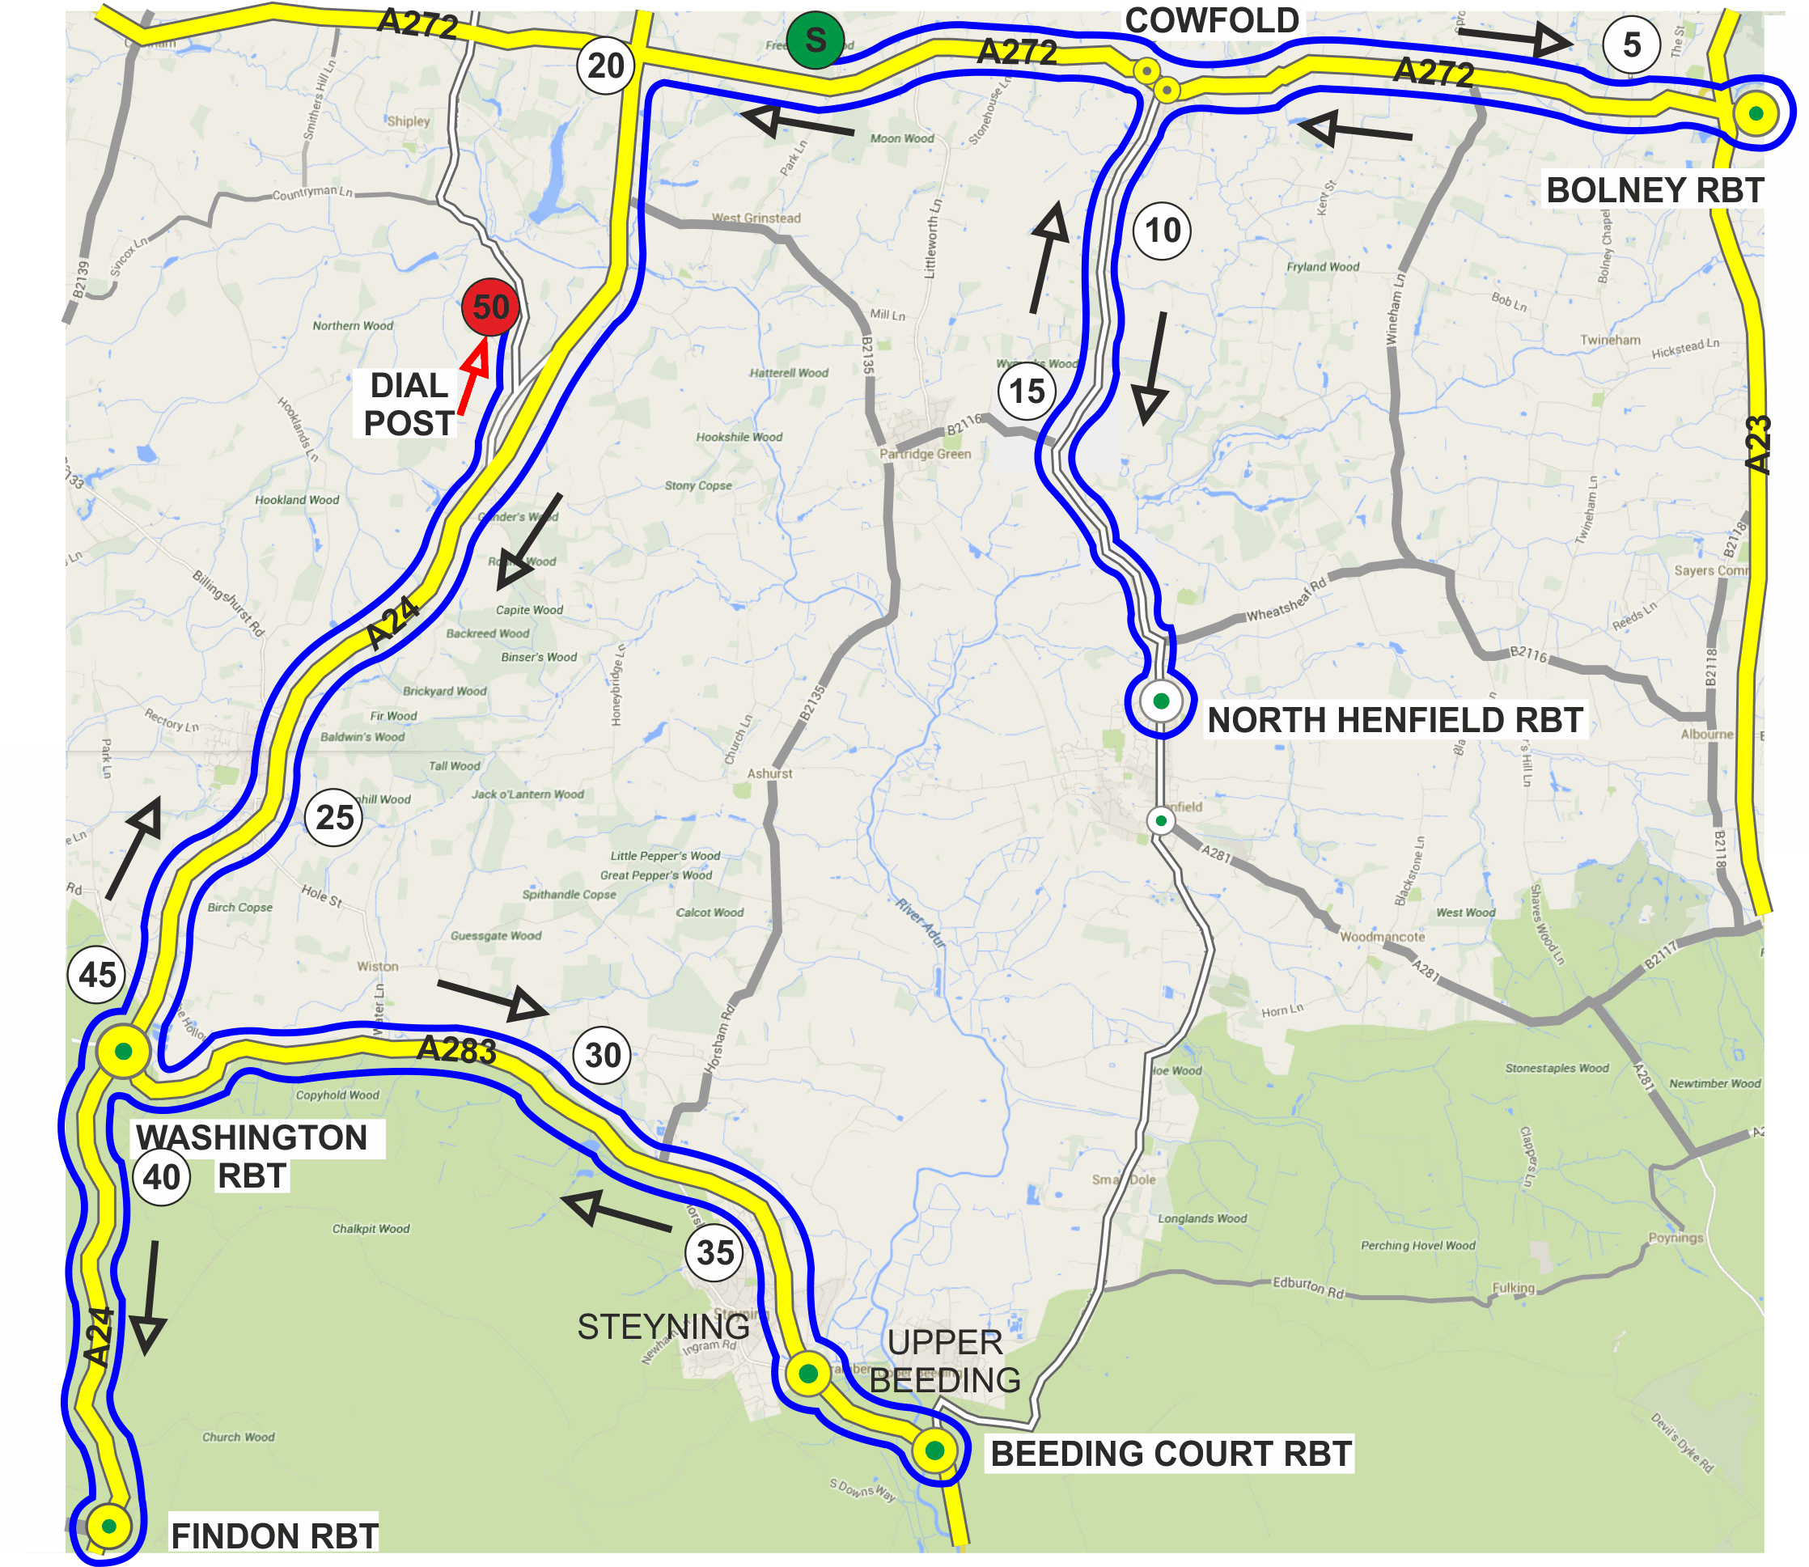
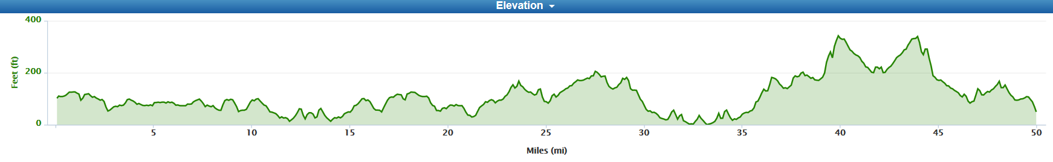

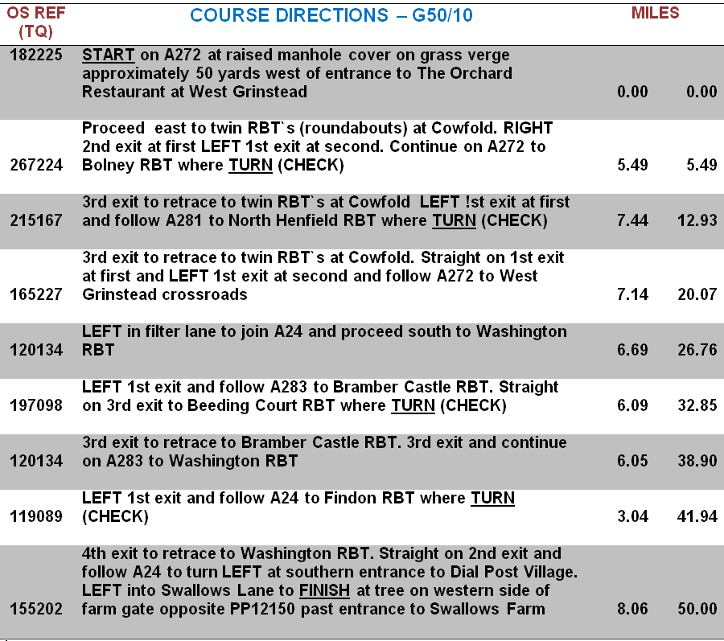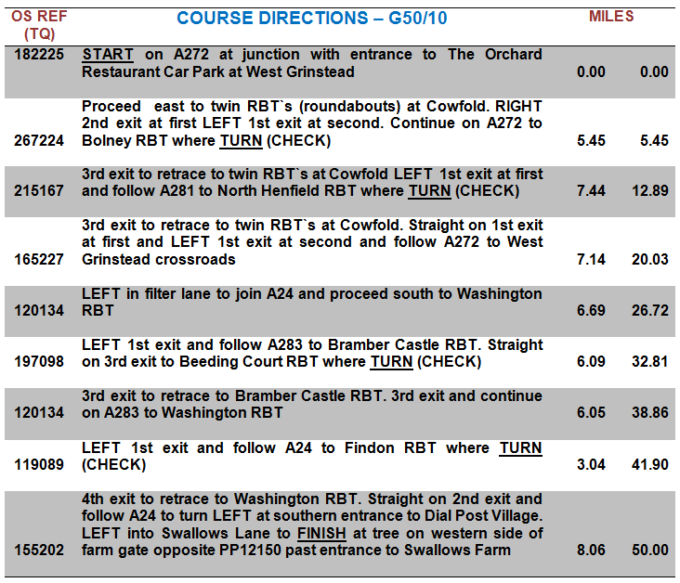

Open 50 miles Time Trial Sunday 2nd July 2017
Course G50/10

REQUEST TO RIDERS
At events on this course last season there were vociferous and repeated complaints about noise early in the morning from a resident of a property by the North Henfield Roundabout. These related to calling out to marshals and also the noise emanating from disc wheels at the turn.
We are keen that the situation does not escalate.
Riders are requested to desist from calling out at this point, and also to consider not using a disc wheel.

No. | Start Time | Name |  | Club | Gender | Category | Age On Day
22 | 06:52:00 | Robin | Johnson | Brighton Mitre CC | Male | Veteran | 69
23 | 06:53:00 | Nicole | Patterson-Lett | Worthing Excelsior CC | Female | Veteran | 45
24 | 06:54:00 | Vince | Freeman | Brighton Triathlon Club | Male | Senior | 37
25 | 06:55:00 | Jim | Burdett | Addiscombe CC | Male | Veteran | 48
26 | 06:56:00 | Matthew | Wakefield | Tooting BC | Male | Veteran | 45
27 | 06:57:00 | Katerina | Avramides | Brighton Mitre CC | Female | Senior | 36
28 | 06:58:00 | Clive | Patterson-Lett | Worthing Excelsior CC | Male | Veteran | 51
29 | 06:59:00 | Clive | Jackson | Central Sussex CC | Male | Veteran | 65
30 | 07:00:00 | Jez | Parsons | Brighton Excelsior CC | Male | Veteran | 51
31 | 07:01:00 | Jon | Fairclough | Woking Cycle Club | Male | Veteran | 63
32 | 07:02:00 | Simon | Howard | South Western Road Club/Evans Cycles | Male | Veteran | 50
33 | 07:03:00 | Jez | Shotter | Brighton Excelsior CC | Male | Veteran | 47
34 | 07:04:00 | Ion | Tsakalis | Brighton Mitre CC | Male | Veteran | 51
35 | 07:05:00 | Kevin | Plummer | South Downs Bikes / Casco Europe | Male | Veteran | 52
36 | 07:06:00 | Peter | Owen | Norwood Paragon CC | Male | Veteran | 56
37 | 07:07:00 | Donald | Parker | Brighton Mitre CC | Male | Veteran | 68
38 | 07:08:00 | Lisa | Davis | Lewes Wanderers CC | Female | Veteran | 42
39 | 07:09:00 | Jack | Churchill | Brighton Excelsior CC | Male | Junior | 16
40 | 07:10:00 | Pip | Jenkins | Southborough & Dist. Whs | Female | Senior | 29
41 | 07:11:00 | Robert | Gilmour | Hounslow & District Whs | Male | Veteran | 65
42 | 07:12:00 | Jonathan | Pontin | Addiscombe CC | Male | Senior | 26
43 | 07:13:00 | John | Marinko | Brighton Mitre CC | Male | Veteran | 52
44 | 07:14:00 | Helen | Webb | Sussex Nomads CC | Female | Veteran | 43
45 | 07:15:00 | Jon | Fry | Horsham Cycling | Male | Veteran | 46
46 | 07:16:00 | Paul | Thompson | Epsom CC | Male | Veteran | 51
47 | 07:17:00 | Ian | Newbold | Worthing Excelsior CC | Male | Veteran | 44
48 | 07:18:00 | Chris | Jones | Bynea Cycling Club | Male | Veteran | 43
49 | 07:19:00 | Jacky | Bernett | South Western Road Club/Evans Cycles | Female | Veteran | 60
50 | 07:20:00 | Howard | Bayley | Blazing Saddles | Male | Veteran | 42
51 | 07:21:00 | Stephen | Morgan | Tooting BC | Male | Veteran | 49
52 | 07:22:00 | Martin | Booker | Worthing Excelsior CC | Male | Veteran | 48
53 | 07:23:00 | James | Thomas | Epsom CC | Male | Veteran | 48
54 | 07:24:00 | Caro | Harper | Brixton Cycles Club | Female | Senior | 37
55 | 07:25:00 | Mike | O'Gorman | Worthing Excelsior CC | Male | Veteran | 65
56 | 07:26:00 | Jamie | Freeland | South London Harriers | Male | Veteran | 44
57 | 07:27:00 | Si | Seymour | Tooting BC | Male | Veteran | 44
58 | 07:28:00 | Colin | Ashcroft | West Kent RC | Male | Veteran | 55
59 | 07:29:00 | Paul | Wishart | Brighton Phoenix Triathlon Club | Male | Veteran | 49
60 | 07:30:00 | Steve | Dennis | East Grinstead CC | Male | Veteran | 54

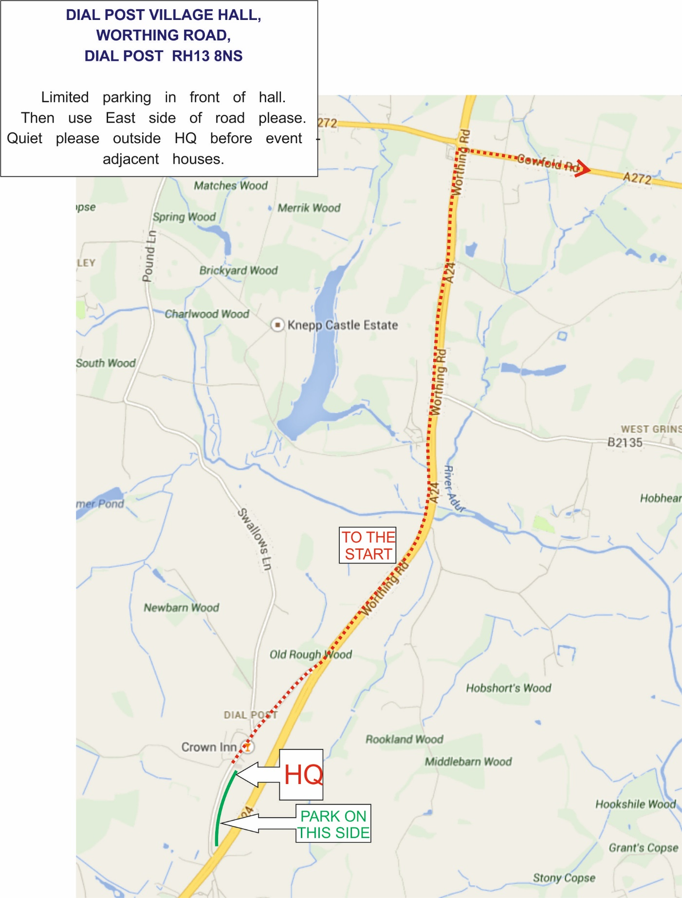

SUSSEX CYCLISTS’ ASSOCIATION - PAST CHAMPIONS
1938 | Ernie Steers | Worthing Excelsior CC | 2:13:14 | SCA RECORD
1939 | Roy Gumbrell | Brighton Excelsior CC | 2:12:25 | NEW SCA RECORD
1947 | Dennis Dean | Worthing Excelsior CC | 2:06:38 | NEW SCA RECORD
1948 | Wally Finch | Worthing Excelsior CC | 2:13:57
1949 | Albert Shanks | Lancing AC | 2:08:49
1950 | Derek Powell | Lancing AC | 2:09:13
1951 | Arthur Gardiner | Lancing AC | 2:08:30
1952 | Colin Whittingham | Brighton & Hove Wheelers | 2:08:33
1953 | Dave Marsh | Lewes Wanderers CC | 2:06:08 | NEW SCA RECORD
1954 | John Dutson | Uckfield & District Wheelers | 2:05:54 | NEW SCA RECORD
1955 | Dave Marsh (2 wins) | Eastbourne Rovers CC | 2:06:12
1956 | Mike Harmer | Brighton Excelsior CC | 2:08:08
1957 | Gerry Atterbury | Brighton Excelsior CC | 2:04:57 | NEW SCA RECORD
1958 | Roy Siggs | Uckfield & District Wheelers | 2:07:56
1959 | Gerry Atterbury | Worthing Excelsior CC | 2:05:47
1960 | Terry Parker | Bognor Regis CC | 2:03:36 | NEW SCA RECORD
1961 | Dave Hardman | Brighton Excelsior CC | 2:07:56
1962 | Dave Funnell | Worthing Excelsior CC | 2:07:55
1963 | Gerry Atterbury | Brighton Mitre CC | 2:05:10
1964 | Gerry Atterbury (4 wins) | Brighton Mitre CC | 2:06:08
1965 | Dick Marchant | East Grinstead CC | 2:07:20
1966 | Tim Mackay | Horsham Unity CC | 2:12:08
1967 | Mike Morgan | Central Sussex CC | 2:06:36
1968 | Mike Morgan (2 wins) | Central Sussex CC | 2:08:48
1969 | Rick Stringer | Brighton Excelsior CC | 2:11:26
1970 | Rick Stringer (2 wins) | Brighton Excelsior CC | 2:10:22
1971 | Keith Dodman | Worthing Excelsior CC | 2:13:42
1972 | Keith Dodman | Worthing Excelsior CC | 2:14:24
1973 | John Dutson | Central Sussex CC | 2:01:27 | NEW SCA RECORD
1974 | Martin Hawes | Central Sussex CC | 2:08:51
1975 | John Dutson (3 wins) | Central Sussex CC | 2:08:21
1976 | Alan Limbrey | Brighton Mitre CC | 2:10:21
1977 | Keith Dodman | Worthing Excelsior CC | 2:08:22
1978 | Keith Dodman (4 wins) | Worthing Excelsior CC | 2:05:29
1979 | Cliff Sharp | Eastbourne Rovers CC | 2:00:37 | NEW SCA RECORD
1980 | Mark Jones | Central Sussex CC | 1:58:10 | NEW SCA RECORD
1981 | John Oakes | VC Etoile | 1:53:52 | NEW SCA RECORD
1982 | John Oakes (2 wins) | VC Etoile | 1:53:16 | NEW SCA RECORD
1983 | Mark Jones | Central Sussex CC | 2:00:35
1984 * | Paul James | Central Sussex CC | 1:54:24
1985 * | Steve Dennis | East Grinstead CC | 1:55:48
1986 | Steve Dennis | East Grinstead CC | 1:57:50
1987 | Peter Danckwardt | Worthing Excelsior CC | 1:58:19
1988 | Mike Coyle | VC Etoile | 2:01:45
1989 * | Mark Jones | GS Stella | 1:58:15
1990 | Paul Lipscombe | Central Sussex CC | 1:58:00
1991 | Steve Dennis | East Grinstead CC | 1:56:27
1992 * | Mark Jones | GS Stella | 1:56:26
1993 | Paul Panagi | Hastings & St Leonards CC | 1:55:05
1994 * | Richard Keevil | GS Stella | 1:58:45

SUSSEX CYCLISTS’ ASSOCIATION - PAST CHAMPIONS
1995* | Steve Blackmore | East Grinstead CC | 2:00:41
1996 | Mark Jones | GS Stella | 1:54:48
1997 | Mark Jones (6 wins) | GS Stella | 2:02:09 | G.50/10 introduced
1998 | Steve Elms | East Grinstead CC | 1:55:31
1999 | Dave Pollard | In-Gear RT | 2:00:59
2000 | Dave Pollard (2 wins) | In-Gear RT | 1:57:21
2001 | Steve Dennis | East Grinstead CC | 1:55:15
2002 | Steve Dennis | East Grinstead CC | 1:54:23
2003 | Steve Dennis | East Grinstead CC | 1:51:32 | NEW SCA RECORD
2004 | Steve Dennis | East Grinstead CC | 1:54:32 | (emergency course)
2005 * | Mike Coyle (2 wins) | VC Etoile | 1:55:39 | (emergency course)
2006 | Sean Yates | In-Gear Quickvit RT | 1:50:31 | NEW SCA RECORD
2007 | Steve Dennis | East Grinstead CC | 1:49:31 | NEW SCA RECORD
2008 | Steve Dennis | East Grinstead CC | 1:53:09
2009 | Steve Dennis | East Grinstead CC | 1:51:56
2010 | David Shepherd | GS Stella | 1:57:30
2011 * | Tom Glandfield | Lewes Wanderers CC | 1:59:16
2012 | Steve Dennis (12 wins) | East Grinstead CC | 1:48:56 | NEW SCA RECORD
2013 * | Steve Kane | Brighton Excelsior CC | 1:49:50
2014 | Steve Kane (2 wins) | Brighton Excelsior CC | 1:52:07
2015 | James Rix | Crawley Wheelers CC | 1:55:45
2016* | Steve Dennis | East Grinstead CC | 1:53:21
2017
In years denoted with an asterisk the overall event was won by a non-Sussex C.A. rider, see below.

PAST (non – Sussex C.A.) EVENT WINNERS
1984 | John Woodburn | Manchester Wheelers | 1:51:00
1985 | John Woodburn | Manchester Wheelers | 1:52:28
1989 | John Woodburn | Manchester Wheelers | 1:55:15
1992 | Mike Harris | Caesaraen CC | 1:54:05
1994 | Julian Pegg | Charlotteville CC | 1:57:12
1995 | Alan Dawson | Antelope RT | 1:59:28
2005 | Malcolm Cox | VC St Raphael | 1:55:00
2011 | Rupert Burbridge | Redhill CC | 1:56:48
2013 | Chris McNamara | Pedal Heaven | 1:49:28
2016 | Jonathan Parker | Team Bottrill | 1:49:40

For originally compiling the list in 1999 thanks are due to the late Les Janman and the late Dave Palmer, both of Bognor Regis CC.
Further contributors have included Dave Hudson of Worthing Excelsior CC, Robin Johnson of Brighton Mitre CC and Mike O’Gorman of Worthing Excelsior CC.

SUSSEX CA CYCLE JUMBLE SALE
and just to finish off: please come and support the Association Cycle Jumble Sale on Saturday 19th August,
at Steyning Centre, Steyning, BN44 3XZ, from 09:00 to 12:30, £1 entrance. Tables are £8.00 from 07:00
Contact: Robin Johnson 01403 783368 for booking a table or for donations of old equipment.

