Promoted for and on behalf of CTT under their rules & regulations.
This is a Northumberland & Durham Cycling Association BAR Event.

Event Secretary: Dr Justine Norman
30 Robsons Way
Amble
NE650GA
Tel: 07725071072

Timekeepers: Peter McGrath
Frances Schultz

Event HQ:

Embleton Village Hall (post code NE66 3UP) will be open from 8:30am to sign on and collect numbers. – please return numbers and sign off at the HQ afterwards. Embleton is a small village so please be respectful while parking/warming up in the village.

Course M13:
Start just north of Embleton on the B1339 opposite the lay-by.
Proceed north on the B1339 to turn left on to the B1340 in the direction of Christon Bank. Proceed to the junction with the B1347 at Christon Bank. Turn left to continue south on the B1340 to the junction with the minor road near Hocketwell.
Bear left on to minor road and continue south to minor road on left near Littlehoughton. Turn left on to minor road and proceed east to the T-junction with the B1339. Turn left on to the B1339 and proceed north towards Embleton. Finish at the lay-by PRIOR to Embleton village. Please shout your number as you pass the finishing timekeeper.

Note:- Any riders returning from last year please note the new finish location.

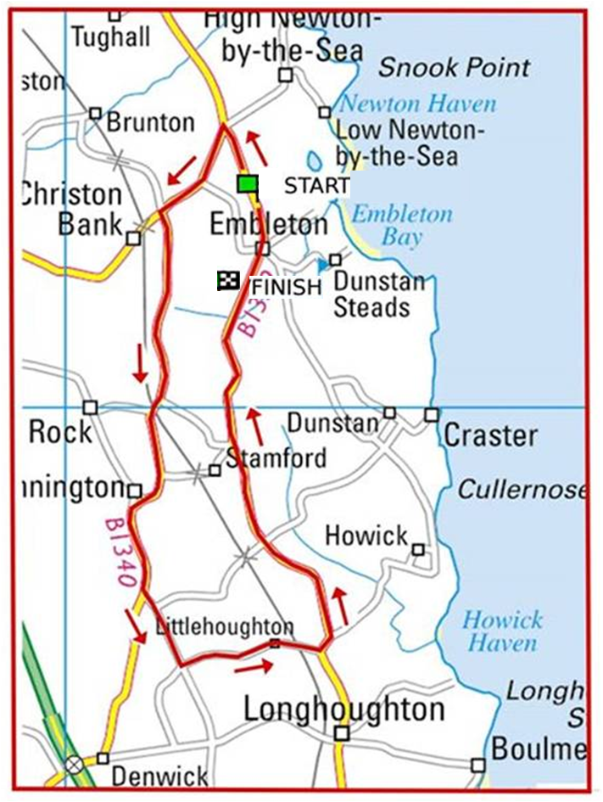

Safety Notes:
- Vehicles of competitors / officials / marshals / helpers to be parked safely and without hindrance to other road users.
- Take extra care at road junctions.
- No U-turns to be made in the vicinity of the timekeeper.
- No pre-race warming up on course.
- Care by riders - do not cross the white line on left hand turns.
- Care by riders – extra care in built up areas.
- No dismounting by riders in finishing area.

In the interests of your own safety, Cycling Time Trials and the event promoters strongly advise you to wear a HARD SHELL HELMET that meets an internationally accepted safety standard.
All competitors under the age of 18 years and/or juniors must wear a Protective Hard Shell Helmet.
It is recommended that a working rear light, either flashing or constant, is fitted to the machine in a position visible to following road users and is active while the machine is in use.

PRIZE'S:

Senior 1st £30, 2nd £20, 3rd £10
Ladies 1st £30, 2nd £20, 3rd £10
Vets 1st £20, 2nd £10
Juniors 1st £10
Roadman 1st £10
Team of 3 £30 (fastest 3rd place rider is the counter for each team)

Alnwick CC Riders Annual TT championship
Male 1st championship trophy
Female 1st championship trophy

Only one prize per rider, except for Team Prize.

- Where a rider qualifies for two prizes, the highest value prize will be awarded.
- If the prizes are of equal value, they will be awarded in the order shown on this page.

To enter the Roadman cat you must comply with N&DCA Roadman BAR rules and put ‘R’ next to name on sign on.

If you find that you can no longer ride, please contact Justine Norman
Justine.norman99@gmail.com

