DIRECTIONS
Great Ouseburn Village Hall from the A1M
The Bungalow, Spring field Rise, Great Ouseburn, York YO26 9SE
From the A1M (North or South) Take Junction 47 onto the A59 towards York
continue until you reach Green Hammerton turn left onto the B6265
Boroughbridge Road continue towards Boroughbridge to turn right at Carrside
Road and follow the CTT signs to the Village Hall
From the Village Hall to the start
From the village hall head towards Main St then turn left onto Main street, straight across on Branton lane
leading to Brown lane leading to Broadgate continue until you reach the B6265
Boroughbridge Rd. Turn right in the direction of Boroughbridge take the first
left onto Gallabar Lane continue along Back lane on to Braimber Lane which
leads to the start . (About 4 Miles)

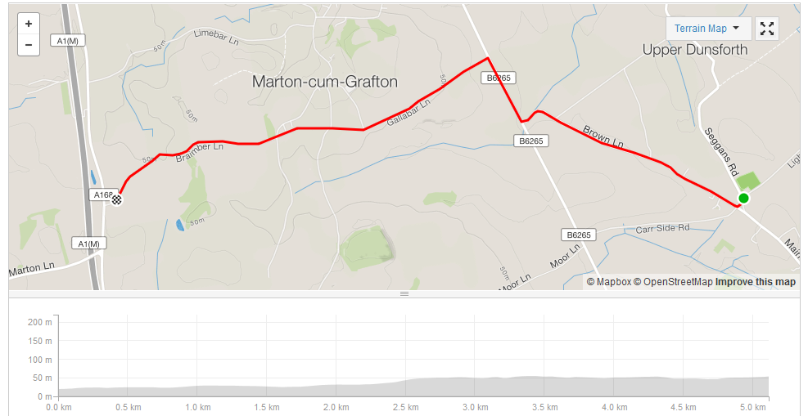CTT direction arrows will be in place on both of these routes.

