Promoted for & on behalf of Cycling Time Trials under their rules & regulations:
17.3 Mile Hilly Time Trial
Course: O17C "Circuit of Longstone Edge"
Wednesday May 24th at 7pm
Event Secretary
Joe Le Sage 24 Green Oak Road, S17 4FP
07864 575912
jjlesage@hotmail.com
Timekeepers: Phil Williams
John Clarke
Headquarters: Hassop Station Cafe, Hassop Road, DN45 1NW
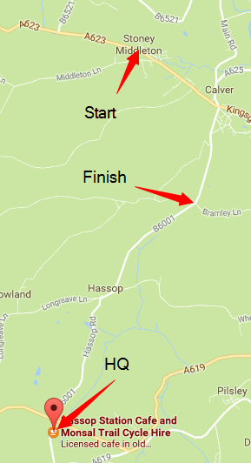
Parking: Please note that the car park is divided into a pay & display, and parking for the cafe. Riders should park in the pay & display rather than the cafe parking.
Refreshments: refreshments are not provided; the cafe doesn't charge for using their facilities, so please support them by buying refreshments.

Course Description: Start on A623 in Stoney Middleton opposite Lamp Post 76262 (adjacent to waste ground parking). Proceed westwards up Middleton Dale, past B6465 junction (3.12 miles). Left turn onto Mires Lane (signposted ‘Litton, Cressbrook’) (3.43 miles). Through Litton to B6049 (4.94 miles). Left onto B6049. Left turn, signposted ‘Priestcliffe’ (8.00 miles). Left onto A6 (8.68 miles), down Taddington Dale and past Buxton Road turn into Ashford in the Water (12.86). Left onto A6020 (13.36 miles). At TI left onto B6001 (15.33 miles). Through Hassop to finish on brow of hill opposite Bramley Lane (17.62 miles)
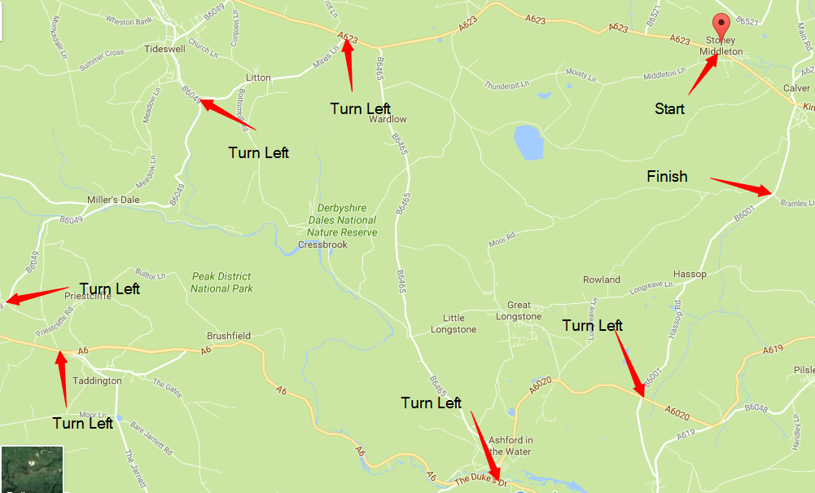
Please leave at least 15 minutes to get to the start from the HQ

IN THE INTERESTS OF YOUR OWN SAFETY
Cycling Time Trials and the event promoters strongly advise you to wear a HARD SHELL HELMET that meets an internationally accepted safety standard.
In accordance with Regulation 15 ALL JUNIOR competitors must wear Protective Hard Shell Helmets.
It is recommended that a working rear light, either flashing or constant, is fitted to the machine in a position visible to following road users and is active whilst the machine is in use.
Please consider the use of a front light - sections of the course have dense tree canopy cover, particularly the final 2 miles, and will be quite dark even if the sun is shining!
Any competitor making a “U” turn in the vicinity of the start or finish will be disqualified from the event.
Riders must not ride with their head down - you are riding on public roads, please take care.
Please remember that you are now required to sign off after you have finished - failure to do so will result in DNF.
Competitors are reminded that this event may be subject to doping control - it is your responsibility to check. Race numbers required will be displayed by the results board - if your number is listed you must report immediately to doping control.

Prize List
Athlete prize open to riders using standard road bikes, bars & helmet; no disc wheels, aero helmet, TT bars or clip-on tri-bars. It is the rider's responsibility to inform the timekeeper at the start that they wish to compete for the athlete category. Eligibility at timekeeper's discretion.
 | Women | Men | Athlete | Team of 3
1st | £30 | £30 | £20 | £15 each
2nd | £15 | £20 | £10 | £5 each
3rd | - | £10 | - | -

Rider List
No | Name |  | Club | Start time
5 | Adam | Lathbury | Rutland Cycling Club | 19:05
6 | Jack | Ward | Sharrow CC | 19:06
7 | Paul | Armstrong | Sheffrec CC | 19:07
8 | Josephine | Gilbet | Vertex Biemme RT | 19:08
9 | Conor | Salisbury | Rutland Cycling Club | 19:09
10 | Chris | Dyke | Langsett Cycles Race Team | 19:10
11 | Simon | Hall | Rutland Cycling Club | 19:11
12 | Dominic | Watts | Veloviewer | 19:12
13 | Simon | Watson | Buxton CC/Sett Valley Cycles | 19:13
14 | Rachel | Batt | Buxton CC/Sett Valley Cycles | 19:14
15 | Andrew | Whiteley | Langsett Cycles Race Team | 19:15
16 | Tony | Grassby | Peak Road Club | 19:16
17 | Toby | Wilson | Rutland Cycling Club | 19:17
18 | Jamie | Raven | Rutland Cycling Club | 19:18
19 | Graham | Waller | Sharrow CC | 19:19
20 | Sam | Walsham | Team Bikebox Alan | 19:20
21 | Andrew | Hicklin | Fusion Cycling Club Dronfield | 19:21
22 | Ann | Walsham | Maxx R. T. | 19:22
23 | Pete | Laud | Common Lane Occasionals | 19:23
24 | Jim | Stewart | Buxton CC/Sett Valley Cycles | 19:24
25 | Andy | Nichols | Team B38/Underpin Racing | 19:25
26 | Chris | Myhill | Peak Road Club | 19:26
27 | Nicholas | Baker | Chesterfield Spire Cycling Club | 19:27
28 | Thomas | Canaway | Rutland Cycling Club | 19:28
29 | Peter | Collins | Sharrow CC | 19:29
30 | Steve | Gibson | Peak Road Club | 19:30
31 | Daryl | May | Sheffrec CC | 19:31
32 | Arne | Beswick | Buxton CC/Sett Valley Cycles | 19:32
33 | James | Russell | Macclesfield Wheelers | 19:33
34 | Bruce | Luxton-Brookes | Fusion Cycling Club Dronfield | 19:34
35 | Sam | Clark | Buxton CC/Sett Valley Cycles | 19:35
36 | Alex | Deck | Rutland Cycling Club | 19:36
37 | Jez | Reynard | Common Lane Occasionals | 19:37
38 | Sally | Maitland | Beeston Cycling Club | 19:38
39 | Robin | Barker | Common Lane Occasionals | 19:39
40 | Darryl | Wall | Out of the Saddle CC | 19:40

