Riders information Pack
Round 4 of 6 Knights Composites Classic TT Series

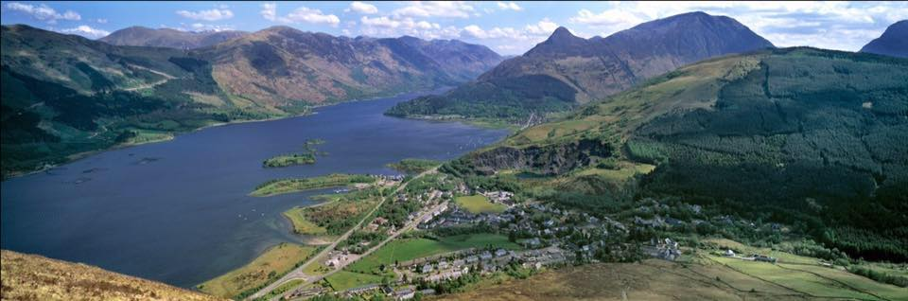
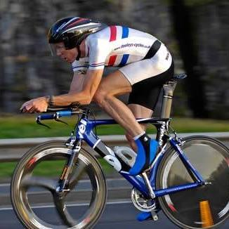
Incorporating the Jason Macintyre Memorial Event 2017

Promoted for and on behalf of Cycling Time Trials and under their regulations
Sunday 14th May 2017, 1st Rider off at 09:01 hours
HQ: At Ballachulish Local Community Centre
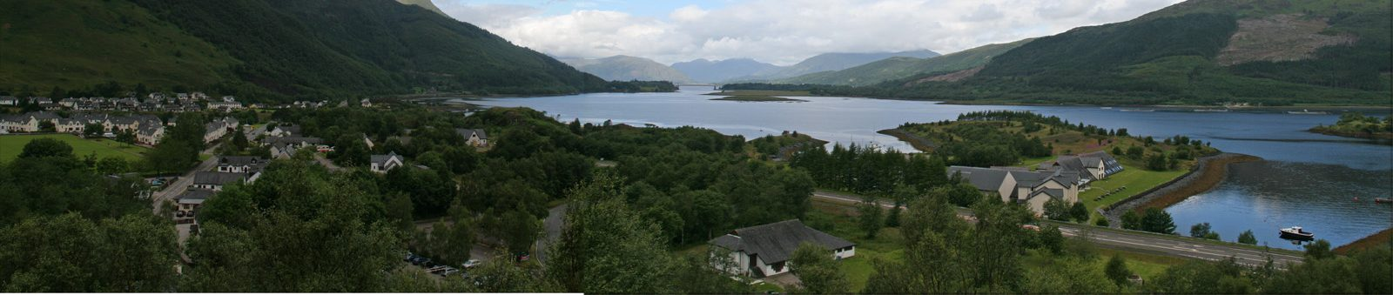
Loan Fern, Ballachulish PH49 4JB
Figure 1

http://balla-hall.co.uk/about-the-hall/
Open at 08:00 am for registration. Printed copies of the start sheet will be available for collection, along with race numbers. There are toilet facilities and tea, coffee and snacks will be available
There will be Car parking spaces available, however if you cannot find any then please check for an alternative option across the main road (A82) ‘Sea Xplorer OR Isles of Glencoe Hotel + Leisure Centre.
Organiser: Stevie Blom, 18 Queen St Flat 2/3, Paisley, Renfrewshire, PA1 2TU. Tel: 0141 0141 389 0738. Email: stephenblom@hotmail.com. Mobile number for use on the day: 07896986776 (note that reception will be patchy, so text messages are likely best on the day)
Timekeepers: Jann Lapsley (Start) Linda Smith (Finish)
Marshals: Co-ordinator on the day George Skinner along with friends and locals from Lochaber District.
Course: 17.8 Miles Sporting Route
Men and Male Espoirs, Woman, Juniors, Veterans are to complete 17.8mile Course.
Course Description
Start line is on the A82, 0.5 Miles South of the Ballachulish Bridge Roundabout, Adjacent to a Lay by adjacent to Blue and White Transport Scotland Sign Post.
Coordinates: 56 Degrees 40 North,5 Degrees 09 West,30 Feet Altitude
Proceed South for approximately 2.2 Miles and Turn Left onto B863 Heading Kinlochleven.
Please follow the B863 For the remaining distance of the race until you reach the Finish line at 17.8 Miles.
You will be racing 1x anti clock wise loop of Loch Leven, The Finish line is at the 20mph Sign Post 150 yards from where the B863 Terminates, NORTH BALLACHULISH.
Video Footage Can be found on the Dedicated Facebook Page :-
https://www.facebook.com/pg/tourofglencoe2017/videos/

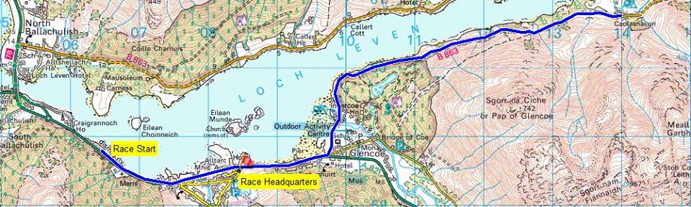
Part 1 of the Course

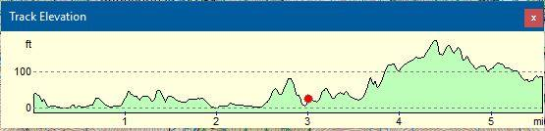

Part 2 of the Course
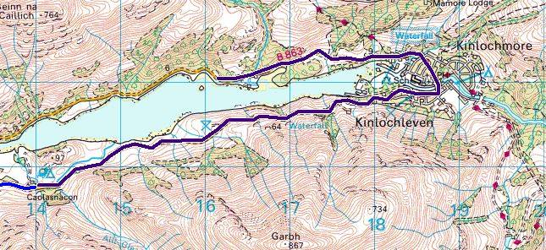

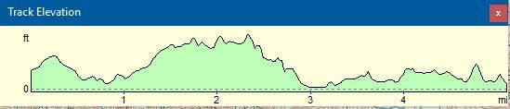

Warnings/Caution
Distance from HQ to Start line is approximately 1.3 Miles, please allow 10 minutes at least to make your Start time.
Lay by at Start is in excellent condition to allow for ample riders queuing and Race Staff.
The course is Flat, Hilly and very Fast in sections.
When you turn left onto the B863 you will immediately see a 1 Road, 2 way bridge. (INVERCOE BRIDGE)
YOU have the right of way and it will be Marshalled accordingly.
Please be aware of Blind Summits + Adverse Camber sections, We, advise you Ride the course before hand to familiarise yourself.
Scenery is Stunning so please be careful and DO NOT FALL /CRASH INTO THE LOCH, The Monster may, Eat you.
You will descend into Kinlochleven Village, Please, take note that this will be a very fast descent and you will need to ride over a Zebra Pedestrian Crossing.
This Pedestrian Crossing in the Village Centre will be Marshalled with Red Flags. The Marshals will do their best to stop Pedestrians from crossing but please be vigilant at all times.

Please remember this is a Hilly time trial, so bring some low gears, good tyres and brakes, and take care on the descents. Most riders should be OK with 39 x 23 bottom gear. Please avoid parking on the course, particularly on the Lay by at the Start. Do not congregate at the finish. Times will be available at the HQ.

Regulations
Riders must exercise caution at all junctions. Any competitor who crosses the white line when approaching or leaving a junction will be liable to disqualification from the event and may be reported to the District Committee for further disciplinary action. No "U" turns in the vicinity of the start and finish. Observers will be watching. Head up and observe local regulations at all times. Pace must not be given or received and the onus is on the caught riders to adhere to this rule

Mechanical Station
We have a Mechanical Station on hand day of the race.
If you have any last minute Mechanical Issues please see Co Organiser Willie Cosh, Q Bikes Bike Mechanic, A dedicated station will be set up near the HQ.
Small Donations are welcome for this service.

Riding back from Finish Line to HQ
This is important, When, you finish Turn Left back onto the A82 North Ballachulish, Proceed Over the Ballachulish Bridge.
Once you come out of the Bridge please turn left at the Roundabout BUT YOU MUST JOIN THE ADJACENT BIKE PATH! Marshal will point you in right direction
This is to avoid any riders crossing the Start line again causing any interference/confusion.

The Bike Path Runs Parallel to the A82 and Will take you back to the Race HQ.

Prize Presentation
If you can, please stay for the prize presentation, which takes place as soon possible after the finish at the HQ.
Graeme OBree, Mark Atkinson, Carolyne Macintyre Will be part of the Prize Giving.
Media
Local Media will be there on the day to cover the event and prize Giving.
Lochaber local paper Oban times Will cover the Story and aim to put in an article on the Internet this week Coming and a Race Report Week After the Event.
CTT Media will be there and aim to have photos of the Prize Winners which will be sent to Cycling Weekly.

Event Sponsorship
Ben Thompson @ Nevis Cycles
https://www.neviscycles.com/
Nevis Cycles, have Kindly agreed to sponsor this event.
They have generously awarded this event Vouchers for Position 4 & 5 in each event out with the CTT Advertised Cash prize allocation.

Prize List

1st Local £25.00 Nevis Cycles Voucher
2nd Local £15.00 Nevis Cycles Voucher
3rd Local £10.00 Nevis Cycles Voucher

1st Men’s event £25 Cycling Time Trials Cheque
2nd Men’s event £15 Cycling Time Trials Cheque
3rd Men’s event £10 Cycling Time Trials Cheque
4th Mens Event £15.00 Nevis Cycling Voucher
5th Mens event £10.00 Nevis Cycling Voucher

1st Veteran (Scratch) £25 Cycling Time Trials Cheque
2nd Veteran (Scratch) £15 Cycling Time Trials Cheque
3rd Veteran (Scratch) £10 Cycling Time Trials Cheque
4th Veteran (scratch) £15.00 Nevis Cycles Voucher
5th Veteran (Scratch) £10.00 Nevis Cycles Voucher

1st Junior event £25 Cycling Time Trials Cheque
2nd Junior event £15 Cycling Time Trials Cheque
3rd Junior event £10 Cycling Time Trials Cheque

1st Women’s event £25 Cycling Time Trials Cheque
2nd Women’s event £15 Cycling Time Trials Cheque
3rd Women’s event £10 Cycling Time Trials Cheque
4th Women’s event £15.00 Nevis Cycles Voucher
5th Woman’s event £15.00 Nevis Cycles Voucher
1st Veteran (Target) £25 Cycling Time Trials Cheque
2nd Veteran (Target) £15 Cycling Time Trials Cheque
3rd Veteran (Target) £10 Cycling Time Trials Cheque
4th Veteran (Target) £15.00 Nevis Cycles Voucher
5th Veteran (Target) £10.00 Nevi Cycles Voucher

Trophies
1 x Fastest Veteran
1 x Fastest Female
1 x Fastest Local
Jason Macintyre Memorial Trophy for Fastest Rider

Other Prizes

Spot Prizes Will be awarded also.

We would like to thank Nevis Cycles for helping out with the Prize Fund as well as

We hope you enjoy the event and complete the Course Safely, hopefully this will be the Start of bigger things to come with this event.

Best Regards,

Stevie Blom

 | Start Time |  |  |  | Cat | Target Time
1 | 09:01:00 | Alexander | Dent | Nevis Cycles Racing Team | Juv
3 | 09:03:00 | Zak | Coleman | Team PedalRevolution.co.uk | J
5 | 09:05:00 | Adam | Robertson | Verulam CC | J
7 | 09:07:00 | Emma | Parkinson | Velo Club Vitesse | W
8 | 09:08:00 | Sharon | Bird | Edinburgh Road Club | W
9 | 09:09:00 | Gill | Barnes | Nevis Cycles Racing Team | WV | 00:56:03
10 | 09:10:00 | Sonya | Drummond | Dundee Thistle | WV | 00:49:08
11 | 09:11:00 | Valerie | Martin | Dooleys RT | WV | 00:51:20
12 | 09:12:00 | Amanda | Tweedie | RT 23 | W
14 | 09:14:00 | laura | nicolson | Dooleys RT | W
16 | 09:16:00 | Catriona | MacGillivray | RT 23 | W
18 | 09:18:00 | Jackie | Field | CC Ashwell | WV | 00:52:06
20 | 09:20:00 | Tina | Reid | Trainsharp | WV | 00:52:06
22 | 09:22:00 | lynsey | curran | Dooleys RT | W
24 | 09:24:00 | Paul | Lawson | Weaver Valley CC | V | 00:47:01
25 | 09:25:00 | Andy | Jack | Glasgow Green CC | V | 00:46:20
26 | 09:26:00 | Joe | Fee | Deeside Thistle CC | V | 00:46:20
27 | 09:27:00 | David | Gibson | Dooleys RT | V | 00:50:13
28 | 09:28:00 | David | Barry | Team Bottrill / HSS Hire | V | 00:54:50
29 | 09:29:00 | Alan | Linstead | Glasgow Couriers | V | 00:48:04
30 | 09:30:00 | Robert | Shennan | Johnstone Wheelers | V | 00:48:04
31 | 09:31:00 | Martin | Lawson | Dundee Thistle | V | 00:50:36
32 | 09:32:00 | James | Skinner | SVTTA | V | 00:46:00
33 | 09:33:00 | alex | mcphee | Dooleys RT | V | 00:50:13
34 | 09:34:00 | stuart | Field | CC Ashwell | V | 00:49:08
35 | 09:35:00 | Nick | Charlton | North Argyll CC | V | 00:47:43
36 | 09:36:00 | Alan | Davidson | Dundee Thistle | V | 00:50:36
37 | 09:37:00 | Stephen | Malaney | Glasgow Couriers | V | 00:45:20
38 | 09:38:00 | Brian | Cameron | Lomond Roads CC | V | 00:49:08
39 | 09:39:00 | Scott | Glasgow | Glasgow Nightingale CC | V | 00:46:20
40 | 09:40:00 | Jonny | May | Edinburgh Road Club | V | 00:48:46
41 | 09:41:00 | Greg | Quinn | Deeside Thistle CC | V | 00:49:08
42 | 09:42:00 | Brian | Sproul | Dundee Thistle | V | 00:47:01
43 | 09:43:00 | Donald | Paterson | SVTTA | V | 00:46:20
44 | 09:44:00 | John | McCrory | Glasgow United CC | V | 00:45:40
45 | 09:45:00 | Sean | Gray | Dooleys RT | V | 00:47:43
46 | 09:46:00 | sean | quinn | Law Wheelers | V | 00:46:20
47 | 09:47:00 | Steve | Nutley | RT 23 | V | 00:52:29
48 | 09:48:00 | Graham | Smith | Law Wheelers | V | 00:46:20
49 | 09:49:00 | David | Hargreaves | North Lancs RC | V | 00:56:03
50 | 09:50:00 | James | Cusick | Dooleys RT | V | 00:49:08
51 | 09:51:00 | Lewis | Duff | GTR | V | 00:46:20
53 | 09:53:00 | Angus | Wilson | Dundee Thistle | V | 00:47:22
55 | 09:55:00 | Daryl | May | Sheffrec CC | V | 00:46:00
57 | 09:57:00 | Jon | Entwistle | GTR | V | 00:46:41
59 | 09:59:00 | Joe | Le Sage | Rutland Cycling Club | V | 00:46:20
61 | 10:01:00 | Peter | Nicholls | Race Hub | V | 00:45:00
63 | 10:03:00 | Steven | Groom | North Argyll CC | S
64 | 10:04:00 | Ewan | Thorburn | Nevis Cycles Racing Team | S
65 | 10:05:00 | Steven | McLean | Born to Bike -Bridgtown Cycles | S
66 | 10:06:00 | Scott | taylor | Dundee Thistle | S
67 | 10:07:00 | Andy | Wilson | GTR | S
68 | 10:08:00 | Gary | Macdonald | Nevis Cycles Racing Team | S
69 | 10:09:00 | Joe | Hands | Velo Club Vitesse | S
70 | 10:10:00 | Jack | Rebours | Caesarean CC (Jersey) | Esp
71 | 10:11:00 | Kyle | Johnston | Pro Vision Cycle Clothing | Esp
72 | 10:12:00 | Cameron | Scade | Dumfries CC | S
73 | 10:13:00 | Ewen | MacGillivray | RT 23 | S
74 | 10:14:00 | Aidan | Quinn | Dooleys RT | Esp
75 | 10:15:00 | Tom | Broadbent | HD Revolutions | S
76 | 10:16:00 | Daniel | Halksworth | Team Bottrill / HSS Hire | S
78 | 10:18:00 | Chris | Smart | GTR | S
80 | 10:20:00 | Matthew | Davies | Rhino Velo Race Team | S
82 | 10:22:00 | John | Archibald | Pro Vision Cycle Clothing | S
84 | 10:24:00 | George | Evans | Team Bottrill / HSS Hire | Esp

