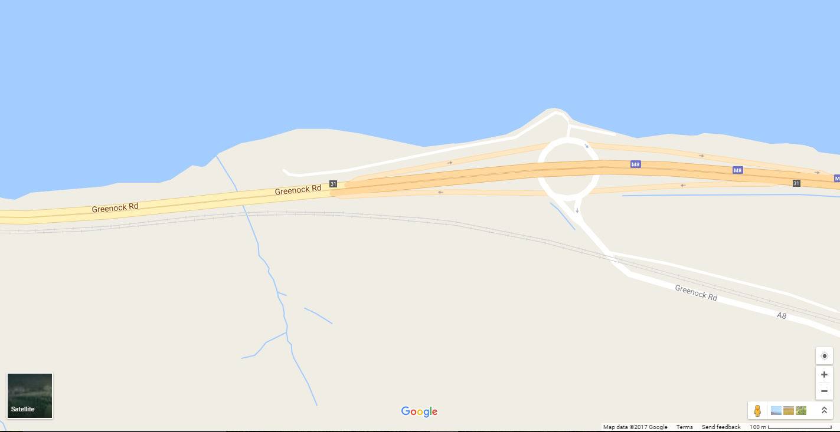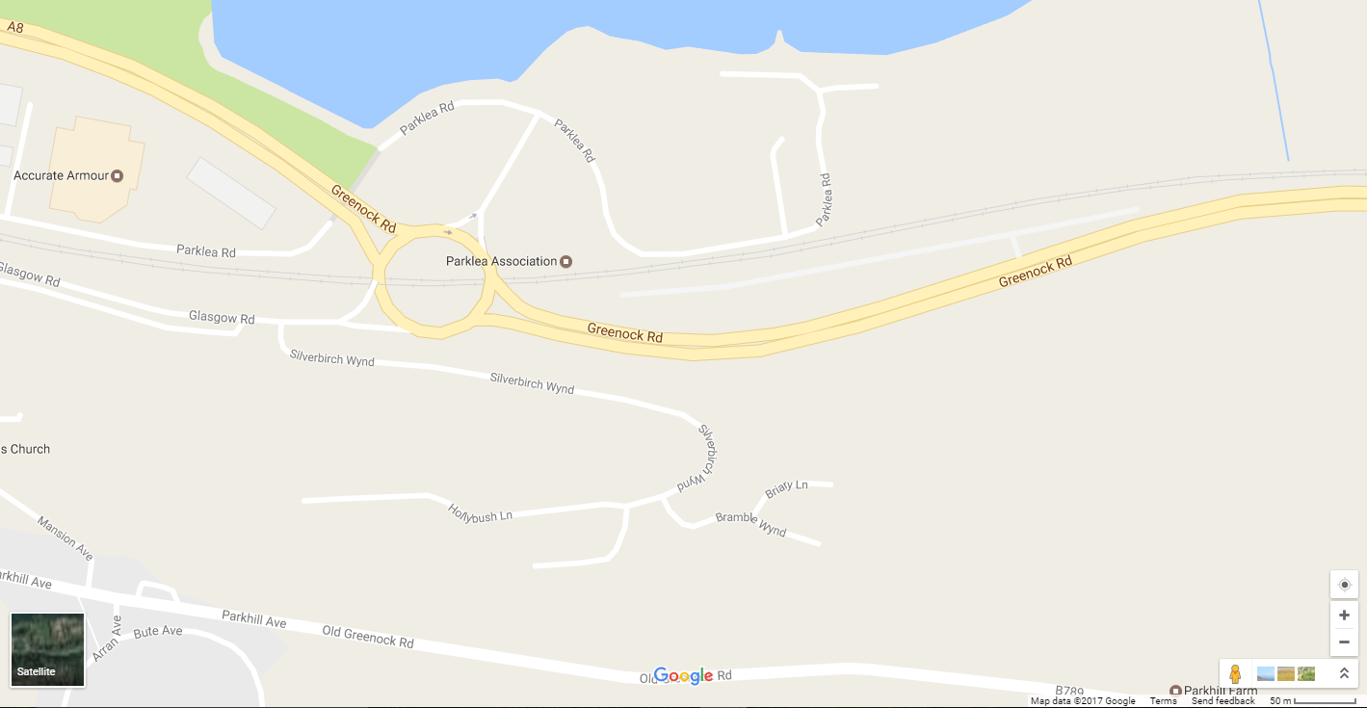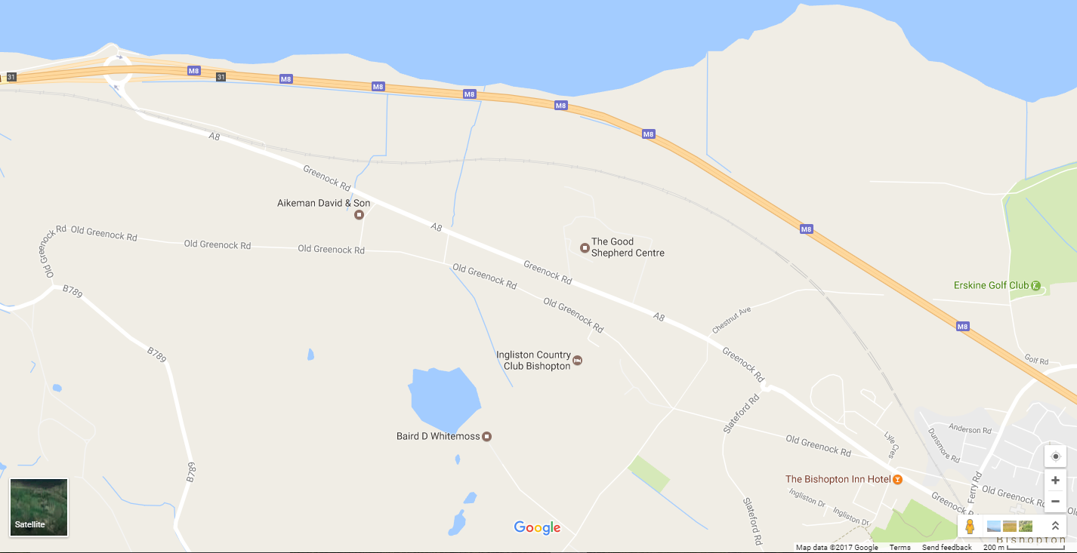

Turn at Woodhall Roundabout

Take 1st exit at roundabout and join A8

Start at layby at top of bishopton hill (same as ’25’)

Start

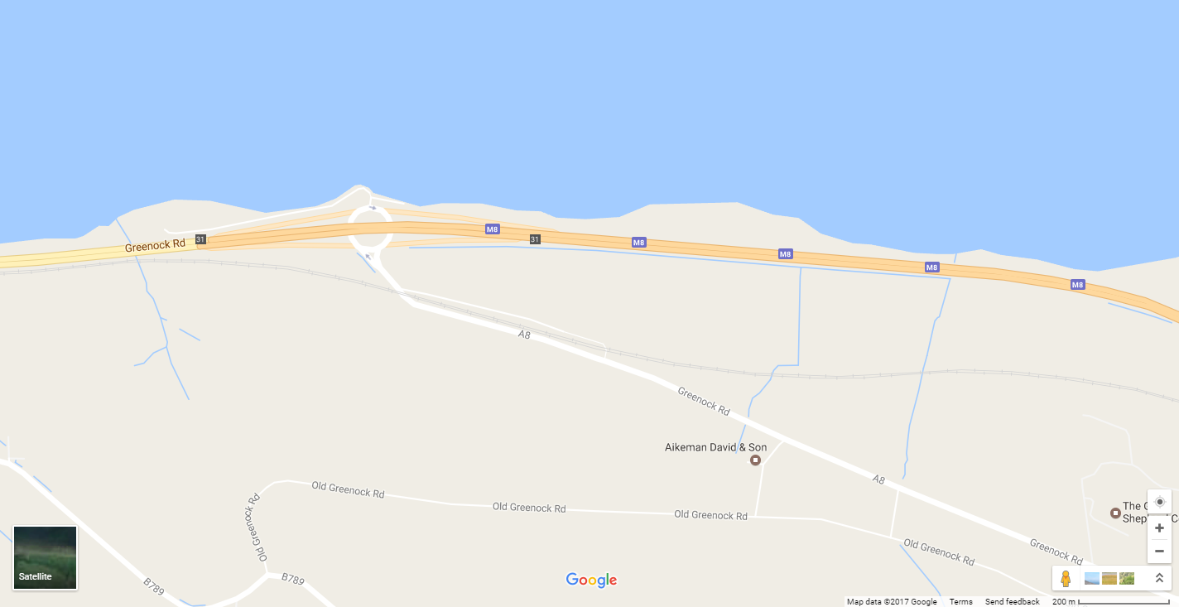

Exit at Westferry Roundabout (completion of 2nd lap).

Finish opposite start

Turn at Woodhall Roundabout

Turn at Westferry Roundabout (completion of 1st lap)

Finish