SDW Racing sponsored by
www.southborough-wheelers.co.uk
This event is promoted for and on behalf of Cycling Time Trials (CTT) under their Rules & Regulations
Southborough & District Wheelers Open 10-mile Time Trial
Saturday 18th May 2024 @ 14:30h

Event Headquarters: Homewood School & Sixth Form Centre, Ashford Rd, Tenterden TN30 6LT.

Please use entrance off A28, through the green gates by the fire station between St Michaels & Tenterden. There is ample parking for all riders.

The HQ will be open from 1pm

Please note that all competitors are required to sign out when returning their number. Failure to do so will result in the competitor being recorded as DNF.

Event Secretary: Julian Fussell (Southborough & District Wheelers), Tunbridge Wells, Kent.
Contact: timetrials@southborough-wheelers.co.uk

Timekeepers: Doug Finch & John Watson (Southborough & District Wheelers)

Records: Solo open - Neil Harris 00:20:07 // Solo female - Pip Jenkins 00:24.21 // Junior - Theo Tadros 00:22:29

Prizes (subject to entry numbers – so please do sign up early):

Solo Scratch  First: £30  Second: £20  Third: £10  Solo Lady  First: £30  Second: £20  Third: £10 | Veterans  First: £30  Second: £20  Third: £10  Junior (< 18 years)  First: £20  Second: £15  Third: £10 | Veterans  First: £30  Second: £20  Third: £10  Fastest Team (3 riders)  £60  (3 x £20) | Road Bike Scratch  First: £30  Second: £20  Third: £10  Road Bike Lady  First: £30  Second: £20  Third: £10 | Tandem  First: £40  Marshals  Rider of the Day  Pongo Socks
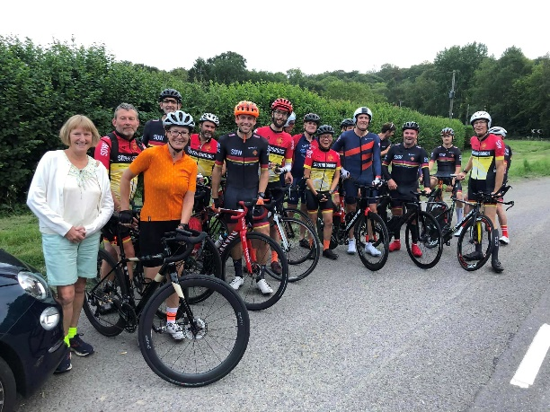
Regulations:
14 (i) No competitor shall be permitted to start either a Type A or Type B event unless such competitor has affixed to the rear of their machine a working rear red light, either flashing or constant, that is illuminated and in a position that is clearly visible to other road users.
(j) No competitor shall be permitted to start either a Type A or Type B event unless such competitor has affixed to the front of their machine a working front white light, either flashing or constant, that is illuminated and in a position that is clearly visible to other road users.
All competitors must wear a properly affixed helmet which must be of the hard/soft shell construction. Helmets should conform to a recognised standard such as SNELL B95, ANSI Z90.4, AUS/NZS 2063:96, DIN 33-954, CPSC or EN 1078.
Additional Rider Information:
Riders must not warm up / turn in sight of the start and finish areas.  Position your number as shown.  Riders must not warm up on the course once the event has commenced. | 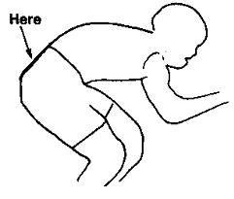

COURSE:

Q10/33  Start on the B2080 at the junction of hedge and fence on the north side of the Green and East of the lane to Finchden Manor, Leigh Green at GR 901330. Proceed through Reading Street to Appledore Heath. Turn left (CARE) (M) to Woodchurch where the road becomes the B2067. Bear left through Brook Street to finish at the verge immediately after the lane to Finchden Manor (GR909380)  Cycling Time Trials: Course Code: Q10/33 | 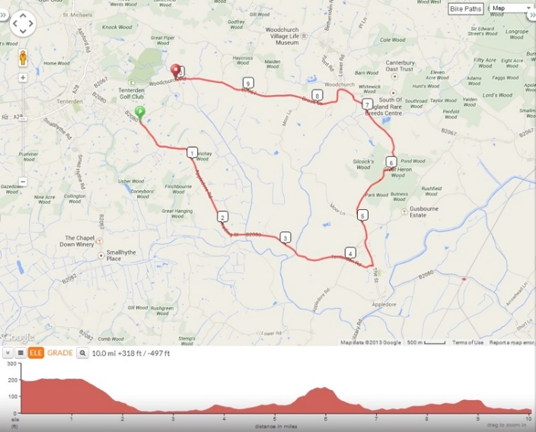

Please exchange your event number for a tea or coffee after the ride.

Good luck, safe riding and thank you for entering.

