RNRMCA 10 MILE TIME TRIAL
S4/10

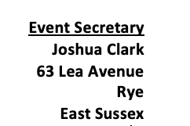
Sunday 3rd September 2023
Course- S4/10 (Fastest course in SW) 10-mile TT Buckfastleigh A38
(Promoted for and on behalf of Cycling Time Trials under their Rules and Regulations)

The Headquarters- Rattery Village Hall, Rattery, South Brent TQ10 9LD
50.43884° N, 3.77674° W
Headquarters are open from 0530 onwards- First rider off at 0701, But if you’re like me and you like to be early, The HQ will be open 90 minutes before start to cater for the keen beans among us!
Timekeepers:
Start- Martyn Heritage-Owen (Bushhealthcare CRT)
Finish- Lynn Marris

Position | TT Male | TT Female | RB Male | RB Female | Junior | Team
1st | £20 | £20 | £20 | £20 | £20 | £20
2nd | £15 | £15 | £15 | £15 | £15 | £15
3rd | £10 | £10 | £10 | £10 | £10 | £10

Prizes will be presented following the event, after everyone has had a chance to recover/cool down and eat loads of cake. Please hang around to either be awarded your prize or help in congratulating the victors. Prizes not received during the presentation will be sent via bank transfer.
***It is COMPULSORY that a WORKING FRONT AND REAR LIGHT, either flashing or constant, is fitted to the machine in a position visible to following road users and is active while the machine is in use. ***
***It is COMPULSORY that a HARD-SHELL HELMET that meets an internationally accepted safety standard is to be worn. ***

HQ- Rattery Village Hall, Rattery, South Brent TQ10 9LD
50.43884° N, 3.77674° W
The Post code above is to the Village Hall according to google maps, the actual Village Hall is just down the road, this is easily visible as it is the only location with a large car park in Rattery accommodating 85 spaces, so we can have two spaces each. For anyone who hasn’t been to HQ before, below is a pin drop to the exact location of the Village Hall
https://maps.apple.com/?auid=11298238342416848258&ll=50.438843,-3.776740&lsp=7618&q=Dropped%20Pin&_ext=EiYpKOxHLw8xSUAxJ5EzA0s0D8A5rV0k/nI9SUBBI28UtCT7DcBQDA%3D%3D&t=h

To start-https://www.strava.com/routes/3106911234217095876
Distance to Start and back to HQ is 2.2 mile, not only is this “added value” but an opportunity to gain composure before entering the HQ- Allow 10 minutes to get to the start, 6 minutes for the Flying Whippets.
Turn right out of HQ and take the second left turn follow road past junction on left hand side and keep right at the next junction on the left, follow road (Narrow Lane) and proceed over bridge of A38 to the turn immediate right down slip road, with caution continue onto the A38, follow until finish on left hand side.

Back to HQ- https://www.strava.com/routes/3106939238189773388
Continue past finish until slip road sign posted “RATTERY” take slip road and immediately turn left, follow road down, keeping left at both junctions, retracing back to the HQ, at junction turn right and HQ will be on your left.

You’ll be glad to hear we can now race normally again without Covid protocols in place, please still be courteous to fellow riders and crew, not everybody appreciates affectionate greetings, especially a sweaty, smelly one post-race.

COURSE DETAILS-
S4/10 - Start on the A38 approximately 1.3 miles Southwest of Buckfastleigh at a point level with the penultimate sink in the acceleration lane opposite Dean Prior Parish Church (GR SX730634). Proceed Northeastwards towards Exeter and take the second slip road signed “Ashburton” (Linhay), where filter left into slip road. At the give way line turn right and bear right in 50 yards to cross A38 and re-join the A38 towards Plymouth. Retrace outward route passing Ashburton, Buckfastleigh and the slip road signed “Lower Dean”. Finish at the drain cover level with the start of the taper at the western end of the lay-by and approximately 500 yards before Dean Prior Church (GR SX730640).
Intermediate mileage – Ashburton Town Sign 5.33miles.

At the finish, please shout your number for the finish timekeepers; it’s not fun trying to lip read from 20M away. Please do not approach the finish timekeepers, it’s an important job and they haven’t had their cake yet! All times will be published after everyone has finished racing and all numbers have been returned.

Course Records-

Solo Male
00:17:51
Marcin Bialoblocki
04-Jul-19 | Royal Navy & RMCA
Solo Female
00:20:40
Tamsin Miller
30-Jun-21 | Royal Navy & RMCA
Solo Male (Junior)
00:19:52
Harrison Wood
25-May-17
Solo Female (Junior)
00:24:39
Hannah Rainger
16-Aug-20 | City Cycle Couriers RT
Team TT
00:19:52
Rob Scott, Andrew Parnowski
13-Jul-19 | City Cycle Couriers RT

Notes to riders: PLEASE READ

- Riders waiting to start must do so 20 metres before the timekeeper and stand well to the left in the layby and in single file. Please only approach start 5 mins before your start time.
- The course used for this event is on a main road. Overtaking traffic will be moving fast. For your own safety, keep well to the left.
- There will be time when you join an ‘A’ road from a ‘B’ road. The traffic has the right of way. Be aware of this when you join the main road.
- Do observe the Highway Code.
- Event officials must not seek to regulate or interfere with other traffic.
- Ride with your head up. Do not “white line”
- Drafting-Paced Riding: CTT regulation No.21 must be applied at all times. Any rider seen taking pace from another competitor will be disqualified. Overtaken teams are to fall back to a distance behind the other one...At least 50 yards is required.
- On completion of their ride, all competitors must continue without turning in the road to the event HQ Rattery turn on the A38.
- Numbers will be at the start and must be signed for on pick up and return otherwise the ride will be DNF
- Riders are to ensure they read the course Risk Assessment (which will be next to the sign on paperwork in the HQ) before riding the event.
- There may not be a Marshall to push off riders at the start, In this case please start with one foot unclipped and on the ground until given the all clear from the start timekeeper.

Official Timekeepers and Marshalls.
Name | Location | Role
Phil Bowden | Start | Timekeeper
Lynn Marris | Finish | Timekeeper
Gavin MacDougall | Start | Marshall
Tim C | Turn | Marshall
Desmond Hall | Turn | Marshall
David Hall | Turn | Marshall
Steve Baldie | Finish | Marshall

This is an official event under Cycling Time Trial (CTT), The national governing body for cycling time trials regulations. Hosted by the Royal Navy Royal Marines Cycling Association (RNRMCA) on 03rd Sept 2023. All Marshalls and timekeepers are required by the RNRMCA under safety regulations stated in the Risk assessment formulated by CTT alongside Devon and Cornwall Police. This event is covered by the RNRMCA event matrix for duty events.

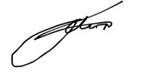

Joshua Clark- Event Organiser/Manager

Map and Elevation below-

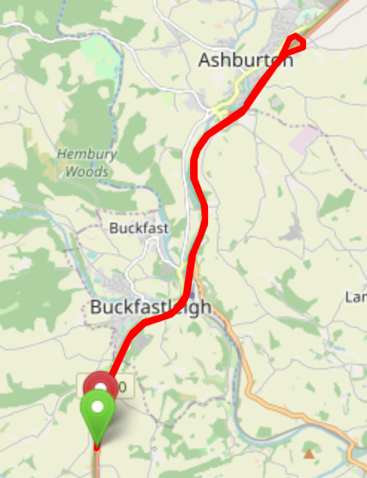

Elevation chart to show the incredible lack of hills for Devon, don’t confuse it for the Netherlands, you are in the right place, it’s just the only place in Devon you might get 10 miles of fairly flat riding.

