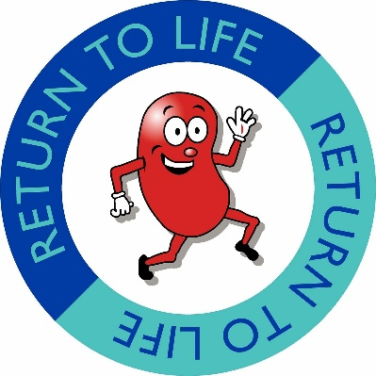
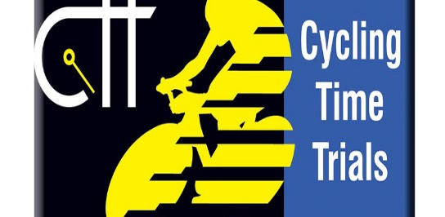
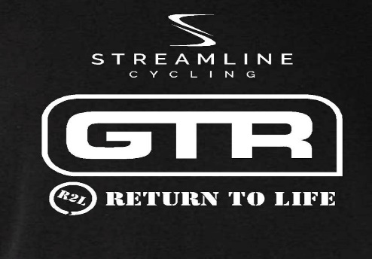
GTR- Return To Life p/b Streamline
TT weekend
22/06/23 19:01

HQ
Visitor Centre Carpark
Eglinton Park
Irvine
KA12 8TA

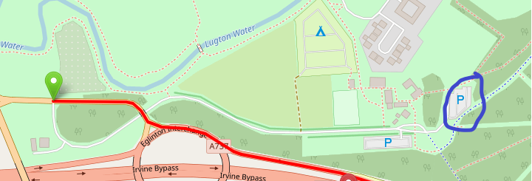

Promoted for & on behalf of Cycling Time Trials under their rules & regulations

Return To Life
Return to life is a charity that supports patients, families diagnosed with chronic kidney disease pre and post- Save transplant. Life on dialysis is cruel so together we can help promote organ donor awareness and save lives. All the entry money raised for these events will be donated to this great cause. Thank you
The Course
This event is being run on the WW10/03 course.
Start at lamp No R5 opposite entrance to Eglinton Country Park. Follow A78 south under two interchanges to turn at Dundonald Camp roundabout. Retrace to finish on slip road at Eglinton interchange. This course is otherwise known as the AY4

HQ and parking
The HQ will be located in the carpark to the rear of the Eglington park. Please be aware that the visitor centre may be closed so toilet facilities may not be available. When parking, please be aware there will be other park users around so take car when driving/riding about. Make sure you sign in and collect your number. Remember to sign back out when you are done.

Safety notes

Vehicles of competitors / officials / marshals / helpers to be parked safely and without hindrance to other road users.
No U-turns to be made in the vicinity of the timekeepers
Please be considerate to those on the course and racing.
Remember 2017 regulation to sign-off and return number, failure to signoff may result in DNF
All riders are responsible for their own safety
You must obey the rules of the road and obey all traffic signs, signage and direction indicators
- It is your responsibility to ensure that your machine is roadworthy and that you ride safely at all times
- You must look ahead and not ride with your head down
- You must not take pace or shelter from any other vehicle or competitor (no drafting)
- Failure to comply with any of the above may lead to disciplinary action being taken
- No warming up on the course once the race has started

All competitors must wear a hard-shell helmet
A working front and rear light are compulsory for all riders. No lights, no ride.

