Prize list 2023

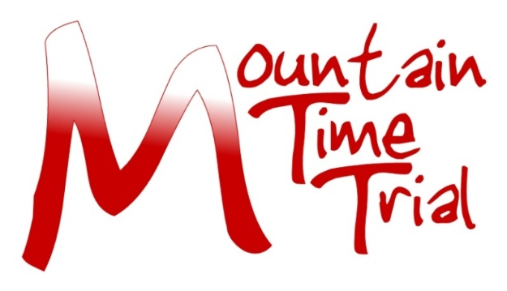

Tyneside Vagabonds CC 69th Mountain Time Trial 21st May 2023
Results & Prizes
Provisional results are likely to be available from the N&DCA Facebook page as soon as possible after the event. Official results will be on the CCT website and emailed to all competitors once formalised.
There will be a prize giving and buffet available after the event for those who wish to attend. We will also contact prize winners who are not available for the prize giving, as soon as possible once the results have been verified.
All profits from this event go to the Great North Air Ambulance;
https://www.greatnorthairambulance.co.uk.
Please let the event secretary or club treasurer (Alex Buckthorp alexbuckthorp@yahoo.co.uk) know if you prefer to donate your prize to this worthy cause
Trophies
Fastest Time Marion Bunton Trophy
Fastest Female Dorothy Dent Trophy
Fastest Junior Ian Vaughan Trophy
Fastest Vet on Standard J.K.Marshall Trophy
Fastest Ascent of Bilsmoor (Male) Russell Thompson Trophy Fastest Ascent of Bilsmoor (Female) Ron Steele Trophy
Prizes
Overall
First £40
Second £30
Third £20
Female
First £40
Second £30
Third £20
Road bike
Male
First £40
Second £30
Third £20
Female
First £40
Second £30
Third £20
Bilsmoor Climb
Fastest male £40
Fastest female £40
Thanks to our sponsors Ian and Tina Sutton.
One prize per rider, except for Ascent of Bilsmoor.
For the Road Bike Category the following rules apply;
No tri bars, wheels no deeper than 90mm and with a minimum of 12 spokes (no disc wheels). Skin suits, aero helmets and aero socks now permitted.

