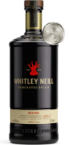

CC Sudbury Mad March Hilly Time Trial
Sunday March 5th – Course BS24/R, 22 miles 8.00am
Entries via CTT – Cycling Time Trials
Last Entry 21st February
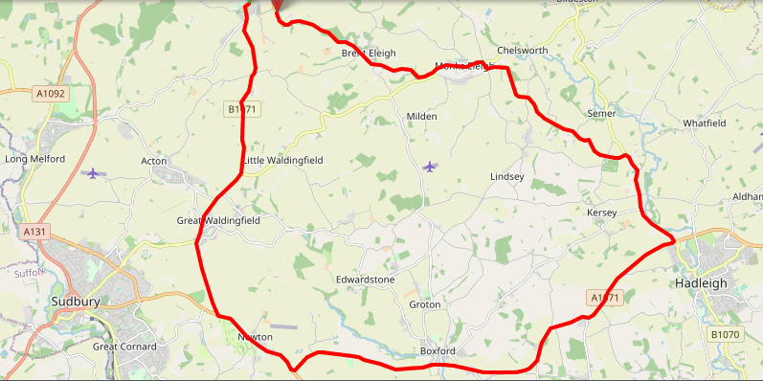
Prizes
Male |  |  | Female |  |  | Fastest Junior
1st | £25 and 1.75L spirit |  | 1st | £25 and 1.75L spirit |  | £15
2nd | £20 and 1.00L spirit |  | 2nd | £20 and 1.00L spirit
3rd | £15 |  | 3rd | £15 |  | Team of 3
1st Vet | £15 |  | 1st Vet | £15 |  | £10 per rider
Course Record | £50 |  | Course Record | £50
Road Bike | £15 |  | Road Bike | £15

Any questions contact Rob Davies, rob.ev.jack@gmail.com, 07788 413 524

