Wotton Hill Climb, UH14, hosted by Sodbury Cycle Sport
Promoted for and on behalf of Cycling Time Trials under their rules and regulations

We were all deeply saddened to hear the news of the death of Queen Elezibeth Ⅱ on Thursday 8th September. The country is in mourning and so we will hold a minute's silence before the prize presentation. Thank you all.

Course records
Men:Andrew Feather 4 mins 50 seconds (September 2021)
Women:Rosie Whaland 6 mins 28 seconds (September 2021)
Junior men: Jacob Hardy 5 mins 35 seconds
Junior Women: Laura Curle 7 mins 26 seconds

9am Start, Saturday 17th September 2022
Part of the WTTA Hill Climb Series

Organiser: Matt Reynolds. 07826 534448. sodburycs@gmail.com
Timekeepers: Rob Hutchinson and Martin McGreary.

HQ:
The HQ is in The Star Pub, 21 Market St, Wotton-under-Edge GL12 7AE
HQ will be open from 7.30am.
All competitors must sign on before and after the event.
Refreshments will be available after the event. Please remember to return your number.

Parking:
Parking is available in The Chipping car park, Long Street, Wotton-under-Edge, GL12 7BD
Please be aware of parking restrictions in part of the car park.

Course:
The event is being run on the UH14 course.

Strava address https://www.strava.com/segments/18916368?hl=en-GB

Cycling Time Trials address https://www.cyclingtimetrials.org.uk/course-details/uh14

A 1.4 Mile Hill Climb starting at the lay-by on the B4058 Coombe Rd coming from Wotton Under Edge. Map ref 51.643397, -2.343902 and finishing at 51.656521, -2.330305
The road is two way and in good condition, it is wide enough for traffic to pass in either direction. See map below.
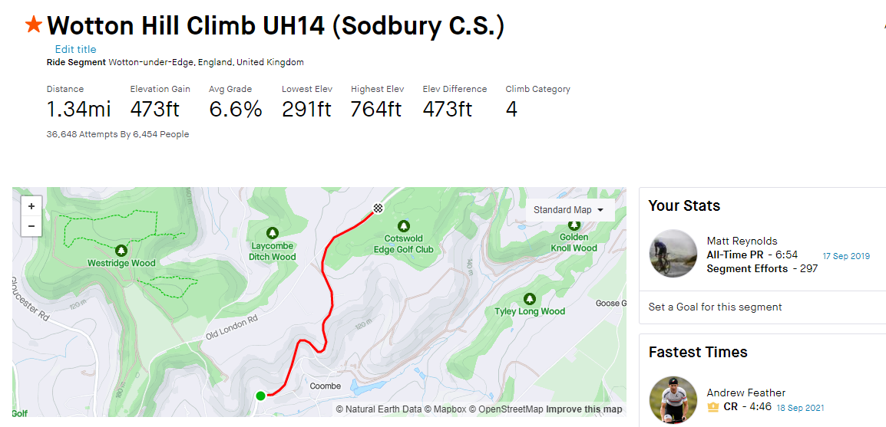

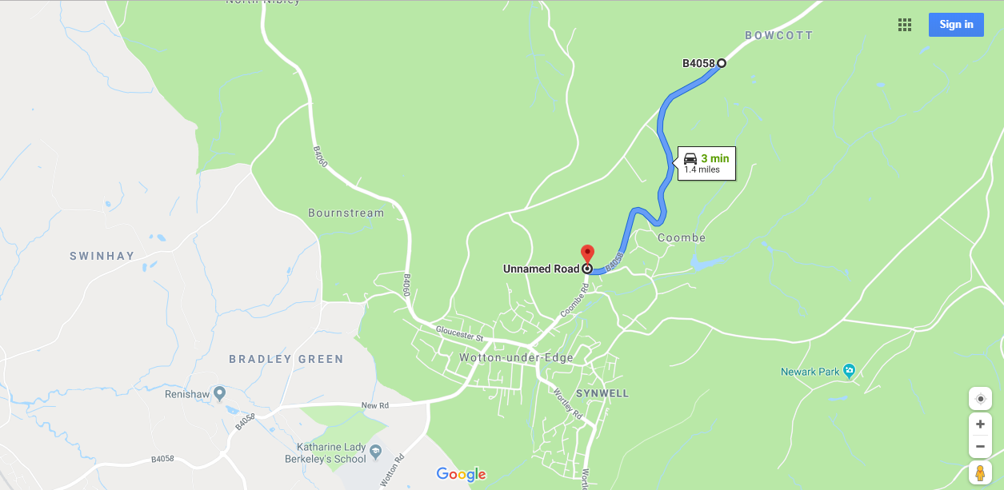
Safety:
- All riders MUST have front and rear lights. Please do not embarrass the start team by not showing the required lights (and they are switched on). This is NOW a CTT regulation.
- Remember the Highway Code applies at all times.
- Riders MUST give way to traffic having the right of way.
- Do NOT drift onto the wrong side of the road. Be vigilant.
- Use of an approved helmet is mandatory for junior competitors, and is strongly recommended for all others.

General notes:
- Race Numbers: Please attach to the rear of your Jersey to the lower right to make easy reading for the time keepers. You wouldn’t want them to miss you.
- Warming up: Please do not warm up on the course whilst racing is in progress. A recommended warm-up route is to head towards Charfield along the B4058 or towards Dursley on the B4060
- Start area: Please queue back along the lay-by. Please do not arrive too early as this may block the entrance, which is access for local residents.
- At the finish, shout your race number to the timekeeper.
- DO NOT return to the time keeper, continue to the HQ where results will be available.

Riding from the HQ to the Start:
Head out of the HQ down market street, turn left up High street, turn right at T-junction along Bear st, Turn right at T-junction along Old Town, take 1st exit at roundabout along Culverhay, continue to join Coombe Rd for 0.3 mile, the start is on the left in the Lay-by.
Allow 5-10 minutes to ride from HQ to the start.

