Cleveland Wheelers 10 Mile Time Trial
T101 Course Details
Start on Stokesley - Hutton Rudby Rd at gateway, approx 200 yds East of Seamer Rd. Proceed to Hutton Rudby, keeping left at the bottom of Skutterskelfe Bank (with care). At the top of Hutton Rudby Bank, in the village bear left (M) and then take 4th road (Black Horse Lane) on the left (signposted Swainby)(M). Proceed straight across junction at Potto Hall to T junction with A172 (M). Turn left and continue along A172 in easterly direction to finish approx 1mile before Stokesley turn off, local to Busby Hall Cricket Club on north side of road.(10miles)
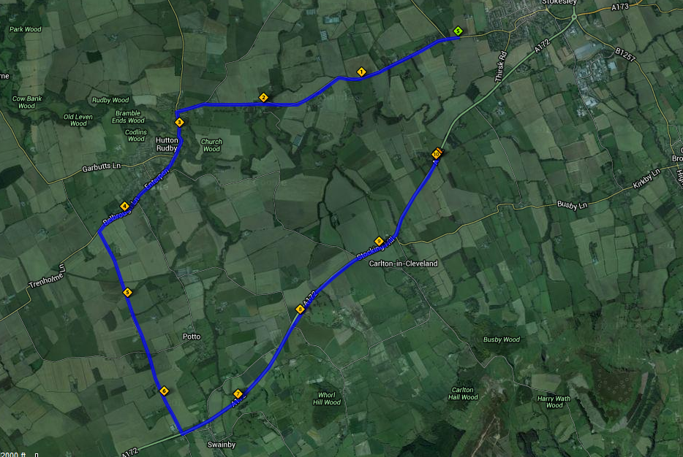
Turn 3
Turn 2
Turn 1

Turn 1 - Left turn in Hutton Rudby (top of the bank)
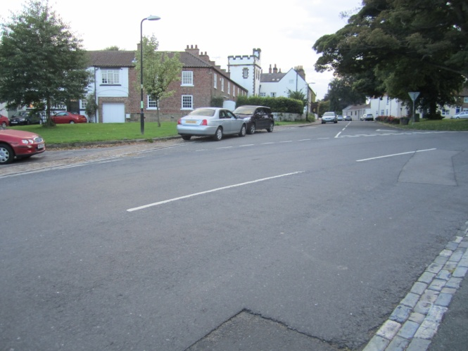
Turn 2 – Left Turn to Potto / Swainby
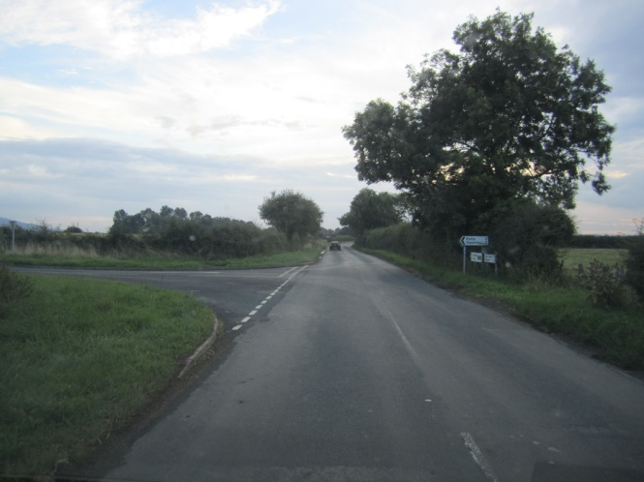
Turn 3 - Left Turn to Stokesley
