Aylesbury CC 10 mile Open Time Trial
Promoted for and on behalf of Cycling Time Trials under their Rules and Regulations
Event HQ - Longwick Village Hall, 5 Blenheim Close, Thame Road,
Princes Risborough, HP27 9SG
(Entrance opposite Village shop)
07th August 2021 at 09.00am HCC202a (Longwick) Course
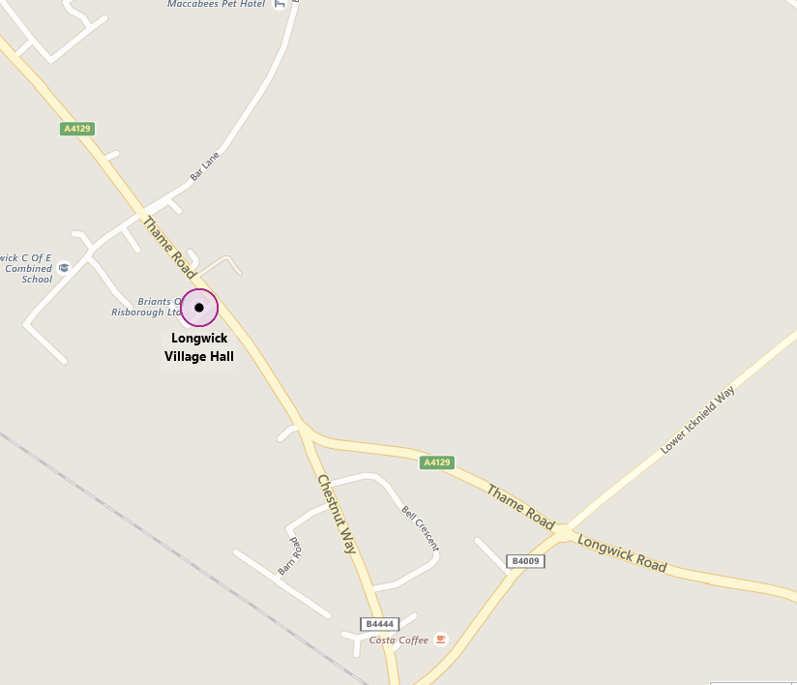
HQ Open for sign on from 7.30am
Event Secretary - Bryce Taylor, 36 Creslow Way, Stone Aylesbury, Bucks, HP17 8YW
Phone - 07889 326010 email - aylesburytt@gmail.com

Timekeepers – Mark Ashton & Geoff Booker

Prizes

Road Bike Event

1st (Men) £20 1st (Women) £20 1st (Vet) £20

TT Bike Event

1st (Men) £25 2nd (Men) £15
1st (Women) £25 2nd (Women) £15
Fastest Vet (on Standard) £25

HCC202a Course Description

Start in the apex of Longwick layby at the eastern entrance, and approximately 127 yards before the Dept of Transport 30 mph de-restriction signs at the entrance to Longwick village. Proceed through Longwick village, over the pedestrian crossing to the “Sportsman” roundabout (M1) with the B4009 1.10 miles. Turn around the roundabout and take the 4th exit still on the A4129 and retrace through Longwick Village. Continue on the A4129 past the start point 2.2 miles. Continue on the A4129 through Kingsey village to the roundabout junction with the Thame ring road (A4129) and the B4012 (M2). 6.35 miles. Turn around the roundabout and take the 4th exit (ignoring a track into the Thame Show ground) to retrace on the A4129. Proceed via Kingsey village to finish at a point by the grass verge 32 yards short of telegraph pole number DP651 which is on the opposite side of the A4129, and 32 yards after the Department of Transport ‘cross roads’ signs positioned on both sides of the A4129. 10 miles.
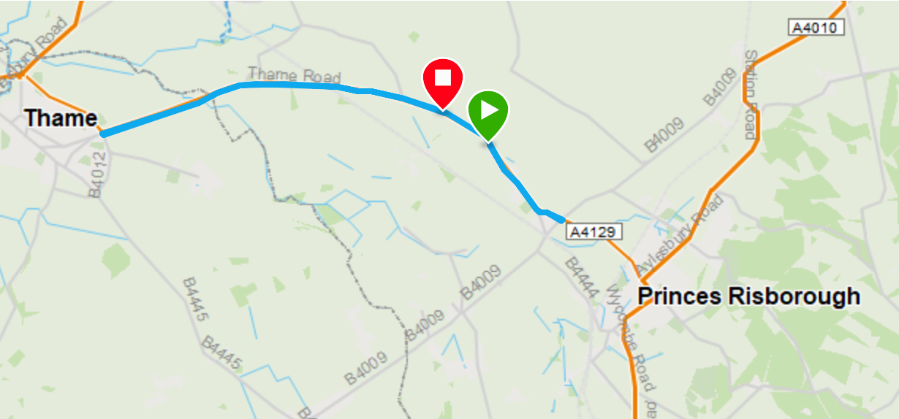

General Event Information
Park in the Village Hall Car Park where there is adequate parking. There is limited additional parking in the lay-by north of the village of Longwick. This is the start lay-by so avoid parking near the south exit onto Thame Road where the race starts.
There are toilet facilities at HQ. Please use these and do not urinate elsewhere.
If you wish to warm up on the road, please be aware the course passes the entrance to HQ in both directions. We suggest you turn left then right at Bar Lane in 200yds. This will access minor local roads where you can warm up. Take care not to interfere with competing riders.
To reach the start, turn left onto the A4129, ride to the lay-by north of Longwick village, 0.7ml approx. Please take care not to interfere with riders already on the course. Enter the lay-by at the far end.
The course is very straightforward, staying on the A4129 with 360° turn at roundabouts at 1.1ml and 6.3ml. There will be a marshal at both roundabouts.
There is a light controlled pedestrian crossing in Longwick Village. There will be a marshal present try to dissuade pedestrians from using the crossing, until any oncoming rider has passed. However if the crossing is used you must stop on the red light, as you will be disqualified if you fail to do so.
In the interests of your own safety, Cycling Time Trials strongly advise you to wear a hard shell helmet that meets an internationally accepted safety standard and to have a rear light intermittently flashing. FROM 2022 YOU ARE NOW ALSO REQUIRED TO HAVE A FLASHING FRONT LIGHT.
NOTE - The return route to HQ passes the start point so earlier riders will encounter racers waiting to start. Please wait until the next rider has started and ride behind them until you reach the right turn into HQ.

RULES FOR THE ROAD BIKE EVENT
1. No aerobars, clip on aerobars or aero extensions can be used
2. Hands must be holding the handlebars at all times whilst racing (ie. not with forearms resting on the handlebar)
3. Wheels must have a minimum of 12 spokes each, and have a maximum rim depth of 90mm
4. Helmets must have no visor
5. Ears must not be covered by the helmet (Giro Aerohead helmets are not permitted)

