Addiscombe Cycling Club
Open 25 mile Time Trial
For the E.V. Mills Trophy
(Promoted for and on behalf of Cycling Time Trials under their Rules and Regulations)
Also forming round 4 of the London Womens Racing TT League
Sunday April 23rd 2017 – Course G25/54
HQ: Broadbridge Heath Village Centre Social Club, Wickhurst Lane, Broadbridge Heath, Horsham, RH12 3LY – The HQ will be open from 5:45am
Promoter: Jonathan Pontin, 6 Hurst Way, South Croydon, CR2 7AP
Tel: 07732674317
email: jonathanpontin@hotmail.co.uk
Timekeepers: Mick Irons, Peter Delve
Please Note: The HQ is in a residential area so please keep noise and parking disruption to the minimum possible. Also any public displays of indecency may result in disqualification and reporting to CTT.
Remember: You must now sign out of the race when you hand your number back at the HQ. Failure to do so will result in disqualification.
Course Details:
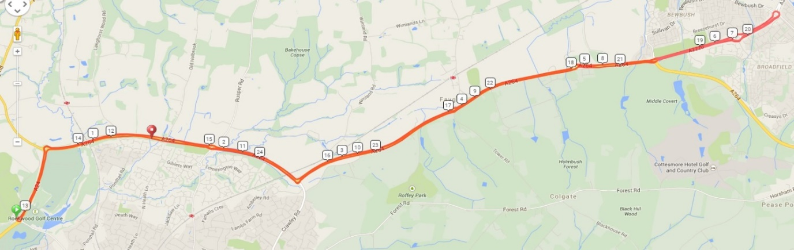

G25/54 Start in Robin Hood Lane at clearway sign 5 yards from Robin Hood RBT. Proceed to Robin Hood RBT. LEFT and follow A24 to Great Daux RBT. RIGHT and follow A264 and A2220 to TURN at Broadfield RBT. Retrace to Bewbush Manor RBT. STRAIGHT on and follow A264 to Great Daux RBT. LEFT to Robin Hood RBT. TURN and repeat route to Broadfield RBT. TURN and retrace to Rusper Road RBT. STRAIGHT on to FINISH at white line at eastern edge of lay-by where edge of lay-by becomes parallel to A264 .44 mile west of Rusper Road RBT.
A full size version can be seen here: http://ridewithgps.com/trips/3351637

Route from HQ to Start

Please remember to leave enough time to get from the HQ to the start, last year a number of riders were late, mostly Addiscombe admittedly, and the timekeepers were not happy.
If you do turn up late, inform the timekeeper immediately and they will allow you to start in the next available slot.
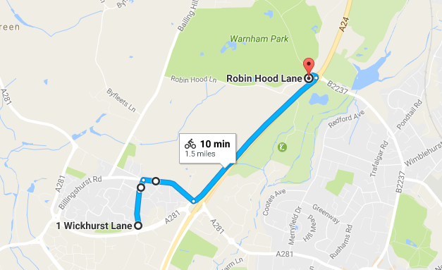

Local Regulations

(1) It is a London South District Regulation that no vehicles, except those of the timekeepers and event officials, shall be parked in the vicinity of the start and finish areas.

Safety Instructions
- Competitors are requested not to warm up on the course after the first competitor has started.
- Details of any additional hazards not listed on the start sheet will be displayed or advised at the Signing On point. All competitors must take note of these details when they sign on.
- Competitors must exercise extra care when negotiating all roundabouts.
- No times will be given at the finish.
- CTT regulations require the compulsory use of helmets for the under 18’s. In the interests of your own safety, Cycling Time Trials and the event promoters strongly advise all competitors to wear a hard/soft shell helmet that meets internationally accepted safety standards.
- Competitor’s machines: it is recommended that a working rear light, either flashing or constant, is fitted to the machine in a position clearly visible to following road users and is active while the machine is in use.
HEADS UP, RIDE SAFELY!
Prizes
Scratch: 1st £50 2nd £30 3rd £20
Women: 1st £50 2nd £30 3rd £20
Veterans: 1st £40 2nd £30 3rd £20
Junior: 1st £10
Team £20 each
- The scratch winner will also receive two tickets to the club dinner where the trophy will be awarded.
Notes on prizes:
- One prize per rider except for the Team prize the highest value prize being paid.
- A Team is the fastest 3 riders from a single club / team.
- Any prizes not awarded on the day will be sent out with the results sheet.

Startsheet:
Bib Number | Name | Club | Category | Start Time
31 | Anthony Haslam | Addiscombe CC | J16 | 00:07:01
32 | Keith Geere | GS Stella | V66 | 00:07:02
33 | Robert Coniglio | Dulwich Paragon CC | S30 | 00:07:03
34 | Robert Royle-Evatt | Addiscombe CC | V49 | 00:07:04
35 | Paul Townsley | Worthing Excelsior CC | V68 | 00:07:05
36 | Tony Dodsworth | Sigma Sport.co.uk | S33 | 00:07:06
37 | Will Worsdell | Tri Training Harder | S35 | 00:07:07
38 | Daniel Goldsmith | Twickenham CC | V54 | 00:07:08
39 | Richard Claxton | VC Elan - Harry Perry Cycles | V73 | 00:07:09
40 | Jonathan Pontin | Addiscombe CC | S26 | 00:07:10
41 | Caroline Reuter | London Phoenix CC | VW41 | 00:07:11
42 | Jody Coxon | Adalta Cycling Club | SW37 | 00:07:12
43 | Helen Bridgman | Kingston Wheelers CC | SW37 | 00:07:13
44 | Elinor East | Brixton Cycles Club | SW32 | 00:07:14
45 | Katrina Murphy | Dulwich Paragon CC | SW28 | 00:07:15
46 | Emma Bentley | Team Athlete Lab CC | SW26 | 00:07:16
47 | Jacintha Hamilton-Love | Dulwich Paragon CC | SW32 | 00:07:17
48 | Natasha Jarman | Dulwich Paragon CC | SW36 | 00:07:18
49 | Valerie Place | 7 Oaks Tri | VW56 | 00:07:19
50 | Katerina Avramides | Brighton Mitre CC | SW36 | 00:07:20
51 | Jane dennyson | Regents Park Rouleurs | VW42 | 00:07:21
52 | Kathryn Morris | Dulwich Paragon CC | SW38 | 00:07:22
53 | Robyn Yates | Addiscombe CC | VW54 | 00:07:23
54 | Rachel Przybylski | Charlotteville Cycling Club | SW36 | 00:07:24
55 | Lizzy Brama | Crystal Palace Triathletes | SW33 | 00:07:25
56 | Madelaine Lee-Smith | Oxted Cycle Club | VW45 | 00:07:26
57 | Elise Sherwell | Blazing Saddles | VW41 | 00:07:27
58 | Katie Crowe | Dulwich Paragon CC | VW40 | 00:07:28
59 | Lucy Francis | London Dynamo | VW48 | 00:07:29
60 | Richard Tully | Elite Cycling | V40 | 00:07:30
61 | Stephen Allport | Bec CC | V41 | 00:07:31
62 | Steve Grout | Epsom CC | V54 | 00:07:32
63 | Stuart Jago | GS Stella | V60 | 00:07:33
64 | Kaushal Sampat | Addiscombe CC | S32 | 00:07:34
65 | Paul Thompson | Epsom CC | V51 | 00:07:35
66 | Rome Bhamra | Worthing Excelsior CC | V50 | 00:07:36
67 | David Bridle | Southdown Velo | V57 | 00:07:37
68 | ben fielden | GS Stella | V75 | 00:07:38
69 | Russell Hicks | Oxted Cycle Club | V63 | 00:07:39
70 | Phil Allen | South Downs Bikes / Casco Europe | S39 | 00:07:40
71 | Ian Newbold | Worthing Excelsior CC | V44 | 00:07:41
72 | Paul Cannon | Epsom CC | V67 | 00:07:42
73 | Nigel Perry | San Fairy Ann CC | V53 | 00:07:43
74 | Thomas Seller | Oxted Cycle Club | S28 | 00:07:44
75 | Julian Pegg | Hitchin Nomads CC | V53 | 00:07:45
76 | Shaun Marlor | Bec CC | V44 | 00:07:46
77 | Tim Whitehead | Oxted Cycle Club | S36 | 00:07:47
78 | Joshua Davies | CC London | E19 | 00:07:48
79 | Fidel Gonzalez | South Western Road Club/Evans Cycles | V49 | 00:07:49
80 | pete tadros | In-Gear Quickvit Trainsharp RT | V46 | 00:07:50
81 | Mark Thomas | Bigfoot CC | V54 | 00:07:51
82 | Neil Crowther | Worthing Excelsior CC | V43 | 00:07:52
83 | Donald Parker | Brighton Mitre CC | V68 | 00:07:53
84 | Andrew R Green | Bec CC | V42 | 00:07:54
85 | Brian Molloy | Brighton Excelsior CC | V49 | 00:07:55
86 | Martin Booker | Worthing Excelsior CC | V48 | 00:07:56
87 | Pete Hargreaves | Oxted Cycle Club | V55 | 00:07:57
88 | Paul Fairman | Abellio - SFA Racing Team | V62 | 00:07:58
89 | Sam Bennett | 7 Oaks Tri | V44 | 00:07:59
90 | James Rix | Crawley Wheelers | V41 | 00:08:00
91 | Neil Hughes-Hutchings | Morden CRC | S37 | 00:08:01
92 | Nick Davy | C and N Cycles RT | V53 | 00:08:02
93 | John Marinko | Brighton Mitre CC | V51 | 00:08:03
94 | Paul Sewell | Bigfoot CC | S39 | 00:08:04
95 | Lee Turner | Sigma Sport.co.uk | V48 | 00:08:05
96 | Michael Draper | Charlotteville Cycling Club | V60 | 00:08:06
97 | Mark Jones | GS Stella | V57 | 00:08:07
98 | Katharine Hibbert | Islington Cycling Club | SW35 | 00:08:08
99 | Theo Tadros | In-Gear Quickvit Trainsharp RT | J15 | 00:08:09
100 | Mark Newton | Elite Cycling | V50 | 00:08:10
101 | Rick Hughes | Worthing Excelsior CC | V54 | 00:08:11
102 | Jennifer Millmore | Islington Cycling Club | SW30 | 00:08:12
103 | Nick Eisinger | Dorking Cycling Club | V44 | 00:08:13
104 | Drew Hosie | ...a3crg | V53 | 00:08:14
105 | John Powell | Team ASL | S39 | 00:08:15
106 | Barrie Robinson | Sunderland Clarion | V47 | 00:08:16
107 | Richard Payn | 34 Nomads CC | V53 | 00:08:17
108 | Rob Luff | GS Stella | V59 | 00:08:18
109 | Mark Valios | Bigfoot CC | V43 | 00:08:19
110 | Keith Lea | Paceline RT | V47 | 00:08:20
111 | Michelle Lock | GS Stella | VW53 | 00:08:21
112 | Mark Bernhardt | GS Stella | V54 | 00:08:22
113 | Kevin Plummer | South Downs Bikes / Casco Europe | V51 | 00:08:23
114 | George Brent | Addiscombe CC | V42 | 00:08:24
115 | Dave Dent | GS Stella | V53 | 00:08:25
116 | Stu Nisbett | Crawley Wheelers | V43 | 00:08:26
117 | Paul Haywood | Epsom CC | V42 | 00:08:27
118 | Trevor Leeding | Worthing Excelsior CC | V51 | 00:08:28
119 | Damian Poulter | Hounslow & District Whs | V43 | 00:08:29
120 | Liam Maybank | Twickenham CC | V44 | 00:08:30

