Risk Assessment proforma*

Course | K48/10 | 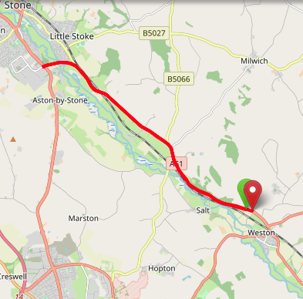
Area | Midland DC
Description | Weston/Aston by Stone
HQ | Weston
Measured | 30/09/2023
Measured by | D Grant
Risk assessed | 30/09/2023
Assessed by | DC Risk Assessor
Date approved | 23/06/2002
Type A | Approved for Type A & Type B
Type B
Police Authority | Staffordshire
Additional information | The junction of Litchfield Road to the A34 traffic island is part of the District Border. Permission to use course must also be obtained from Manchester DC
Notes for riders
OS Grid # | Course description | Distance | Risk (L/M/H) | Risk description | Minimum management  (Without prejudice)
SJ9698827860 | Start on A51(Rugeley - Stone road) at field gate about 0.5 mile northwest of Weston and just beyond Lodge house at the end of Boat lane. Ride northwest (A51) | 0 | M | Riders and officials on or near the highway  Riders congregating at the start | Cycle event in progress signs.  Officials on or near road to wear high viz jackets.  Riders not yet started to wait off the carriageway.
SJ9698827860 | CARE POINT | 0 | M | Dual Carriageway | Cycle event in progress signs on approach to and end of dual carriageway  Advise Rider Caution  Riders to stay left on dual carriageway ahead
SJ9109632188 | At island junction with A34 at Aston-by-Stone Encircle island; taking fourth exit; to retrace (A51) | 4.93 | M | Traffic island | Cycle event in progress signs on all approaches to the island.  Marshall on the island  Advise Rider Caution
SJ 9489 2925 | CARE POINT | 8.31 |  | Dual Carriageway | Cycle event in progress signs on approach to and end of dual carriageway  Advise Rider Caution  Riders to stay left on dual carriageway ahead
SJ9716627827 | Finish at field gate just before junction with Sandy Lane | 10 | L | Riders and officials on or near the highway | Finish sign at approach to finish and finish board by timekeeper.  Officials on or near road to wear high viz jackets.  Finished riders to return to HQ

References:

CTT GN22 – Risk Assessment

Date of Issue | Reason of Revision | Author
March 2013 | New edition | David Barry  (CTT Board Director)  (CTT Course Risk Assessor)
August 2018 | Revised format | Nick Sharpe  (CTT National Secretary)
October 2022 | Revised to reflect current CTT Articles, Rules, and Regulations | David Barry  (CTT Board Director)

