Risk Assessment proforma*

Course | K4/23 | 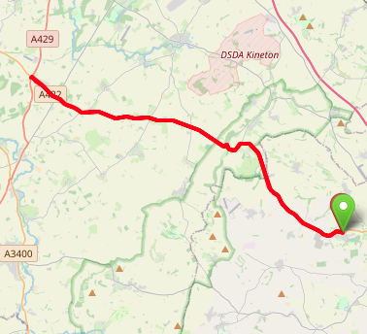
Area | Midland DC
Description | Wroxton (A422) - Sunrising Hill - Ettington TI (A429)
HQ | Wroxton, OX15
Measured | 21/05/2001
Measured by
Risk assessed | 29/11/2022
Assessed by | DC Risk Assessor
Date approved | 21/05/2001
Type A | Approved for Type A & Type B
Type B
Police Authority | Warwickshire  tma@warwickshire.police.uk
Additional information
Notes for riders
OS Grid # | Course description | Distance | Risk (L/M/H) | Risk description | Minimum management  (Without prejudice)
SP4180041900 | Start on A422 (Banbury - Stratford on Avon road) level with tree outside "White Horse" Inn, Wroxton (3 miles from Banbury Cross) Ride west on A422. | 0 | M | Riders and officials on or near the highway  Riders congregating at the start | Cycle event in progress signs.  Officials on or near road to wear high viz jackets.  Riders not yet started to wait off the carriageway.
SP3593046090 | Continue towards Stratford, down Sunrising hill. | 5.17 | M | Hairpin bend on descent, Junction on left at bottom of the hill (riders have right of way) | Warning signs, a marshal and warning on start sheet
SP2650049310 | At island junction with A429 west of Ettington encircle island to retrace along A422 | 11.65 | M | Riders have to give way to traffic from their right and encircle island | Minimum 2 marshals and cycle event signs on all approaches to the island
SP3593046090 | Climb Sunrising hill. | 18.27 | L
SP4090041700 | Finish: opposite junction with unclassified road to North Newington about 800 yards before starting point | 23.5 | L | Riders and officials on or near the highway | Finish sign at approach to finish and finish board by timekeeper.  Officials on or near road to wear high viz jackets.  Finished riders to return to HQ

References:

CTT GN22 – Risk Assessment

Date of Issue | Reason of Revision | Author
March 2013 | New edition | David Barry  (CTT Board Director)  (CTT Course Risk Assessor)
August 2018 | Revised format | Nick Sharpe  (CTT National Secretary)
October 2022 | Revised to reflect current CTT Articles, Rules, and Regulations | David Barry  (CTT Board Director)

