Risk Assessment proforma* Assessed 02/03/2024
Updated 26/04/2024

Course | B10/53 | 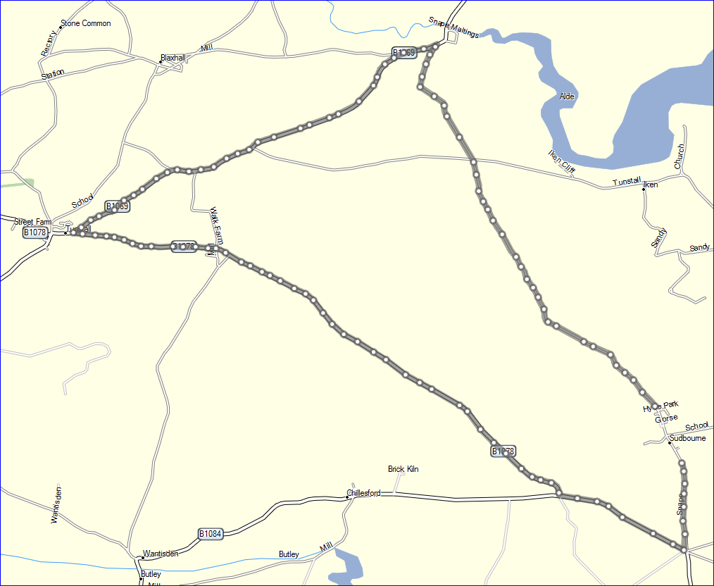
Area | East
Description | Rural circular course
HQ | Sudbourne Village Hall or Forest tracks
Measured
Measured by
Risk assessed
Assessed by | Pete Whelan
Date approved
Type A
Type B
Police Authority | Suffolk
Additional information | Expect grit/sand anywhere, even though areas will be swept where possible. Take EXTREME CARE at the 1st and 2nd turns. Be prepared to STOP
Notes for riders | Do not cross centre line anywhere on course.
OS Grid # | Course description | Distance | Risk (L/M/H) | Risk description | Minimum management  (Without prejudice)
TM 41184 53371 | Start, edge Sudborne village at national speed limit sign | 0 | L | Riders queuing, cars passing | cones and signs
TM 39484 56112 | Cross road (riders have right of way) | 2.3 | L | Vehicles | Signs, rider awareness
 | Whole course |  | L | Forest animals | Rider awareness
TM 39109 57391 | Left at Snape onto B1069 | 3.0 | M | Vehicles, Traffic from Right. Hair-pin turn. | Signs, rider awareness, marshal. Riders Must be prepared to STOP for other traffic. Riders MUST NOT cross the central white line on the entry or exit roads.
 | Side roads on B1069 |  | L | Vehicles, horses | Signs, rider awareness
TM 36127 55106 | Left at Tunstall onto B1078 | 5.5 | M | Vehicles, Traffic from Right. Poor sight line for traffic | Signs, Rider awareness, marshal. This is a STOP line and riders MUST be prepared to STOP for other traffic. Riders MUST NOT cross the central white line on the entry or exit roads
TM 37419 54945 | Side roads at Tunstall Common | 6.4 | M | vehicles | Signs rider awareness
TM 40410 52343 | B1084/ B1078 junction | 8.8 | M | Traffic from right | Signs, Rider awareness, marshal
TM 41512 51742 | Left to Sudbourne | 9.6 | L | Traffic from right | Signs, Rider awareness, marshal. Riders Must be prepared to STOP for other traffic. Riders MUST NOT cross the central white line on the entry or exit roads
TM 41446 52734 | Finish, at telegraph pole 022C | 10.2 | L | Traffic | Signs
References:
CTT GN22 – Risk Assessment

B10/53 .Start at National Speed limit sign on Snape bound edge of Sudbourne village. Proceed north to Snape, where left at ‘triangle’ onto B1069 (EXTREME CARE, Hairpin turn, approaching traffic). Do not take the short cut across the rough area. Proceed to Tunstall, where left onto B1078. (STOP line, EXTREME CARE, Be aware of traffic from the right). Proceed on B1078 to junction with B1084, where left to Sudbourne 5 –ways, where left.. Finish at telegraph pole 022C before Sudbourne Village, after 30mph sign
Do Not cross the white central line anywhere on the course

