Risk Assessment proforma*

Course | K32/5 | 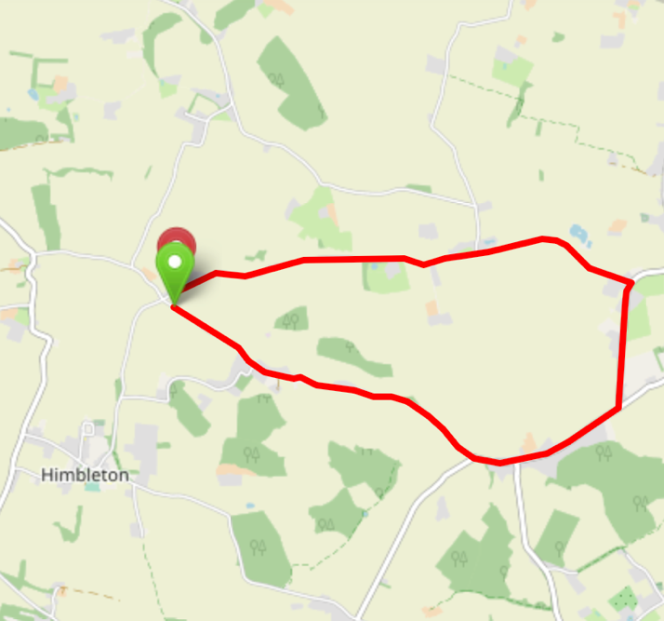
Area | Midland DC
Description | Shell Ford, Earls Common, Middle Road
HQ | Himbleton, WR9
Measured | 01/12/2022
Measured by | D Grant
Risk assessed | 01/12/2022
Assessed by | DC Risk Assessor
Date approved | 01/12/2022
Type A | NOT APPROVED
Type B | APPROVED
Police Authority | West Mercia  ian.connolly@westmercia.police.uk
Additional information | DC Committee to approve upgrade of course for Type A events
Notes for riders | Riders to gather on Shell Ford parking area and only ride to start 1 minute before start time
OS Grid # | Course description | Distance | Risk (L/M/H) | Risk description | Minimum management  (Without prejudice)
SO95215959 | Start: level with hedgerow / start of the second field approx. 100 yards up from Shell Ford cross roads | 0 | L | Riders congregating at start in road | Cycle event in progress signs.  Officials on or near road to wear high viz jackets.  Riders to gather on Shell Ford parking area and only ride to start 2 minutes before start time
SO95736922 | Road narrows through Earls Common | 0.40 | M | Road narrows, approaching traffic | Rider caution, advise to stay to the left hand side of the road. Note on start sheet.  Cycle event sign at junction with Stoney Road
SO97405850 | Potential traffic joining Earls Common Road from side road and rider caution through Stock Green village | 1.57 | L | No significant risk | Cycle event signs on side road
SO98425886 | Turn Left onto Middle Road | 2.28 | L | No significant risk | Cycle event signs  Riders have right of way
SO98525976 | Turn Left onto | 2.84 | L | No significant risk | Cycle event signs  Riders have right of way
SO95225969 | Finish: level with driveway to farm | 5.00 | L | Officials on or near road.  Riders congregating at finish | Finish sign at approach to finish and finish board by timekeeper. Officials on or near road to wear high viz jackets.  Riders advised to not stop and gather at finish point – note on start sheet.

References:

CTT GN22 – Risk Assessment

Date of Issue | Reason of Revision | Author
March 2013 | New edition | David Barry  (CTT Board Director)  (CTT Course Risk Assessor)
August 2018 | Revised format | Nick Sharpe  (CTT National Secretary)
October 2022 | Revised to reflect current CTT Articles, Rules, and Regulations | David Barry  (CTT Board Director)

