Risk Assessment proforma*

Course | K3/23 | 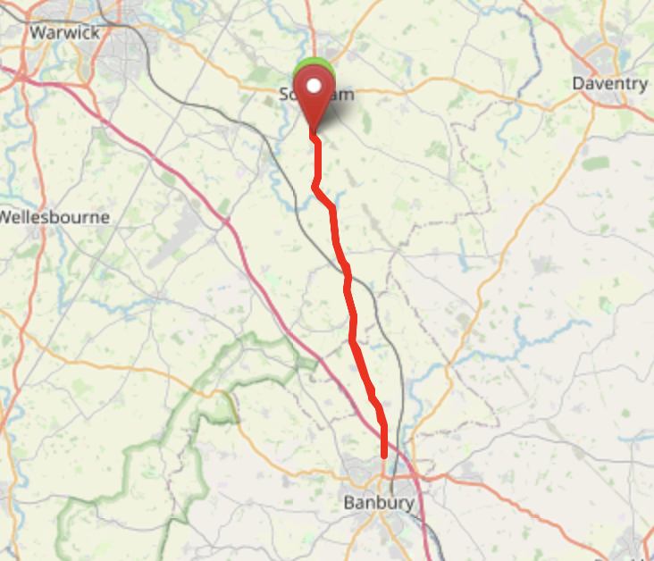
Area | Midland DC
Description | Southam – Banbury – Southam (A423)
HQ | Southam United FC, Lark Road, Kineton Road, Southam, CV47 2TT
Measured | February 2023
Measured by | SJW / DB
Risk assessed | 7th March 2023
Assessed by | DB
Date approved | 7th March 2023
Type A | Approved
Type B | Approved
Police Authority | Warwickshire  tma@warwickshire.police.uk  Thames Valley
Additional information
Notes for riders
OS Grid # | Course description | Distance | Risk (L/M/H) | Risk description | Minimum management  (Without prejudice)
SP416610 | START: Unadopted access to site at 50 mph Post (Southam - Banbury (A423)), proceed on A423; through Mollington and Little Bourton to Banbury North TI (A423/Noral Way); turn and retrace (4th exit) to Finish | 0 | L | Rider and pusher off standing in the road with their backs to the traffic. | Cycle event in progress signs. Officials on or near road to wear high viz jackets.
 | Care Points: Wharf Inn (Fenny Compton X-Roads) signage (4.19 miles): Left turn to Claydon (5.28 miles): Farnborough (Right turn) Marshal (6.29 miles): Layby on Left (7.00 miles): Left turn to Claydon (7.65 miles): Mollington X-Roads (8.1 miles): Left turn to Cropredy/Gt Bourton signage (9.65 miles): The Dirt House PH signage/marshal (10.4 miles): new housing estate entrance (10.85 miles): Descend Hardwick Hill (0.4 miles at 10%) to Turn.
SP455428 | Turn: Proceed on A423 to Finish | 11.25 | M | Riders have to give way to their right and encircle island. | Cycle event signs on all approaches to the island.  Island to be marshalled in high viz jackets
 | Care Points: From turn, ascend Hardwick Hill (0.4 miles at 10%): Mollington X-Roads (14.25 miles): Entrance to Caravan Park (11.45 miles):Left turn to Farnborough (Marshal/signage)(14.75 miles): Wharfe Inn (Fenny Compton X-Roads)(18.1 miles): Ladbroke Left turn (signage)(21.65 miles): Ladbroke Left turn (signage) (22.25 miles): Entrance to layby at Finish Point (22.45 miles).
SP418580 | FINISH at 50 mph Post (at entrance to Layby) | 22.45 | H | Competitors finishing and congregating in the layby. Traffic in both directions. | Finish sign at approach to finish and finish board by timekeeper. Officials on or near road to wear high viz jackets.  Warn riders not to congregate at finish

References:

CTT GN22 – Risk Assessment

Date of Issue | Reason of Revision | Author
March 2013 | New edition | David Barry  (CTT Board Director)  (CTT Course Risk Assessor)
August 2018 | Revised format | Nick Sharpe  (CTT National Secretary)
October 2022 | Revised to reflect current CTT Articles, Rules, and Regulations | David Barry  (CTT Board Director)

