Risk Assessment proforma*

Course | K34/10F | 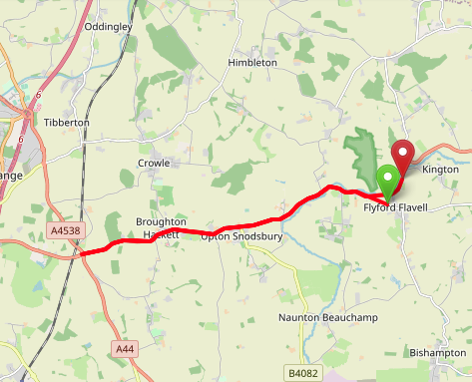
Area | Midland DC
Description | Flyford Flavell –  Spetchley – Flyford Flavell
HQ | TBA
Measured | 30/09/2023
Measured by | D Grant
Risk assessed | 30/09/2023
Assessed by | DC Risk Assessor
Date approved | 30/09/2023
Type A | Approved for Type A & Type B
Type B
Police Authority | West Mercia
Additional information
Notes for riders | A short descent at the start to a give way junction and turn onto A road  Advise - riders to be prepared to stop and give way at the junction
OS Grid # | Course description | Distance | Risk (L/M/H) | Risk description | Minimum management  (Without prejudice)
SO 977 550 | Start at: On Radford Road level with the footpath steps approx. 160 metres downhill from the junction with Old Hill | 0 | M | Riders and officials on or near the highway  Riders congregating at the start | Cycle event in progress signs.  Officials on or near road to wear high viz jackets.  Riders not yet started to wait off the carriageway.
SO 972 552 | At the junction, give way and turn left onto the A422 | 0.3 | M | Left turn onto main A422 after a short descent from the start | Cycle event in progress signs on all approaches to the junction  Marshall on junction  Rider Caution – advise riders to be prepared to stop and give way at the junction
SO 906 538 | Encircle the island, taking third exit to retrace route (A422) | 4.8 | M | Major road / traffic island with occasional heavy traffic. | Cycle event in progress signs on all approaches to the island.  Marshall on the island
SO 980 556 | Finish at: on the A422 level with the Bridleway to Woodend | 10 | L | Riders and officials on or near the highway | Finish sign at approach to finish and finish board by timekeeper.  Officials on or near road to wear high viz jackets.  Finished riders to return to HQ

References:

CTT GN22 – Risk Assessment

Date of Issue | Reason of Revision | Author
March 2013 | New edition | David Barry  (CTT Board Director)  (CTT Course Risk Assessor)
August 2018 | Revised format | Nick Sharpe  (CTT National Secretary)
October 2022 | Revised to reflect current CTT Articles, Rules, and Regulations | David Barry  (CTT Board Director)

