West DC: Risk Assessment
Cycling Time Trials – West DC Course Risk Assessment Document. The measures to reduce risk identified in the right hand column must be included on the start sheet or implemented for the duration of the event as applicable. Failure to comply with the requirements of this document may result in approval being withheld with respect to subsequent race promotions by the promoting club. (CTT Guidance Note 22 – Appendix 2 – Issue 2 September 2011 provides additional advice)

Course/Road(s) Assessed: North Road, Bath | Course: UH50  Distance (in miles):  0.75
Date of Assessment/Review: 27 September 2022 | Name of Assessor: David Atkinson
Course Description:
Start at lower entrance, King Edward's School. Proceed up North Road to finish at Quarry Road entrance to Bath University
Link: https://ctt.org.uk/course-details/uh50
Traffic Flows:
Low traffic, 30-50 vehicles per hour
Course / Event History:
First used 2021, no issues reported
Key Identified Risks
No. | Distance / Location | Risk/Hazard | Level of  Risk  (L / M / H) | Measures to reduce Risk  (if applicable)
a) Introduction
1 | General  Requirements | Time of Road Usage meets CTT Traffic Standards | L | Traffic counts within acceptable numbers
b) HQ to Start
2 | Before Start | Competitors riding from Event HQ; Competitors warming up | L | Riders advised to use Bathwick hill to proceed to start area and not warm up on  North Road
3 | Area of Start:  W3W:  ///smashes.rival.occup y | Turning into start area, queuing for start | L | Queue off road in single file. Be aware of traffic when turning into start area. Cycle Event warning signs.
c) Start to Finish
 | Description of road feature with cumulative running distance total | Description of Hazard | Assessed  level of risk | Mitigation to reduce risk
4 | Bath Golf Club | Possibility of traffic turning across course. Riders have right of way | L | Cycle Event Warning signs
5 | Finish:  W3W:  ///paints.tell.common | Awareness of surroundings | L | Continue into Quarry Road to warm down. No stopping at finish. Be aware of timekeeper's vehicle at finish.  Cycle Event warning signs.
6 | After finish | Competitors returning to event HQ. | L | Return to HQ through University
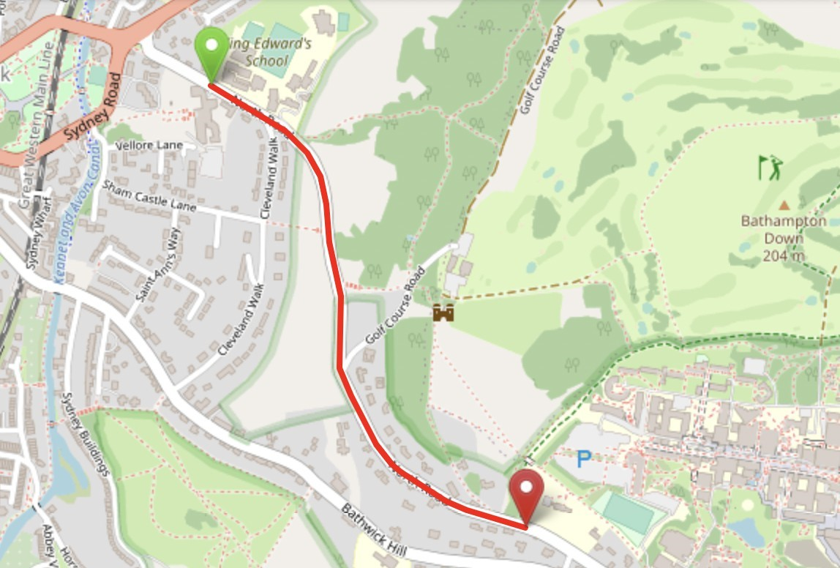
This document remains live and any changes to the items listed above or new hazards/risk that arise should be notified to the district committee at the earliest opportunity. This document was last updated on 10 August 2022.

