West DC: Risk Assessment

Cycling Time Trials – West DC Course Risk Assessment Document. The measures to reduce risk identified in the right hand column must be included on the start sheet or implemented for the duration of the event as applicable. Failure to comply with the requirements of this document may result in approval being withheld with respect to subsequent race promotions by the promoting club.
(CTT Guidance Note 22 – February 2024)

Course/Road(s) Assessed:  B4069; Dauntsey; Little Somerford; Great Sommerford; Lower Seagry | Course:  UC862/25  Distance (in miles):  25
Date of Assessment/Review:  13 February 2024 | Name of Assessor:  Paul Winchcombe
Review History:  First Produced (if known): N/K  Last Review:1 March 2023 | Sponsoring Club or Organisation:  Chippenham & District Wheelers
Course Description:

Park in Parsonage Way at North Side of Chippenham off B4069

Start on the B4069 between the junctions of Hill Corner Road and Parsonage Way. Continue on B4069 through Kington Langley to Sutton Benger *. Continue to Swallet Gate (SU990808) where turn left. Continue over M4 bridge to junction to Dauntsey where turn right. Continue through Dauntsey to Little Somerford where turn left. Continue through Great Somerford to Sutton Benger. At the junction with the B4069 turn left and complete the circuit from * to finish opposite junction with access road to disused pit (SU945792).
Link:
https://www.cyclingtimetrials.org.uk/course-details/uc862
Course Type:
- Single Carriageway
- Circuit
- No identified traffic calming
Traffic Flows:
With the collapse of Lyneham Banks Traffic Flows are now very low.
Course / Event History:
Course is used through season by Chippenham Wheelers and has been in regular use since at least 2010
Police Authorities:
Wiltshire Constabulary - Mr Bob Eccleston. Bob.Eccleston@wiltshire.police.uk

Key Identified Risks

No. | Distance / Location | Risk/Hazard | Level of Risk  (L / M / H) | Measures to reduce Risk  (if applicable)
a) Introduction
1 | General Requirements | Time of Road Usage meets CTT Traffic Standards | L | Traffic counts within acceptable numbers
b) HQ to Start
2 | Before Start | Competitors riding from Event HQ; Competitors warming up | L | Instructions on Start Sheet and at event HQ signing on advising riders of safe routes; prohibition on warming up past the start
3 | Area of Start - on the B4069 between the junctions of Hill Corner Road and Parsonage Way | Competitors waiting on grass verge before start. | L | Instructions on Start Sheet and at event HQ signing on - warning against making ‘U’ turns, queue in single file; Cycle Event Warning signs
c) Start to Finish
4 | Dodford Lane turning | Traffic joins from left. Visibility is good | L | Nil. Lane leads to isolated farms. Not a through road.
5 | B4069 Swallett Gate Junction /Dauntsey Lock | Riders turn left; Slippery surface when wet  Car Boot Sale some weekends | L | Instructions on start sheet and at start.  (Course is usually only used for evening club events)
 |  | 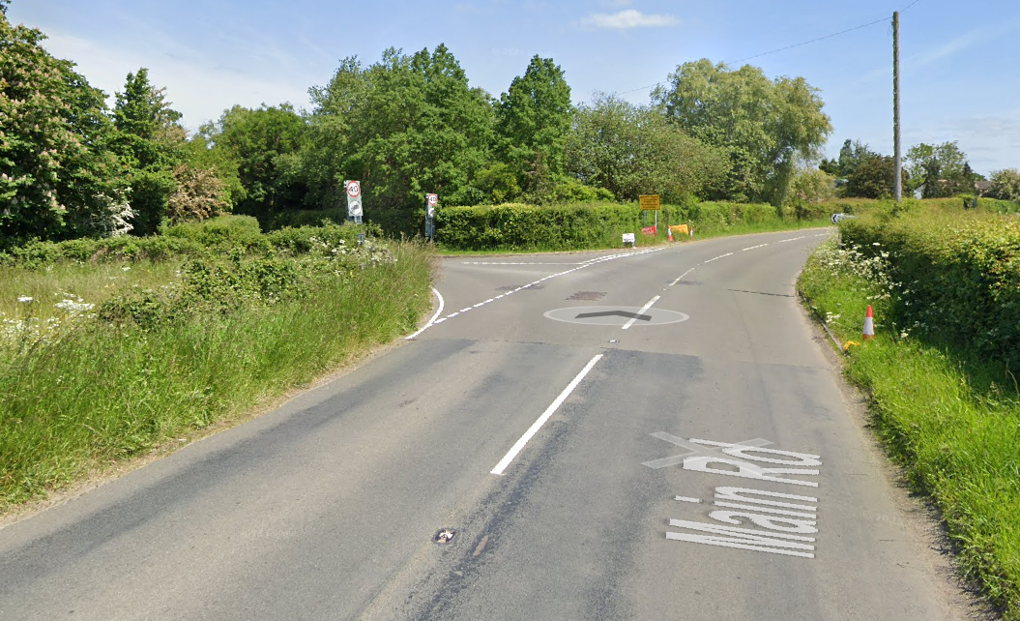
6 | Junction Church Lane / The Green | Riders turn right; Reverse angle turn;  Slippery surface when wet;  Visibility of oncoming traffic is good. | M | Instructions on start sheet  Place 1 x observer wearing high visibility vest (not mandatory).  Riders are warned not to cut corner. (Turn has been discussed with police and traffic volumes are very low)
 |  | 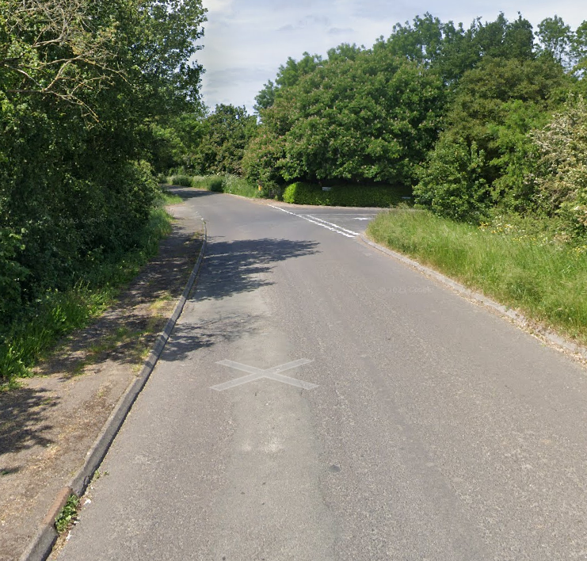
7 | Junction The Street/The Hill, Little Somerford. | Riders turn left but joining traffic has priority due to slip road. Visibility for both oncoming traffic which has to pause to turn and riders is good. Junction is wide. | L | Instructions on start sheet and at start.  Place 1 x observer wearing high visibility vest (not mandatory).
 |  | 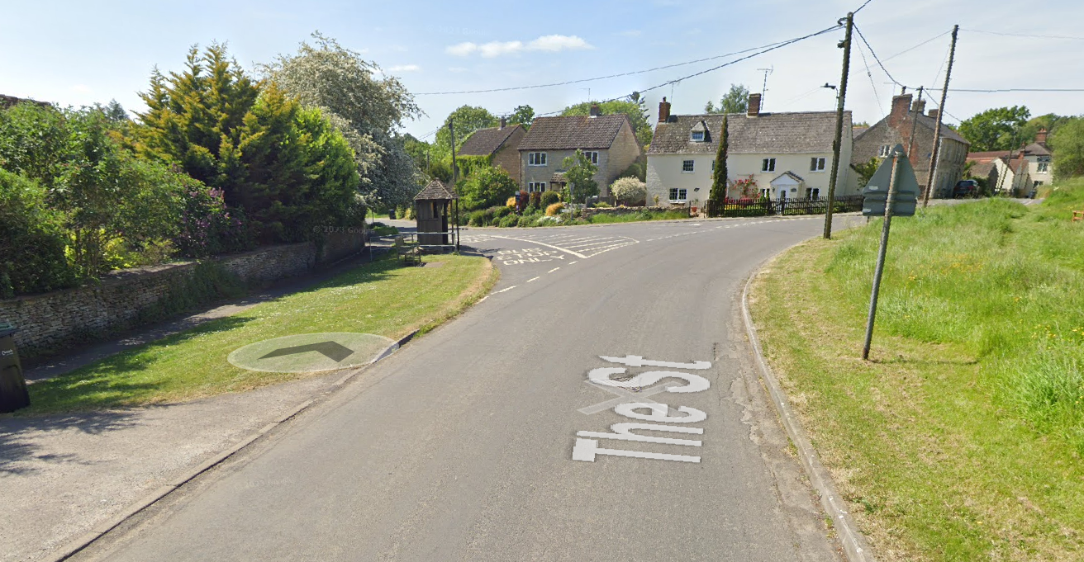
8 | Great Somerford | Parked traffic by church and pub. Road is narrowed. | L | Nil. Visibility towards potential hazard is good.
9 | S Bend near Five Thorn Lane | Slippery when wet. | L;  H when wet. | Verbal warning at signing on.
10 | Junction Seagry Hill/B4069 in Sutton Benger | Riders turn left onto B4069; traffic coming from right has priority | M | Place 1 x marshal wearing high visibility vest
11 |  | 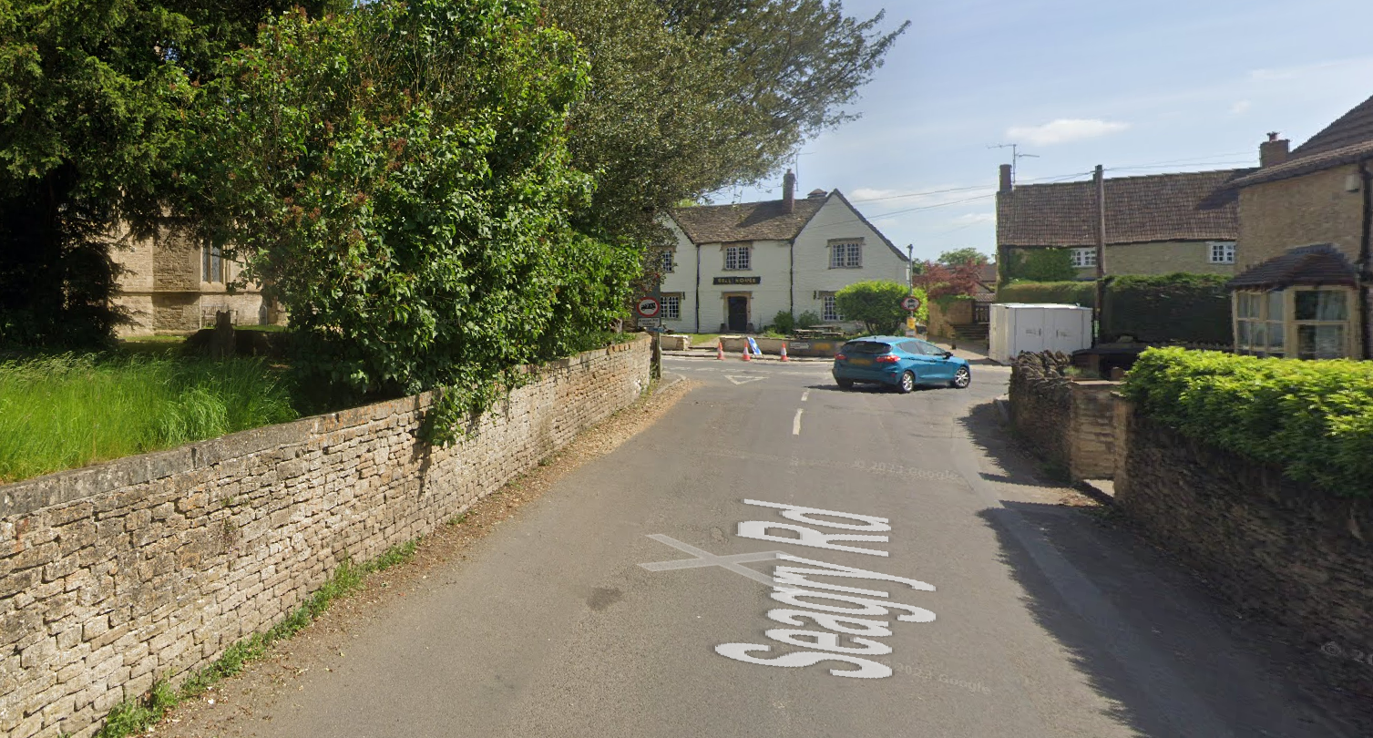
12 | Repeat course from turn to Finish opposite junction with access road to disused pit (SU945792). | Finish area with time keepers vehicle only on grass verge. | L | Instructions that no times will be given to competitors or supporters at the finish.
13 | Finish | Awareness of surroundings | L | No u-turns.  Note on start sheet to be aware of surroundings and other road users at the finish.
14 | After finish | Competitors returning to event HQ. | L | Instructions on safe route back from finish to HQ.

This document remains live and any changes to the items listed above or new hazards/risk that arise should be notified to the district committee at the earliest opportunity.

CYCLING TIME TRIALS IS A COMPANY LIMITED BY GUARANTEE REGISTERED IN ENGLAND No: 4413282
Registered Address: 77 ARLINGTON DRIVE, PENNINGTON, LEIGH, LANCASHIRE. WN7 3QP November 2003

