Risk Assessment proforma*

Course | K47/12H | 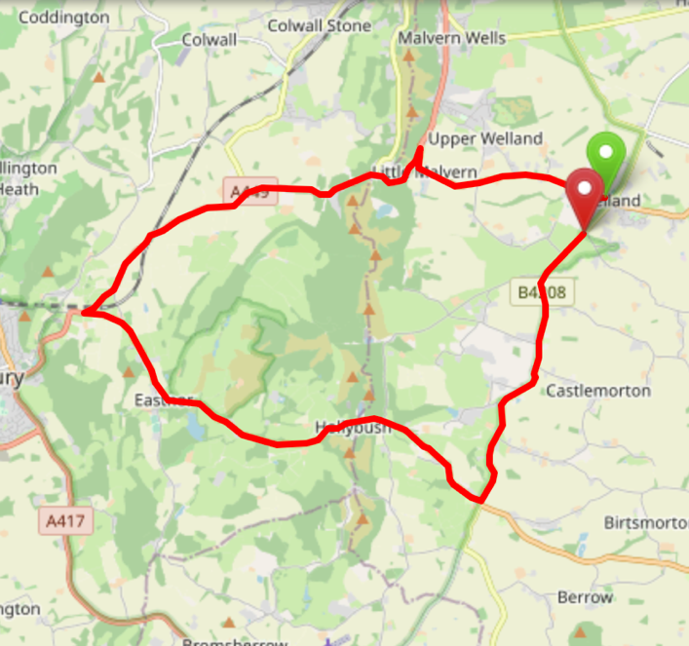
Area | Midland DC
Description | Welland/British Camp/Eastnor/Rye Cross/Castlemorton/Welland
HQ | Welland
Measured | 20/10/2022
Measured by | D Grant
Risk assessed | 20/10/2022
Assessed by | Martin Staines
Date approved | 20/10/2022
Type A | Approved for Type A & Type B
Type B
Police Authority | West Mercia
Additional information | Course borders the West DC, additional permission should be sought for use
Notes for riders | Potential for cattle and sheep to stray onto road from common land in last 4 miles
OS Grid # | Course description | Distance | Risk (L/M/H) | Risk description | Minimum management  (Without prejudice)
SO 796 401 | Start at 30 mph sign on left hand side approx 150yds west of junction of B4208 with A4104. Ride west on A4104 | 0 | L |  | Cycle event in progress signs on approach to start area both sides of road  Officials on or near road to wear high viz jackets.
SO 769 408 | Turn left 20 yards before junction with A449 | 1.9 | L | Left turn into short, steep joining road
SO 769 408 | At junction with A449 turn left (A449). Ride west on A449 | 1.9 | L | Left turn onto main road | Cycle event in progress signs on A449 at the approaches to the junction.
SO 764 404 | Straight on at junction with B4232 | 2.4 | L | Junction with B4232 on right hand side and carpark on left hand side | Place warning sign on B4232 at approach to junction and at carpark exit
SO 744 402 | Straight on at junction with B4218 | 3.7 | L | Junction with B4218 on right hand side | Place warning sign on B4218 at the approach to the junction
SO 722 385 | At junction with A438 turn left (A438) Ride east on A438 | 5.6 | L | Sharp left turn | Place warning sign on A438 and A449 east bound at the approach to the junction. Advice to riders of sharp turn on start sheet and at signing on.
SO 764 364 | Continue east on A438 | 8.9 | L | Minor roads left and right with poor visibility | Place warning signs on minor roads at the approach to junction
CARE POINT |  |  |  | Potential for cattle and sheep to stray onto road from common land | Advice to riders on start sheet and signing on
SO 777 357 | At junction with B4208 turn left (B4208) Ride north on B4208 | 10 | L | Left turn onto main road | Place warning sign on both directions on B4208 and A438 west bound at the approaches to the junction.
CARE POINT |  |  |  | Potential for cattle and sheep to stray onto road from common land | Advice to riders on start sheet and signing on
SO 793 395 | Finish at: Finish opposite the Welland village sign by the 30 mph signs | 12.8 | L |  | Finish sign at approach to finish and finish board by timekeeper. Officials on or near road to wear high viz jackets.

References:

CTT GN22 – Risk Assessment

Date of Issue | Reason of Revision | Author
March 2013 | New edition | David Barry  (CTT Board Director)  (CTT Course Risk Assessor)
August 2018 | Revised format | Nick Sharpe  (CTT National Secretary)
October 2022 | Revised to reflect current CTT Articles, Rules, and Regulations | David Barry  (CTT Board Director)

