Risk Assessment proforma*

Course | K41/25 | 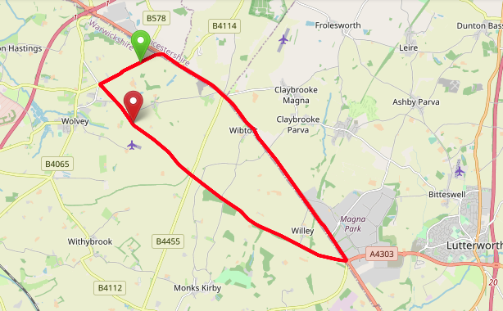
Area | Midland DC
Description | Smockington – Wolvey – Cross in Hand
HQ | Wolvey
Measured | 30/09/2023
Measured by | D Grant
Risk assessed | 30/09/2023
Assessed by | DC Risk Assessor
Date approved | 21/03/2001
Type A | Approved for Type A & Type B
Type B
Police Authority | Warwickshire & Leicestershire
Additional information | The A5 forms part of Highways England Strategic Road Network
Notes for riders | Rider Caution – See below
OS Grid # | Course description | Distance | Risk (L/M/H) | Risk description | Minimum management  (Without prejudice)
SP 4510 8966 | Start on B4114 0.25 mile southwest of junction with A5 (Smockington) in line with field gate on left opposite western end of layby on right. Proceed southwest | 0 | M | Riders and officials on or near the highway  Riders congregating at the start | Cycle event in progress signs.  Officials on or near road to wear high viz jackets.  Riders not yet started to wait off the carriageway.
SP 4368 8890 | At island at Wolvey (Axe & Compass) take first exit towards Lutterworth (Cloudsley Bush Lane) | 0.8 | L | Traffic Island | Cycle event in progress signs on all approaches to the island.
SP 4635 8633 | At Fosse Way B4455 cross roads continue straight on (Coalpit Lane) | 3.12 | L | Cross roads, riders have right of way | Cycle event signs on approach to cross roads from the side roads.
SP 5079 8394 | At the A5 island (Cross in Hand) take the 1st exit (A5) | 6.27 | M | Major road / traffic island with occasional heavy traffic. | Cycle event in progress signs on all approaches to the island.  Marshall on the island  Advise Rider Caution
SP 5032 8465 | Cross the island, first exit onto the A5 | 6.82 | L | Traffic Island | Cycle event in progress signs on all approaches to the island.
SP 5032 8465 | CARE POINT | 6.9 | M | Sections of Dual Carriageway ahead | Cycle event in progress signs on approach to dual carriageway  Advise Rider Caution  Riders to stay left on dual carriageway ahead
SP 4741 8846 | Staggered cross roads from Wibtoft on the left and Monks Kirby from the right. Lane on the left from Wibtoft  Lane on the right from Monks Kirby  Lane on the left from Willey | 9.8 | M | Busy junction on the A5, potential heavy traffic. Riders have right of way | Cycle event in progress signs on all approaches to the junction  Advise Rider Caution
SP 4550 8977 | At Smockington, filter left and give way onto B4114 to complete circuit | 11.25 | L | Left turn via filter lane onto road, give way junction at the end of filter lane | Riders to Give Way
SP 4510 8966 | Ride second circuit | 11.7 |  | As above | As Above
SP 4510 8966 | Commence a third circuit | 23.4 |  | As above | As Above
SP 4368 8890 | At island at Wolvey (Axe & Compass) take first exit towards Lutterworth (Cloudsley Bush Lane) | 24.1 | L | Traffic Island | Cycle event in progress signs on all approaches to the island.
SP 4465 8779 | Finish 0.25 mile past turning to Copston Magna in line with first chevron bend warning sign on the right. | 25 | L | Riders and officials on or near the highway | Finish sign at approach to finish and finish board by timekeeper.  Officials on or near road to wear high viz jackets.  Finished riders to return to HQ

References:

CTT GN22 – Risk Assessment

Date of Issue | Reason of Revision | Author
March 2013 | New edition | David Barry  (CTT Board Director)  (CTT Course Risk Assessor)
August 2018 | Revised format | Nick Sharpe  (CTT National Secretary)
October 2022 | Revised to reflect current CTT Articles, Rules, and Regulations | David Barry  (CTT Board Director)

