
West DC: Risk Assessment

Cycling Time Trials – West DC Course Risk Assessment Document. The measures to reduce risk identified in the right hand column must be included on the start sheet or implemented for the duration of the event as applicable. Failure to comply with the requirements of this document may result in approval being withheld with respect to subsequent race promotions by the promoting club.
(CTT Guidance Note 22 – Appendix 2 – Issue 2 September 2011 provides additional advice)
Course/Road(s) Assessed:  Minor road at Hinton Hill, between Pucklechurch (South Glos) and the A46 | Course:  UH90 Hill Climb Hinton Hill  Distance (in miles): Approx 0.5 miles
Date of Assessment/Review:  17 September 2022. Will be reviewed and updated as necessary in September 2023 | Name of Assessor:  Neil Blessitt, SRC  Image update and review Paul Winchcombe July 2023
Course Description:
Start on the eastern corner of the car park of The Bull at Hinton.
Link:
(Provide a link to the CTT Course Description and Map or to a valid Strava link which may be used until the CTT website has been update)
Traffic Flows:
Traffic flow is relatively light and within acceptable limits but there are corners on the course, and one junction where riders need to be vigilant.
Course / Event History:
UH90 has been in use for decades.

Key Identified Risks
No. | Distance / Location | Risk/Hazard | Level of Risk  (L / M / H) | Measures to reduce Risk  (if applicable)
a) Introduction
1 | General Requirements | Time of Road Usage meets CTT Traffic Standards | L | Traffic counts within acceptable numbers. Traffic count was taken 2 weeks prior to last year’s event (17-09-22) at the same day and time. It will be updated in the two weeks prior to this year’s event.
 | Covid Guidelines | Risk of cross infection between riders, SRC members and general public | M | The event will be run in a manner that is consistent with the latest Infection Control guidelines.
b) HQ to Start
2 | Before Start | The start is located in the road next to “The Bull Inn” car park. The HQ is located in a field 0.5km from the start  Parking is available in the same field. | L | Instructions on start sheet to advise riders to park (if driving) in the parking area further down the road away from the pub, and to ride to the HQ at the pub car park to sign on and start. CYCLE EVENT signs to be located at parking area.
3 | Area of Start | Competitors waiting in Bull Inn car park | L | Instructions on Start Sheet and at event HQ signing on - warning against traffic entering and leaving the pub car park. CYCLE EVENT warning signs and a observer will be located in “The Bull Inn” car park.
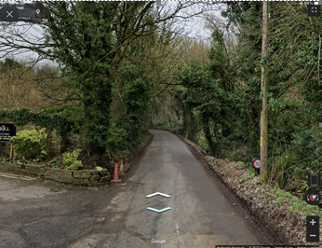

c) Start to Finish
4 | The course | One turning to the right, half way up the climb on the left. This road is lightly used. The race road is narrow, tree-lined with blind bends. | L | Warning on Start Sheet to keep to the left at all times and to take care when descending. Observer and Cycle Event warning signs at minor road junction from right.
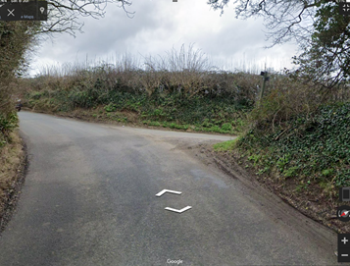
5 | Finish | Road Users – riders performing U turns after the finish. | L | Warning on start sheet not to perform ‘U’ turns at the finish or to impair other competitors climbing the hill on their way back down.  Also a note to be aware of surroundings and other road users at the finish. Cycle Event warning signs beyond the finish to warn vehicles approaching the course from the A46 Bath – Stroud Road.
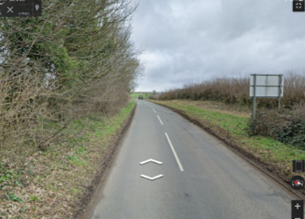

Notes
- The use of a vehicle for the timekeeper(s) at start and finish is where appropriate and is only identified as an example for the action to be taken
- The small junctions or entrances to farms/ facilities (garage,.eatery, etc) that are not identified in this risk assessment have been considered, however are not considered significant to pose a risk and therefore have not been noted.

You may wish to include a jpg image of the course, which indicates key features.

This document remains live and any changes to the items listed above or new hazards/risk that arise should be notified to the district committee at the earliest opportunity. This document was last updated on 10 August 2022.

