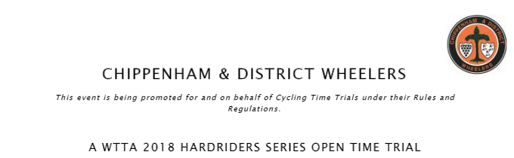
U86/50 – Sunday 9th September – 7:01am
Event Secretary Timekeepers & Officials
Emma Angove Mike & Sheila Edwards
2 Derriads Lane
Chippenham
Wiltshire
SN14 0QH
Mobile: (07827) 337543
Email: eangove@yahoo.com

Thank you

Thank you to all those who entered and rode the event, congratulations to all the prizewinners.

Thank you to our timekeepers today and results board extraordinaire Sheila & Mike Edwards. Thanks to Paul Freegard for pushing off riders, helping rescue Mark after his puncture and generally helping throughout. To Fiona & Maddy for taking care of HQ and keeping everyone well looked after. And the team of marshalls Steve Downs (Bristol South), Sarah Bailey (MTB Swindon) and Andrew Palmer, Simon Cox & Mike Gibbons (all Chippenham Wheelers) without which the event could not go ahead.

Lost Property

A sportful top was found at HQ on clearing up after the event, so if this is yours please get in touch to arrange for it’s safe return to you....I’m afraid it won’t be washed for you
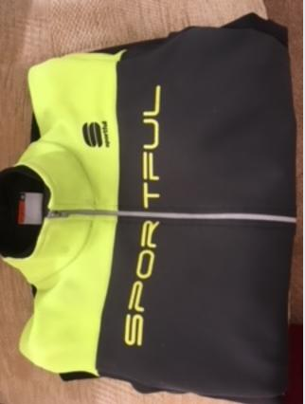

Prizewinners
1st £20 Rich Hunt Army Cycling Union
2nd £15 Harry Walton Cheltenham & County Cycling Club
1st Woman £20 Heather Price Bristol Road Club
1st V40 £20 Tony Chapman Frome and District Wheelers
1st V50+ £20 Roy Carless Swindon Road Club
1st Team £20 Robert Grover Velo Club Walcot
Arran Armstrong Velo Club Walcot

