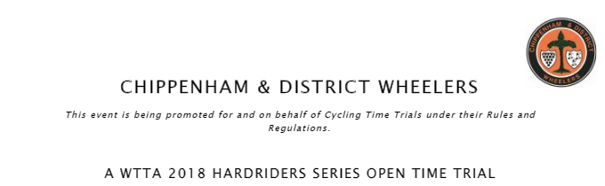
U86/50 – Sunday 9th September – 7:01am
Event Secretary Timekeepers & Officials
Emma Angove Mike & Sheila Edwards
2 Derriads Lane
Chippenham
Wiltshire
SN14 0QH
Mobile: (07827) 337543
Email: eangove@yahoo.com

Prizes to be awarded on the day (one prize per rider – except team prize)
First Overall | £20.00 | First Vet 40 | £20.00
Second Overall | £15.00 | First Vet 50+ | £20.00
First Lady | £20.00 | First Team of two | £10 each

HQ – Minety Village Hall, Hornbury Hill, Minety, Malmesbury SN16 9QH.
From the B4040, turn north on to Silver Street, follow the road as it turns left into Hornbury Hill. The HQ is approx 0.2 miles along Hornbury Hill on your left.
The HQ will be open from around 6am. Strictly no cleats to be worn in the village hall.
Please be mindful of local residents park considerably and legally. Be quiet early in the morning.
No warming up past the start once the event is underway.

Course Description
Start: Minor entrance to the south side of the B4040 west of Minety, immediately opposite Dog Trap Lane.
Course: Leaving the start, progress west on the B4040. Proceed through Charlton and onto the RAB on the A429 just before Malmesbury. Left to turn south on the A429. Proceed to next RAB with the B4042, where left onto the B4042. Proceed eastward, passing through Brinkworth, and The Common til reaching the B4696 (just before the M4 motorway). Left onto the B4696 (sign posted Ashton Keynes, Cricklade, Cirencester). After approximately 2 miles, take the left turn at Braydon Cross (sign posted Garsdon). Follow to top of minor climb, where follow the road through its right turn (signed Minety 1½). Follow through to Minety and the junction with the B4040, where left onto the B4040 to pass the start. This forms the first loop.
The loop is performed twice.
On starting the loop for the third time, continue through to the RAB with the A429, where circle the RAB to return to the B4040, where head east. Pass through Charlton, to finish on the outskirts of Minety, approximately 50yards before the start.
Finish: The finish is in line with the Gate on the north side of B4040, approximately 50 yards west of the start, and with the start just in view.

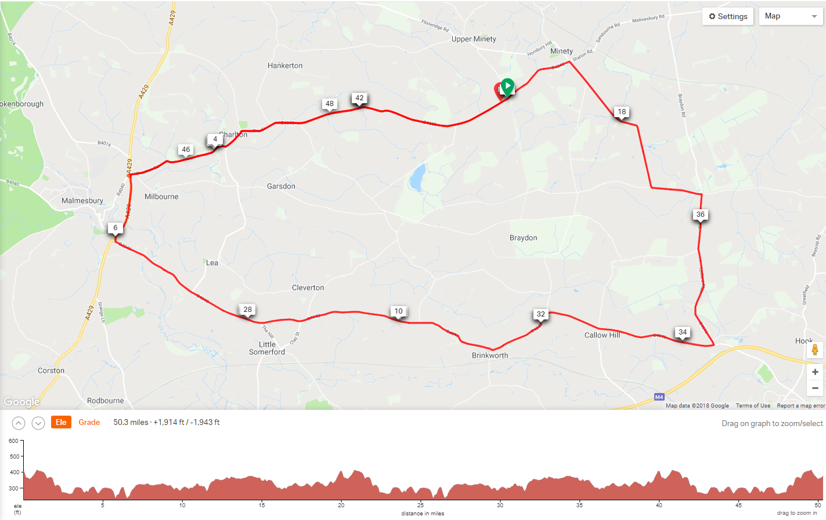

Signing In/Out
Riders must sign on at race HQ to collect their number and check for any last minute information regarding the event or course.
Please return your number for a free tea or coffee, and ensure you sign out at the same time.
Failure to sign-on AND sign-off will result in DNF recorded on your result

Route to Start
Leave the HQ turn left, follow Hornbury Hill and Silver Street back to the B4040 Minety Crossroads. On reaching the B4040 at the Turnpike Inn, carefully cross straight over onto the minor road. The start is approximately 1 mile down the road.

Marshalls
Each turn on the course will be marked with two left arrows ahead, there should be a marshall at each of the five turns but please make sure you are familiar the course. The marshall on the B4040/A429 roundabout will be checking numbers however will not be able to direct you as on your approach they will not know which lap you are on. Please ensure you circle the roundabout on the correct lap to finish.

IN THE INTERESTS OF YOUR OWN SAFETY
The race takes place on public roads with live traffic on the course so competitors must obey the Highway Code at all times and not impede other road users.
Cycling Time Trials recommends that all competitors wear a hard shell helmet that meets internationally recognised safety standards
All junior/juvenile riders MUST wear protective hard shell helmets
Please keep your head up for a safe ride

