Wrekinsport CC Chris Edwards Hilly 17 Mile Time Trial

Friction and Hydraulic Services Shropshire Championship Points Series - Round 1

Fastest Wrekinsport rider to hold the Chris Edwards Shield

Promoted for and on behalf of Cycling Time Trials under its rules & regulations

Charity event to be held on 9th March, 2024 commencing at 2:00pm

Officials

Timekeeper: Dave Fletcher, Wrekinsport CC
Asst Timekeeper: Dave Poulter, Wrekinsport CC
Start line official and Recorder: Stuart Wortley, Wrekinsport CC
Event Secretary: Matt Price, 34 Castle Street, Hadley, Telford TF1 5GH

Headquarters

HQ is Atcham Memorial Hall Malthouse Lane, Atcham SY5 6QE off the B4380 opposite Attingham Park entrance. HQ will be open from 12:30pm.

Safety

Riders are advised to warm up off course towards the start and not on the course. Ride with your head up at all times, and respect the rules of the road as laid down in the Highway Code. Do not perform U-turns on the course within sight of the start and finish points. Per Regulation 15 it is COMPULSORY to wear a properly affixed cycle helmet that meets an internationally accepted safety standard.

The descent from the turn is fast. As the road begins to level off riders are advised to check behind, and if possible to hold primary road position until past the turn to Much Wenlock.

CTT Regulations 14(i) & 14(j) – Compulsory rear red light and front white light

No competitor shall be permitted to start either a Type A or Type B event unless such competitor has affixed to their machine a working rear red light, either flashing or constant; AND a working white front light either flashing or constant and that are illuminated and in positions that are clearly visible to other road users. NO LIGHTS – NO RIDE.

CTT Regulation 16 – Competitor’s Clothing

No trade team tops or tops carrying advertising except where the rider’s club has paid the advertising levy. Manufacturer’s logos are allowed.

CTT Regulation 17d - Signing Off

Competitors MUST return to the event HQ either during the event or within a reasonable time after the last rider has finished the event and must return their race number and sign the official signing out sheet.

Thanks

I would like to thank all the marshals, helpers and officials who have made this event possible. I hope all riders have an enjoyable afternoon and have good, safe and fast rides. Matt Price

Course D317/1

This is the first use of this testing course, entirely ‘out and back’

- Start level with drain cover at north end of field pull-in 30 yards from B5061/B4380 junction between Atcham and Norton 0.00 miles
- Proceed South-East along B4380 until it becomes to A4169 at 6.81 miles
- Continue South-East via Ironbridge by-pass to Jiggers Bank Roundabout 8.58 miles
- Encircle, taking 4th exit to retrace North-West Along A4169 & B4380 to finish at southern end of field gate pull-in approx 150 yards before start 17.18 miles

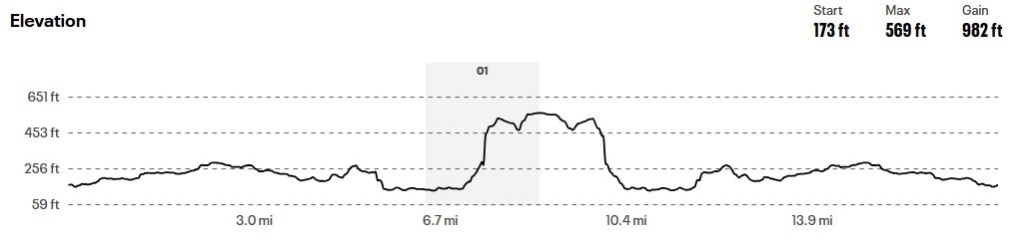

Course map at: https://www.mapmyride.com/routes/view/5430079222

To start line

- Turn right out of car park
- At T-junction turn right onto B4380
- After crossing Atcham river bridge start is near junction first on right in 0.24 miles
- Distance to start: 0.94 miles

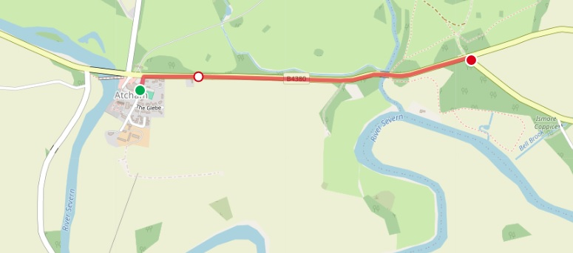

Links

- Visit the Club Website at: www.wrekinsport.org.uk

- Full result will appear on Wrekinsport CC's Twitter at: www.twitter.com/wrekinsportcc

- Visit the Shropshire Cycling Clubs Association Website for race report at: https://shropshirecca.uk/

- Details of other County Series and Competitions appear on Shropshire Cycling Clubs Association's Twitter at: www.twitter.com/shropshirecca

Start Order

No. | Forename | Surname | Club | Class | Cat | Machine | Start Time
1 | Ashley | Kirkham | Wrekinsport CC | Open | Veteran | Road Bike | 14:01
2 | Phil | Guy | North Shropshire Wheelers | Open | Veteran | Road Bike | 14:02
3 | Nick | Giles | Pocomotion Road Club | Open | Veteran | Road Bike | 14:03
4 | Alvydas | Janusauskas | Mid Shropshire Wheelers | Open | Senior | Road Bike | 14:04
5 | Matthew | Garthwaite | Newport (Shropshire) CC | Open | Senior | Road Bike | 14:05
6 | Paul | Bailey | Bridgnorth Cycling Club | Open | Veteran | Road Bike | 14:06
7 |  |  |  |  |  |  | 14:07
8 |  |  |  |  |  |  | 14:08
9 | Oli | Freeman | Wrekinsport CC | Open | Senior | TT Bike | 14:09
10 | Tim | Beardmore | Bridgnorth Cycling Club | Open | Veteran | TT Bike | 14:10
11 | Thomas | Bill | Stafford RC | Open | Senior | TT Bike | 14:11
12 | Philip | Roberts | Wrekinsport CC | Open | Senior | TT Bike | 14:12
13 | Devon | Round | Mid Shropshire Wheelers | Open | Senior | TT Bike | 14:13
14 | Alex | Gibson | Stafford RC | Open | Veteran | TT Bike | 14:14
15 | Paul | Horton | Bridgnorth Cycling Club | Open | Senior | TT Bike | 14:15
16 | Christopher | Riley | Paramount CRT | Open | Veteran | TT Bike | 14:16
17 | Adam | Mumford | Wrekinsport CC | Open | Senior | TT Bike | 14:17
18 | Steve | Smales | Harrogate Nova CC | Open | Veteran | TT Bike | 14:18
19 | Dominic | Gibson | Stafford RC | Open | Veteran | TT Bike | 14:19
20 | Joseph | Costello | Legato Racing Team (LRT) | Open | Veteran | TT Bike | 14:20
21 | Simon | Romei | Paramount CRT | Open | Veteran | TT Bike | 14:21
22 | Jack | Casey | Stafford RC | Open | Senior | TT Bike | 14:22
23 | Allan | Henderson | Wrekinsport CC | Open | Veteran | TT Bike | 14:23
24 | James | Elgar | Paramount CRT | Open | Veteran | TT Bike | 14:24
25 | Sam | Hughes | Liverpool Century RC | Open | Senior | TT Bike | 14:25
26 | Bryn | Davies | Hafren CC | Open | Veteran | TT Bike | 14:26
27 | Robert | McGregor | Paramount CRT | Open | Senior | TT Bike | 14:27
28 | Ian | Connolly | Ludlow CC | Open | Veteran | TT Bike | 14:28
29 | Ben | Wood | Wrekinsport CC | Open | Senior | TT Bike | 14:29
30 | Jonathan | Whittaker | Army Cycling | Open | Senior | TT Bike | 14:30

In Memory of Chris Edwards

